MANTHINK / INDUSTRIAL IoT
GD6
LoRaWAN Gateway
Standardized Device Manual
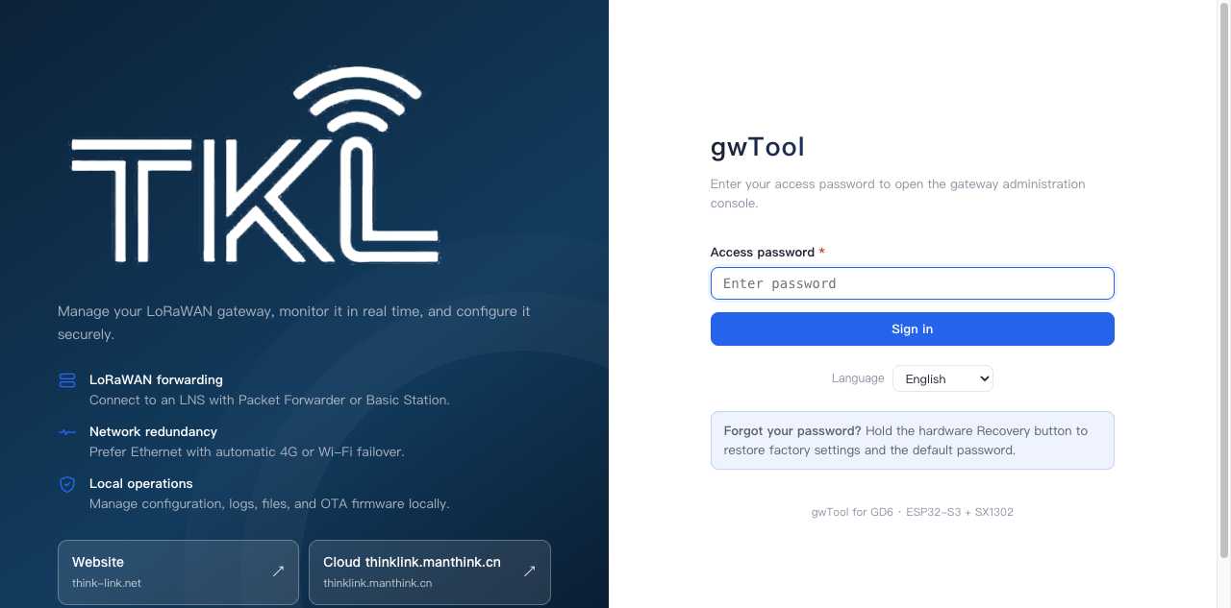
VERSION  1.0 | DOCUMENT  Device Manual

Document version: 1.0
Applies to: LoRaWAN gateways that use the GD6 configuration system

About this guide
This guide is the shared reference for the GD6 gateway configuration system. It covers Web-console access, network backhaul, LoRaWAN server and radio settings, logs, firmware and remote configuration. Future gateways based on GD6 can reference this guide instead of repeating the same procedures in each product manual.
Available Ethernet, Wi-Fi, 4G, RF-band, power and recovery-button features vary by gateway model. Read the applicable product manual before configuration, and follow the device label, ordering code and delivered firmware.
NOTE Interface examples: The screenshots in this guide use GD61x as the example device. Menu names and available options can vary slightly by firmware version. A menu can be hidden or unavailable when the corresponding hardware is not installed.

Open the Web console

Access over Ethernet
The gateway can obtain an address through DHCP. Find its lease in the router and open http://<gateway-address>.
For example, if DHCP assigns 192.168.1.100, open:
http://192.168.1.100

Access through the default Wi-Fi AP
Models with Wi-Fi can use the default configuration access point:
- Join LGW-Config.
- Enter the default Wi-Fi password lgw12345678.
- Open http://192.168.4.1.
If Wi-Fi is disabled, use Ethernet to open the Web console and re-enable it. If all management links are unavailable, follow the product manual to factory-reset the gateway, then connect to the default AP.
Default Web password:
wifi!0804
After the first login, change the password under Users. The Wi-Fi AP password and Web login password are separate credentials.

System overview
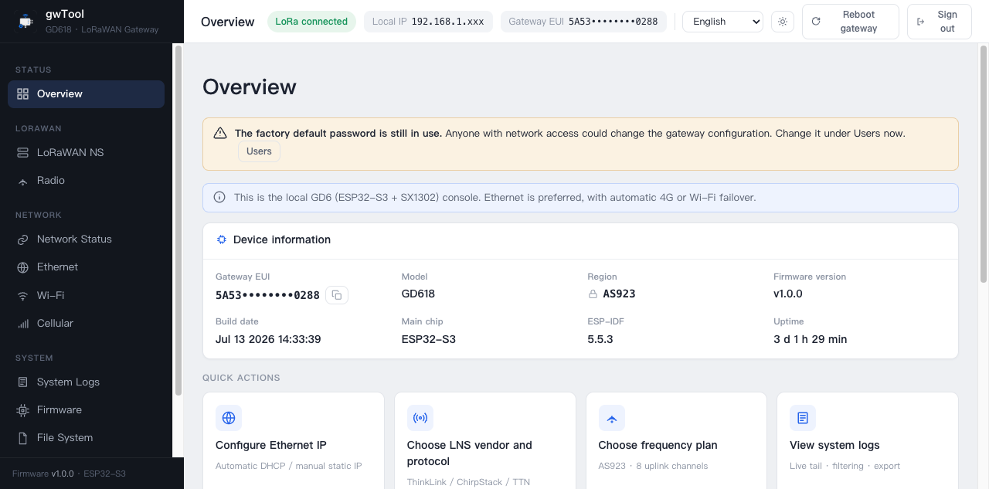
Figure GD6 English system-overview example
Overview displays:
- Controller, firmware version, build date and uptime.
- Heap and SPIFFS usage.
- Ethernet, Wi-Fi and 4G status supported by the current model.
- The active backhaul route.
- Gateway EUI, LoRa driver and service state.
Select Refresh for an immediate update. Reboot Gateway should be used only when no configuration save or firmware update is in progress. A normal reboot takes about 90 seconds.

Configure network backhaul
The GD6 configuration system can manage Ethernet, Wi-Fi STA and 4G backhaul. The available interfaces, route priority and automatic failover policy depend on the gateway model and installed hardware.

Ethernet
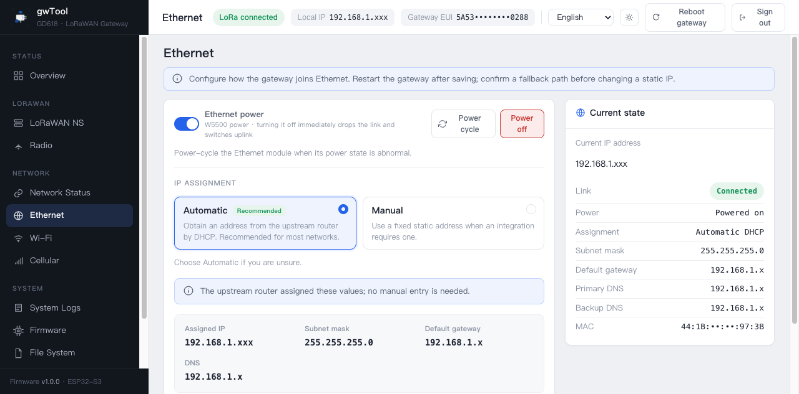
Figure GD6 English Ethernet-page example
- Open Ethernet.
- Select DHCP or Static IP.
- For a static address, enter the IP, subnet mask, default gateway and DNS servers.
- Select Save. An address change may require reconnecting or rebooting.
Ethernet Power controls the gateway's internal Ethernet controller at runtime; it is not an external PoE output. Powering off or cycling the interface temporarily interrupts the current connection.

Wi-Fi
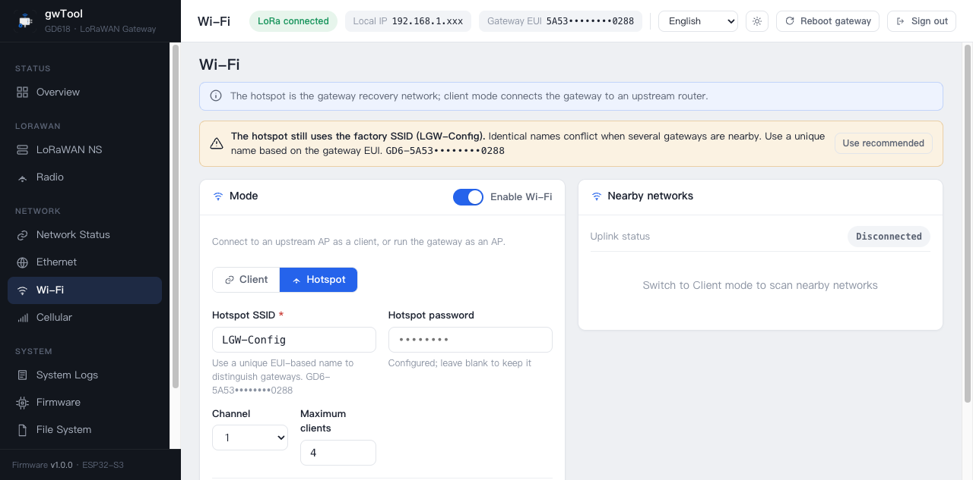
Figure GD6 English Wi-Fi-page example
The Wi-Fi page includes:
- Master switch: disables the complete Wi-Fi radio.
- Access point (AP): changes the local configuration SSID, password, channel and maximum client count.
- Station (STA): scans and joins a site Wi-Fi network for backhaul.
Changing AP settings disconnects the current wireless session; reconnect with the new SSID or password. Before disabling Wi-Fi, confirm that another management link can still reach the gateway.

4G / LTE
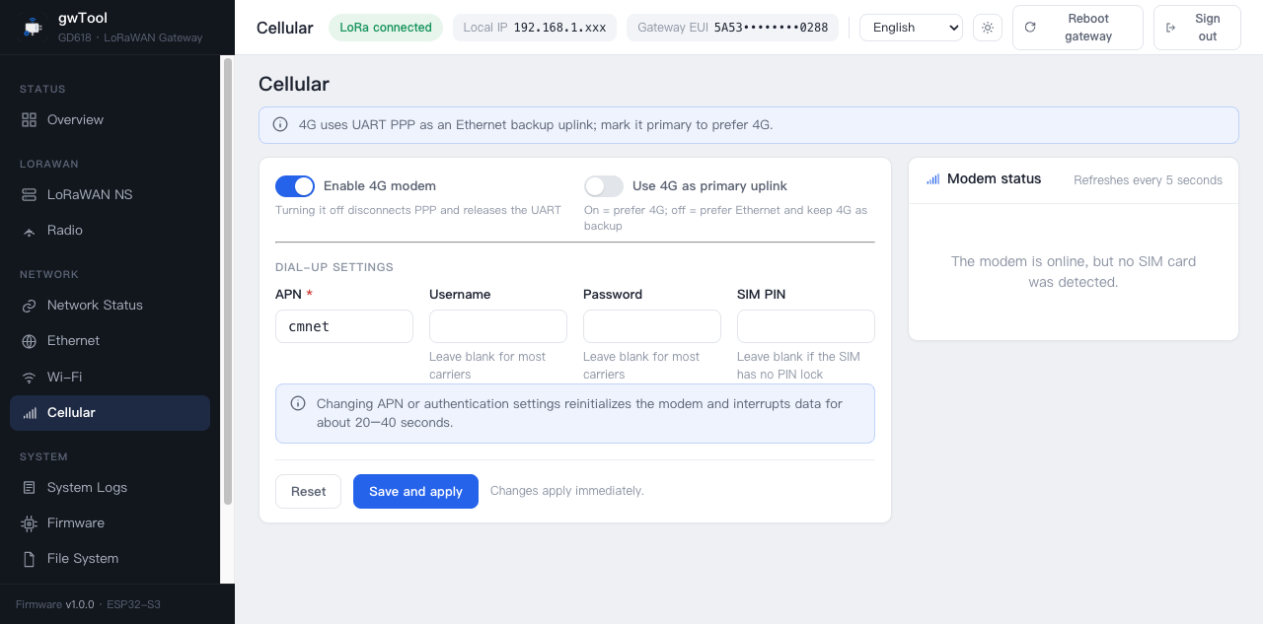
Figure GD6 English 4G-page example
This section applies only to models fitted with a 4G modem and SIM slot.
- Insert an activated SIM and enable the 4G modem.
- Enter the operator APN; username and password are normally optional.
- Enter the SIM PIN if protection is enabled.
- Keep the UART baud rate matched to the delivered modem.
- Select route priority and save.
The status panel shows SIM state, registration, operator, signal, access technology and PPP address. Mask IMEI and ICCID before publishing or sharing screenshots. Supported operators and bands depend on the modem and the applicable product specification.

Configure the LoRaWAN server
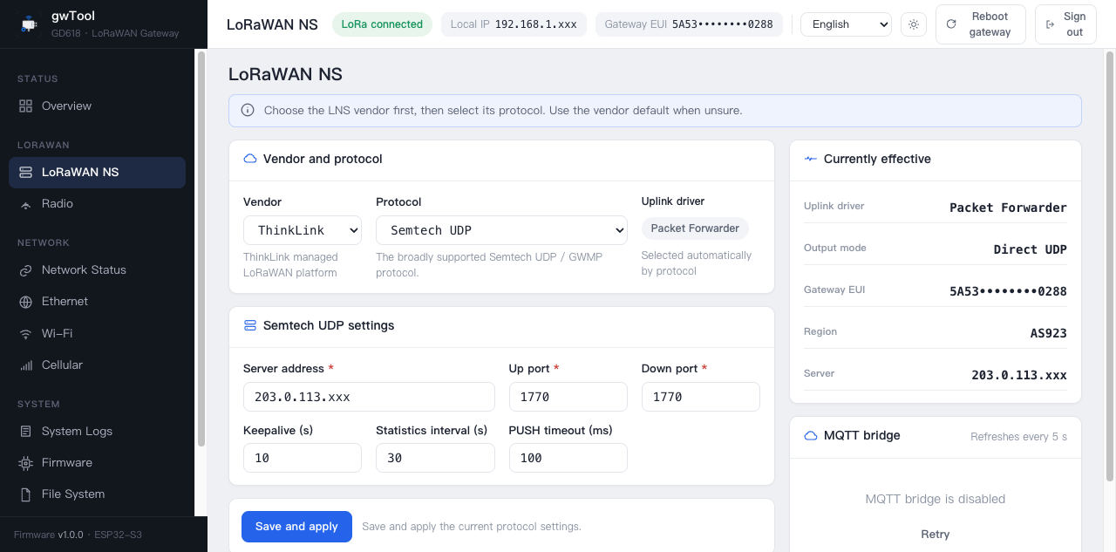
Figure GD6 English LNS Settings example
Open LNS Settings and select an uplink driver:
- Packet Forwarder: Semtech UDP or MQTT Bridge.
- Basic Station: WSS/TLS to an LNS, either directly or through CUPS bootstrap.

Semtech UDP
- Select Packet Forwarder and Semtech UDP.
- Enter the server domain/IP and uplink/downlink ports.
- Set keepalive, status interval and push timeout as required by the server.
- Save and confirm that the LoRa service and server ACK become healthy.

MQTT Bridge
Set the broker URI, Client ID, account, QoS, local UDP ports and TLS options. For mutual TLS, upload the CA, client certificate and private key. MQTT Bridge and Remote Config use independent connections; do not mix their topics or credentials.

Basic Station
- Direct: enter tc.uri and the CA. For token authentication, paste the full Bearer Authorization line; for mTLS, provide the client certificate and private key.
- CUPS: enter cups.uri and its credentials so CUPS can provision or rotate the LNS configuration.
Switching between Packet Forwarder and Basic Station reboots the gateway. Confirm that no OTA or other write is in progress before applying the change.

Configure radio and bands
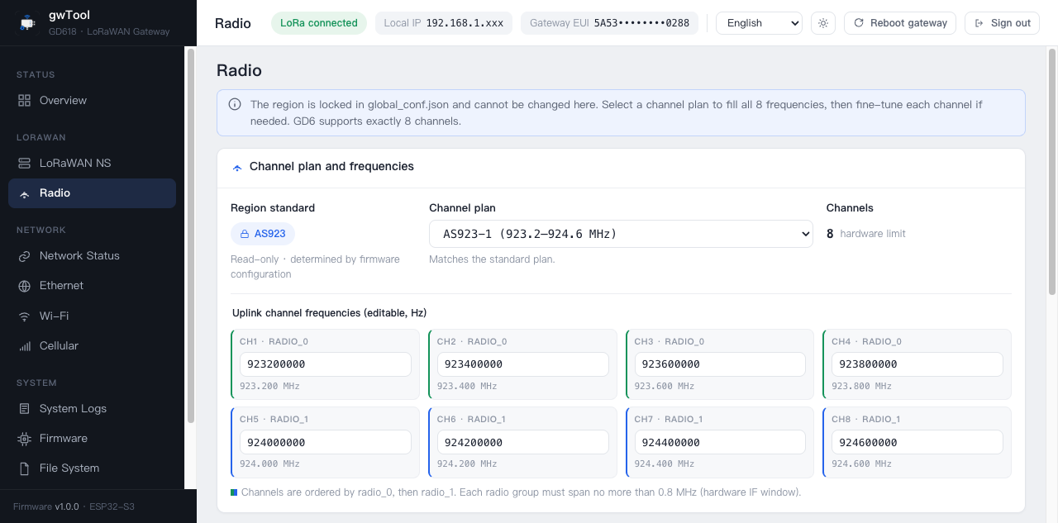
Figure GD6 English Radio & Bands example
Radio & Bands is used to inspect the regional plan, select a sub-band and set receive channels:
- CN470, US902 (LoRaWAN US915) and AU915 provide the applicable sub-band choices for their regional plans.
- AS923 provides AS923-1 through AS923-4 variants.
- EU433, EU868 and other variants use their applicable predefined plans.
- Available regions, channel counts and RF capabilities depend on the gateway model.
NOTE RF hardware limitation: The regional plan must match the RF front end and LoRa antenna. A gateway for one frequency band cannot be converted to another band by changing only the Web setting.

Select Apply after changing channels, then restart only the LoRa service if required. Reboot the complete system only when changing the uplink driver or when prompted.

System maintenance

System Logs
System Logs streams messages from Web, networking, Packet Forwarder, MQTT and installed communications modules. Filter by level/source, pause scrolling, clear or download logs. Check for addresses, EUI and network identifiers before sharing a log file.

Firmware
- Open Firmware and verify the current version and active partition.
- Select the .bin firmware that exactly matches the gateway model, hardware revision and target region.
- Wait for upload, validation and writing to finish.
- Reboot when prompted, sign in again and verify the firmware version.
The GD6 configuration system uses A/B OTA partitions. Do not refresh, disconnect the network or remove power during the update. Do not upload a full-flash manufacturing image through Web OTA.

Filesystem
Filesystem manages configuration files under /spiffs. Configuration JSON files normally take effect after reboot. Replacing files under web/ can make the console inaccessible, and factory reset does not restore damaged Web assets. Do not modify that directory outside a controlled service procedure.

Users and password
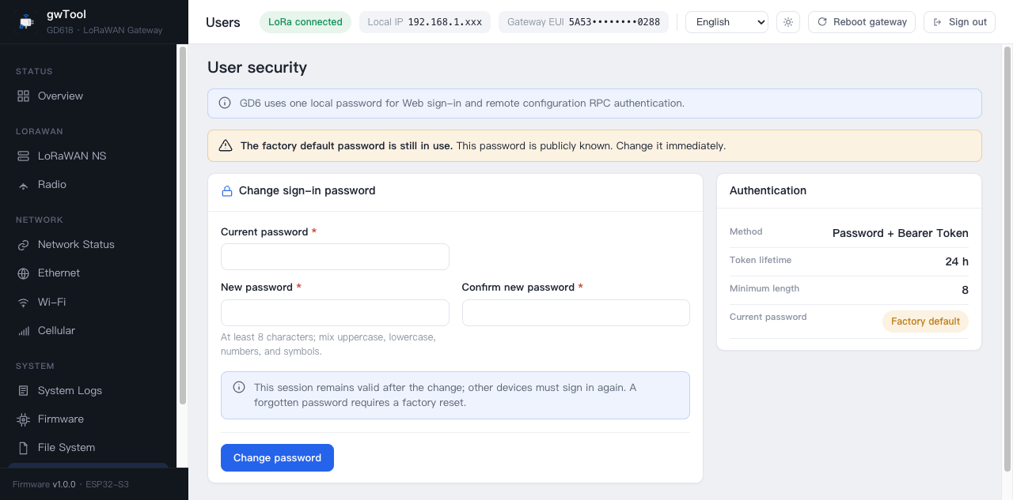
Figure GD6 English Users-page example
Open Users, enter the current password, new password and confirmation, then save. The new password must contain at least eight characters. Existing tokens may become invalid, requiring a new login.

Remote Config
Remote Config uses an isolated MQTT connection to read/write approved settings and request a reboot. Configure its broker, Client ID, topics, QoS and TLS, then monitor connection state. To prevent remote lockout, the channel cannot change its own broker settings.

Factory reset
The factory-reset trigger and indicator behavior depend on the gateway model. Follow the applicable product manual.
A factory reset restores network, LoRaWAN, MQTT, remote configuration and installed communications-module settings. It changes the login password back to wifi!0804, preserves the programmed Gateway EUI and does not overwrite the Web static files.

Configuration troubleshooting
Symptom | Checks and recovery
Web console cannot be opened | Confirm that the client and gateway share a subnet and check the DHCP lease; try the default AP at 192.168.4.1; follow the product manual to factory-reset if all management links are unavailable
Default login fails | Use Web password wifi!0804, not the AP password; factory-reset if necessary
No Ethernet address | Check the cable, DHCP and Ethernet power state; cycle the Ethernet interface if required
4G will not register | Confirm that the model supports 4G, then check the SIM, PIN, APN, signal and modem bands
Wi-Fi STA will not join | Rescan the SSID, verify the password and 2.4 GHz coverage; avoid 5 GHz-only access points
No LoRa uplink | Check the antenna, regional band, Gateway EUI, LNS address/ports and active backhaul
Gateway does not return after OTA | Allow the automatic reboot to finish; if still unavailable, follow the product manual for controlled recovery instead of repeated power cuts

Related documents
- GD61x Specification and User Guide
- LoRaWAN Gateway documentation index

