MANTHINK / INDUSTRIAL IoT
GD61x
LoRaWAN Gateway
Standardized Device Manual
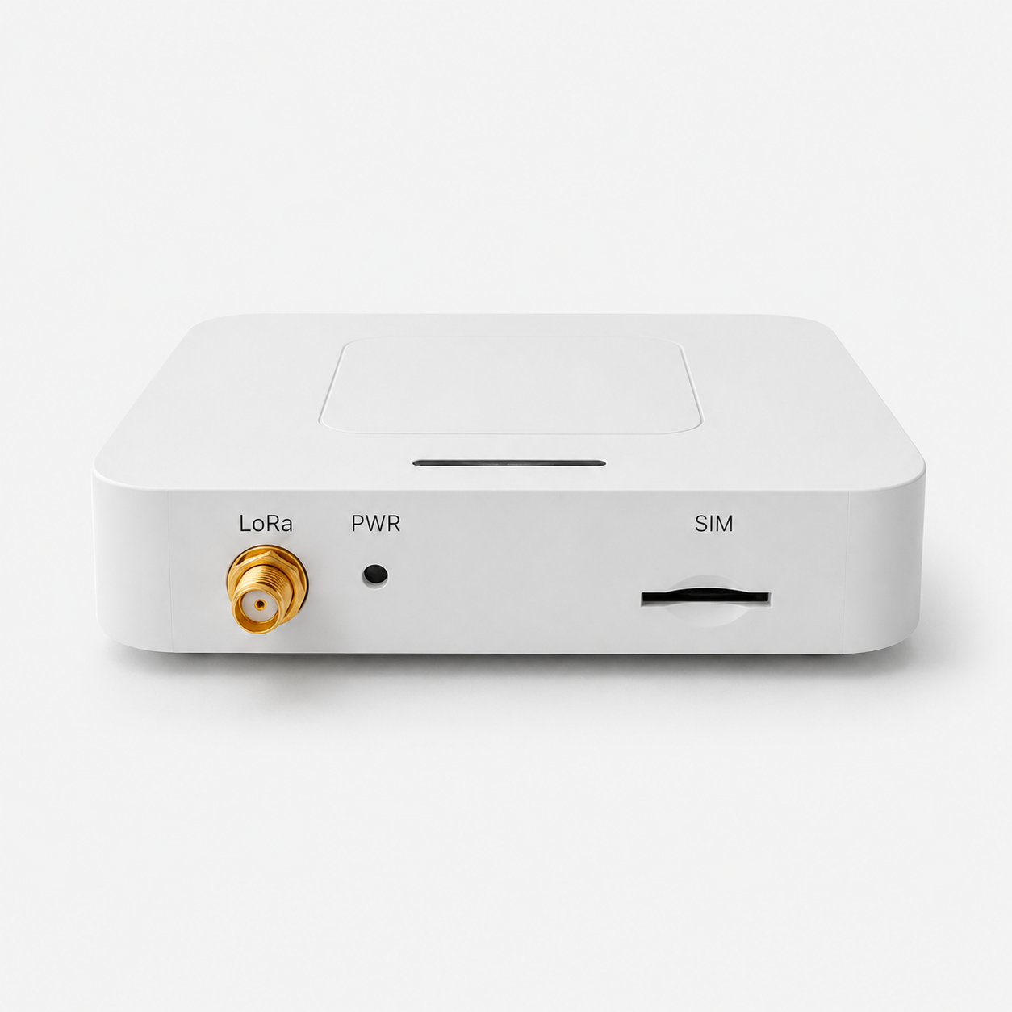
VERSION  1.4 | DOCUMENT  Device Manual

Document version: 1.4
Applicable models: GD61x series (GD614 and GD618 band variants)

Product overview
GD61x is an indoor LoRaWAN gateway based on the ESP32-S3, with a Semtech SX1301 or SX1302 concentrator selected by the ordering code. It combines Ethernet, Wi-Fi and optional 4G backhaul and accepts Type-C or 5–24 V DC power. A 4G option code of G adds the 4G and PoE modules. A Web console provides network, LoRaWAN server, radio, logging and firmware-maintenance configuration.
The only external antenna is the LoRa antenna. The Wi-Fi antenna and, on configurations with 4G, the 4G antenna are installed inside the enclosure, making GD61x suitable for offices, buildings, campuses, equipment rooms and light-industrial indoor sites.
Figure GD61x front view with LoRa, REC and SIM interfaces

Product highlights
- ESP32-S3 controller with 8 MB Flash and 8 MB PSRAM.
- Semtech SX1301 or SX1302 concentrator selected by the model suffix.
- A LoRa architecture: one LoRa antenna, 8 frequency points, 65 channels and half-duplex operation.
- GD614 is the 400 MHz-class RF version; GD618 is the 800 MHz-and-above RF version. The model number does not indicate channel count.
- Ethernet and Wi-Fi STA backhaul; a 4G option code of G adds 4G and PoE. Ethernet is preferred by default, with automatic failover.
- Wi-Fi Soft-AP for local configuration and recovery access.
- Semtech UDP Packet Forwarder, Basic Station and MQTT Bridge.
- DHCP, static IPv4, TLS certificates and a separate remote MQTT configuration channel; configurations with 4G support APN and SIM PIN settings.
- A/B OTA partitions, runtime logs, filesystem management and factory reset.
- External LoRa antenna; internal Wi-Fi antenna and internal 4G antenna when 4G is fitted.
- Type-C and 5–24 V DC input on all variants; PoE when the 4G option code is G.

Technical specifications
Category | Parameter | Specification
MODELS AND COMPUTE
 | Product family | GD61x
 | Model-code format | `GD61{4\ | 8}-A{N\ | G}-{regional-standard}-{version-code}-{1\ | 2}`
 | Band variants | GD614 and GD618
 | 4G / PoE option | In `-A{N\ | G}, N means no 4G or PoE; G` means 4G and PoE are fitted
 | Version code | N: default version; other values: customer-specific or special versions
 | Controller | ESP32-S3 (ESP32-S3-WROOM-1 N8R8)
 | Flash | 8 MB, QIO, 80 MHz
 | PSRAM | 8 MB Octal PSRAM, 80 MHz
 | Configuration storage | SPIFFS; settings persist through power loss

Category | Parameter | Specification
LORAWAN
 | Concentrator | Model suffix 1: Semtech SX1301; model suffix 2: Semtech SX1302
 | LoRa architecture | A: one LoRa antenna, 8 frequency points, 65 channels, half-duplex
 | Model and RF range | GD614: 400 MHz class; GD618: 800 MHz and above; the model number does not indicate channel count
 | Channel bandwidth | Multi-SF channels default to 125 kHz; the LoRa Std channel is configurable
 | Regional plans | GD614: CN470 and EU433; GD618: EU868, AS923, AU915 and US902; the ordered RF hardware and local regulations must match
 | Uplink protocols | Semtech UDP Packet Forwarder, Basic Station and MQTT Bridge
 | Basic Station | Direct LNS or CUPS bootstrap; TLS, token or client certificate
 | Antenna | One external LoRa antenna connector; supplied omnidirectional antenna depends on configuration
 | TX power/sensitivity | Determined by the ordered regional RF front end and antenna; no single value is declared in this guide

Category | Parameter | Specification
NETWORK AND BACKHAUL
 | Ethernet | W5500, 10/100 Mbps, RJ45
 | Ethernet addressing | DHCP or static IPv4 with gateway and primary/secondary DNS
 | Wi-Fi | ESP32-S3 integrated 2.4 GHz Wi-Fi, AP + STA
 | Default Wi-Fi AP | SSID: LGW-Config; password: lgw12345678; management address: 192.168.4.1
 | 4G option | Fitted when the 4G option code is G; omitted when it is N
 | 4G interface | miniPCIe on configurations with 4G; the modem can be replaced for different operator bands
 | Default 4G class | LTE Cat 1 on configurations with 4G; default modem bands match GDI51
 | LTE-FDD bands | Default modem with 4G: B1 / B3 / B5 / B8
 | LTE-TDD bands | Default modem with 4G: B34 / B38 / B39 / B40 / B41
 | SIM | External SIM slot on configurations with 4G
 | Link selection | Automatic Ethernet/Wi-Fi STA failover; configurations with 4G add cellular backhaul; Ethernet is preferred by default

Category | Parameter | Specification
INTERFACES
 | LoRa | External antenna connector
 | SIM | Front SIM slot for configurations with 4G
 | REC (Recovery) | Factory-reset button
 | Type-C | 5 V power and local maintenance
 | RJ45 | Ethernet data on all variants; PoE when the 4G option code is G
 | Terminal block | 5–24V, G, A+, B-
 | RS-485 | A+ and B- are reserved and have no user function in the current release

Category | Parameter | Specification
POWER
 | Type-C | 5 V DC
 | DC terminal | 5–24 V DC
 | PoE | Fitted when the 4G option code is G; use PoE equipment matched to the delivered hardware
 | Multiple power inputs | Do not connect more than one input unless project-specific delivery documents explicitly allow it

Category | Parameter | Specification
SOFTWARE AND MAINTENANCE
 | Management | Chinese/English Web console, REST API and separate remote MQTT configuration channel
 | Network time | SNTP with multiple-source retry
 | Firmware update | Web OTA with A/B application partitions
 | Logs | Live logs, level/component filters, pause, clear and download
 | User security | Password login, token authentication and first-login password-change reminder
 | Factory reset | Restores network and gateway settings and resets the login password; preserves the programmed Gateway EUI

Category | Parameter | Specification
ENCLOSURE AND INSTALLATION
 | Environment | Indoor
 | Mounting | Desktop or wall mounting with the rotating bottom bracket
 | External antenna | LoRa only
 | Internal antennas | Wi-Fi and, when fitted, 4G
 | Dimensions, weight, ingress rating and temperature range | Not declared in this revision; use the order or delivery specification for project selection

Before you begin
This guide covers GD61x model identification, interfaces, installation, power-up and hardware precautions. GD614 and GD618 use the same GD6 configuration system; see the GD6 Configuration Guide for Web login, network backhaul, LoRaWAN server, radio and system-maintenance tasks. The 4/8 distinction identifies the LoRa RF range, not the channel count: GD614 is the 400 MHz-class version, while GD618 is the 800 MHz-and-above version.
Prepare the following:
- A LoRa antenna matching the ordered RF band.
- Type-C 5 V or 5–24 V DC terminal power; a 4G option code of G can also use compatible PoE.
- Ethernet or a Wi-Fi network; an activated SIM is also required when the 4G option code is G and 4G backhaul is used.
- A computer or phone able to reach the gateway's local address.
NOTE Important: Attach the LoRa antenna before applying power. Do not connect multiple power sources at once, do not apply power to the reserved A+/B- pins, and do not remove power during OTA or factory reset.

Identify the model and device

Identify the complete model code

Model example
GD618-AG-AS923-N-2

Model component breakdown
- GD618: product series and RF band.
- GD61 identifies a sixth-generation indoor LoRaWAN gateway.
- 8 identifies the 800 MHz-and-above RF version for EU868, AS923, AU915 and US902.
- Other band option: 4 identifies the 400 MHz RF version for EU433 and CN470.
- -AG: LoRa architecture and 4G / PoE configuration.
- A identifies one LoRa antenna, 8 frequency points, 65 channels and half-duplex operation.
- G identifies a configuration with both 4G and PoE modules.
- Other 4G / PoE option: N identifies a configuration without 4G or PoE modules.
- -AS923: LoRaWAN regional standard.
- AS923 means that the gateway supports the LoRaWAN AS923 regional parameters.
- Other regional codes are CN470, EU433, EU868, AU915 and US902; US902 denotes the LoRaWAN US915 (902–928 MHz) regional parameters.
- The regional code must match the RF version, antenna and local regulations.
- -N: default version.
- N identifies the default version.
- Other values identify customer-specific or special versions.
- -2: LoRa concentrator chipset.
- 2 identifies the Semtech SX1302.
- Other chipset option: 1 identifies the Semtech SX1301.

Complete model meaning
The complete meaning of GD618-AG-AS923-N-2 is:
This is a sixth-generation indoor LoRaWAN gateway using the 800 MHz-and-above RF version for AS923, with one LoRa antenna, 8 frequency points, 65 channels and half-duplex operation. It includes the 4G and PoE modules, uses the LoRaWAN AS923 regional parameters, identifies the default version with N, and uses a Semtech SX1302 concentrator.
The front panel contains the LoRa connector, REC (Recovery) factory-reset button and SIM slot. Only LoRa uses an external antenna. The Wi-Fi antenna and the 4G antenna on G configurations are internal.
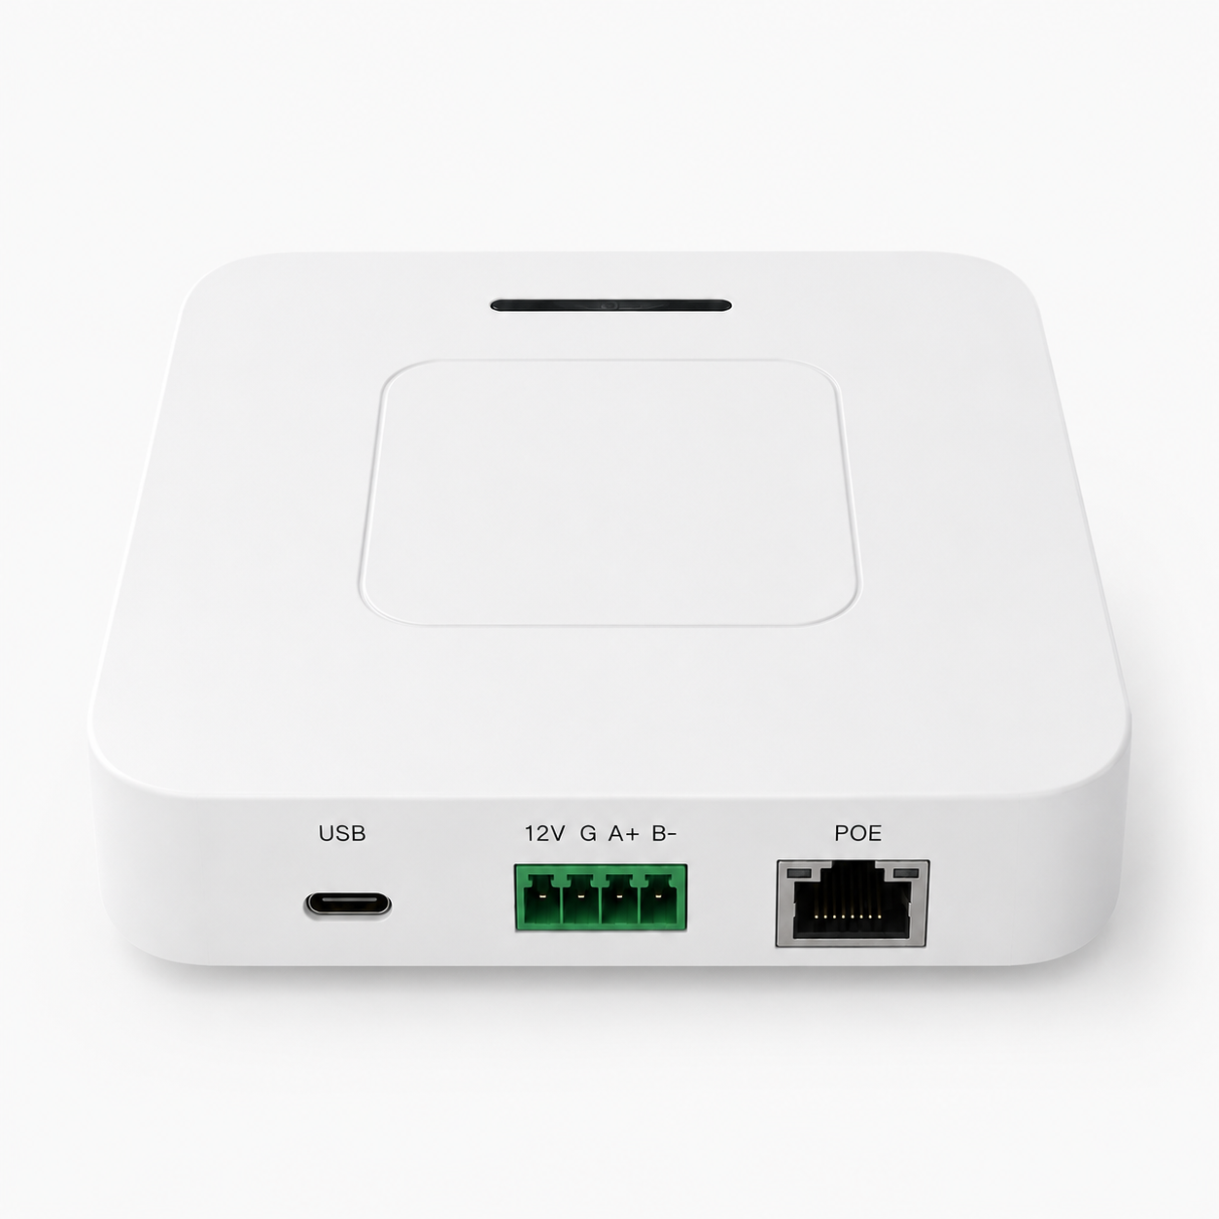
Figure GD61x rear interfaces
Interface | Purpose
USB | Type-C 5 V input and local servicing
5–24V / G | Positive wide-range DC input / ground
A+ / B- | Reserved RS-485 pins; no operational device should be connected in this release
POE | 10/100 Mbps Ethernet on all configurations; PoE input only on G configurations

The rotating bottom bracket supports wall mounting. Keep the bottom ventilation openings clear.

Installation and power-up

Attach the LoRa antenna
- Verify that the antenna band matches the gateway RF version.
- Hand-tighten the antenna on the LoRa connector without side-loading it.
- Never start LoRa transmission with the antenna disconnected.

Install a SIM
This section applies only to G configurations. For 4G backhaul, power the gateway off and insert an activated SIM in the SIM slot. A SIM without a PIN can dial directly. If PIN protection is enabled, enter its 4–8 digit PIN in the Web console.

Select one power method
Use exactly one of these methods:
- Type-C: connect a stable 5 V supply.
- DC terminal: connect the positive lead of a 5–24 V DC supply to 5–24V and negative to G.
- PoE (G configurations only): connect a compatible powered Ethernet cable to POE.
After power-up, the LED slow-blinks continuously (1 s on / 1 s off by default). System initialization, IP acquisition and LoRa service startup take some time.

Configure the GD6 system
GD61x uses the shared GD6 configuration system. The following tasks are maintained in the GD6 Configuration Guide:
- Web-console access and sign-in.
- Ethernet, Wi-Fi and optional 4G backhaul.
- Semtech UDP, MQTT Bridge and Basic Station.
- LoRaWAN region, sub-band and channel settings.
- Logs, firmware, filesystem, users and remote configuration.
- Post-reset configuration state and common troubleshooting.
The ordering code and technical specifications in this guide remain authoritative for the hardware capabilities of a particular GD61x unit.

REC (Recovery) button and factory reset
REC has one function only: factory reset. It does not enable the Wi-Fi AP or perform any other operation. Hold REC; the gateway follows this sequence: solid at the 2 s threshold → reset runs → three fast flashes → reboot.
Factory reset restores network, LoRaWAN, MQTT, remote settings and, on G configurations, 4G settings. It changes the login password back to wifi!0804, preserves the programmed Gateway EUI and does not overwrite the Web static files.

Indicator patterns
ID | Pattern | Meaning
FR6 | LED slow-blinks continuously (1 s on / 1 s off by default) | Normal operation
FR7 | Factory reset: solid at the 2 s threshold → reset runs → three fast flashes → reboot | Factory reset

Troubleshooting
Symptom | Checks and recovery
4G on a G configuration will not register | Check SIM, PIN, APN, signal and modem bands; verify internal antenna and miniPCIe modem installation
No LoRa uplink | Check antenna, regional band, Gateway EUI, LNS address/ports and active backhaul
Gateway does not return after OTA | Allow the automatic reboot to finish; if still unavailable, recover through the Wi-Fi AP or a controlled serial service procedure instead of repeated power cuts
Web, login, Ethernet or Wi-Fi configuration problem | Follow Configuration troubleshooting in the GD6 Configuration Guide

Related documents
- GD6 Configuration Guide
- LoRaWAN Gateway documentation index

