MANTHINK / INDUSTRIAL IoT
GD72
LoRaWAN Gateway
Standardized Device Manual
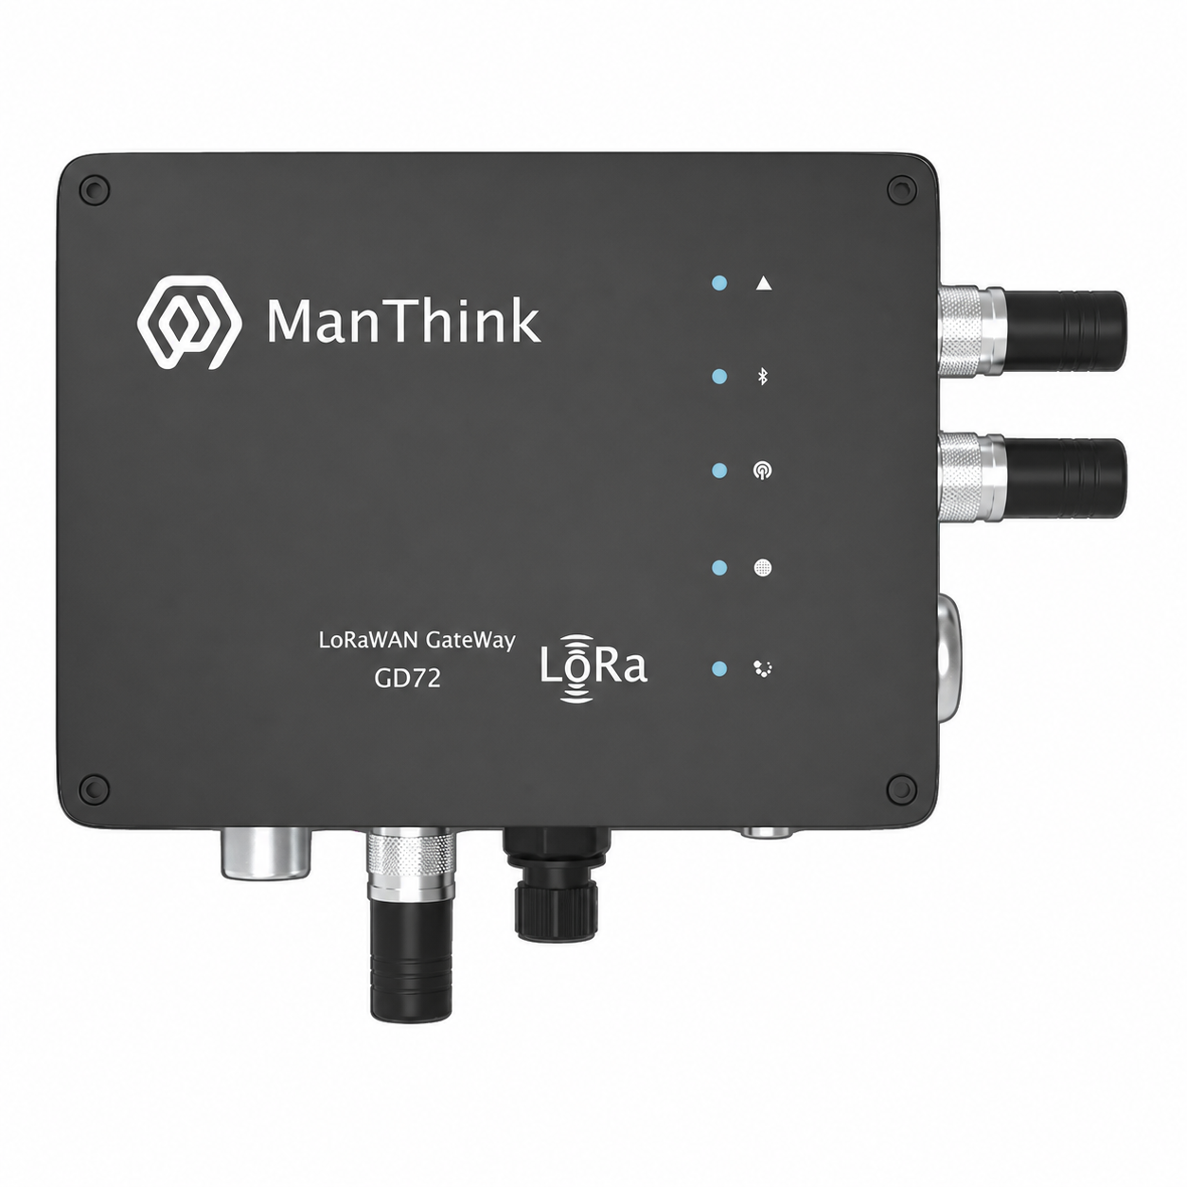
VERSION  Current | DOCUMENT  Device Manual

Revision History
Version | Change Description
Current | Current published version

DOCUMENT NAVIGATION
Contents
1. Product Description 5
2. Main Features 5
3. Technical Specifications 6
3.1 Environment and Enclosure 9
4. Accessories 9
5. Gateway Body 10
6. Product Dimensions 10
7. Interface Description 10
8. Indicator Description 10
9. Product Model 11
9.1 Standard Model 11
9.2 Model Components 11
10. Gateway Installation 12
11. Installation Direction 12
12. Backplate Installation 12

DOCUMENT NAVIGATION
Contents continued
13. Network Cable Installation 13
14. SIM Card Installation 14
15. Power Connection 15
16. Antenna Installation 16
17. Gateway Mounting 17
17.1 Wall Mounting 17
17.2 Pole Mounting 18
18. Waterproofing Connections 19
19. Gateway Ingress-Protection Check 19
20. PoE Adapter Waterproof Installation 20
21. Gateway Configuration 20
22. Using ThinkLink 20
23. Connecting to ChirpStack 20
24. Connecting to TTN 20
25. Security Configuration Recommendations 20
26. Contact Us 21

1. Product Description
GD72 is an outdoor, multi-channel, high-performance gateway designed by ManThink for LoRaWAN systems. It uses a high-performance processor, a Semtech SX1302 LoRa concentrator and an industrial-grade Wi-Fi module. It supports Ethernet, cellular, Wi-Fi access-point/client and Bluetooth Low Energy (BLE) connections. GD72 is suitable for low-power wide-area network deployments in cities, factories, campuses and other outdoor or harsh environments, and can also support edge computing, protocol conversion, data buffering and local application extensions.

2. Main Features
- High-performance chipset, at least 512 MB DDR and at least 16 GB eMMC
- SX1302 LoRa concentrator with at least 8 LoRaWAN uplink channels, up to 16 frequency points and up to 32 demodulators
- -141 dBm LoRa receiver sensitivity at SF12/BW 125 kHz; maximum transmit power is 27 dBm for suffix -1 and 22 dBm for suffix -2, with a maximum-power tolerance of ±2 dBm
- Standard LoRaWAN and the AS923 regional parameters, plus regional configurations for CN470, EU433, EU868, AU915 and US915
- Industrial-grade Wi-Fi module supporting access-point and client modes
- 2.4 GHz or 5 GHz Wi-Fi, IEEE 802.11a/b/g/n, at least 100 Mbps download and at least 50 Mbps upload
- Bluetooth Low Energy (BLE)
- WPA2, AES and TLS
- Ethernet, 4G/LTE and Wi-Fi backhaul options, plus dual-gateway redundancy architecture
- GPS/BeiDou positioning and NTP clock synchronization
- MQTT, MQTTS, HTTP, HTTPS, SNMP, DHCP, static IP, NAT and ICMP
- Secure remote management, configuration and upgrades; supports Python and Node-RED for secondary development
- Automatic fault detection and recovery; reporting of CPU, memory, storage, network and LoRa communication-quality indicators
- Built-in indicators for LoRa, network, power/operation and faults
- Built-in TKL, including LoRaWAN network server and IoT platform, historical data, Thing Model and Dashboard
- IP67 enclosure for pole or wall mounting
- Visual configuration and maintenance through gwTool7

3. Technical Specifications
Category | Parameter | GD72 Specification
COMPUTE AND STORAGE
 | SoC | High-performance multi-core processor
 | Memory | DDR, ≥ 512 MB
 | Storage | eMMC, ≥ 16 GB

Category | Parameter | GD72 Specification
SOFTWARE AND PLATFORM
 | Built-in platform | Built-in TKL LoRaWAN network server and IoT platform
 | External platforms/protocols | ThinkLink, ChirpStack, TTN, Basic Station and GWMP
 | Data services | PostgreSQL, Redis, historical data storage, Thing Model, application data parsing and Dashboard
 | Secondary development | Supports Python and Node-RED
 | Remote operations | Remote management, configuration and upgrades over SSH
 | Fault handling | Automatic fault detection and recovery
 | Monitoring | Reporting of CPU, memory and storage usage, network status and LoRa communication quality

Category | Parameter | GD72 Specification
LORAWAN
 | Concentrator | Semtech SX1302
 | Protocol | Standard LoRaWAN; compliant with LoRa Alliance™ LoRaWAN Specification v1.0.4 or a later version
 | Operating bands | AS923: 920–928 MHz; regional configurations also include CN470, EU433, EU868, US915 (902–928 MHz) and AU915
 | Channels/frequency points | At least 8 uplink channels; up to 16 frequency points at BW = 125 kHz
 | Demodulators | Up to 32, processing up to 32 packets simultaneously
 | Demodulator composition | 16 × SF5–SF12 LoRa®demodulators; 16 × SF5–SF10 LoRa®demodulators
 | Channel capacity | Up to 130 logical channels; each SF, bandwidth and frequency-point combination defines a channel
 | Communication rate | 292 bps to 15.625 kbps
 | Spreading factors | SF5 to SF12
 | Single-channel bandwidth | 125 kHz or higher
 | Operating mode | Half-duplex; dual-LoRa architecture can be provided by configuration
 | Transmit power | Suffix -1: 27 dBm maximum; suffix -2: 22 dBm maximum; maximum-power tolerance: ±2 dBm
 | Receiver sensitivity | -141 dBm at SF12/BW 125 kHz
 | Antenna | Omnidirectional LoRa antenna

Category | Parameter | GD72 Specification
WI-FI AND BLUETOOTH
 | Wi-Fi module | Industrial-grade Wi-Fi module
 | Operating modes | Access-point mode and client mode
 | Bands/standards | 2.4 GHz or 5 GHz; IEEE 802.11a/b/g/n
 | Download/upload | Download ≥ 100 Mbps; upload ≥ 50 Mbps
 | Security | WPA2, AES and TLS
 | Bluetooth | Bluetooth Low Energy (BLE)

Category | Parameter | GD72 Specification
NETWORK AND TRANSPORT
 | Ethernet | 1000M/100M; DHCP and static IP configuration
 | Cellular uplink | CAT1 4G/LTE module by default; LTE-FDD B1/3/5/8 and LTE-TDD B34/38/39/40/41
 | Data forwarding | MQTT, MQTTS, HTTP and HTTPS
 | Network services | NTP, prevailing-version SNMP, NAT and ICMP diagnostics
 | Network redundancy | Dual-gateway architecture for network redundancy

Category | Parameter | GD72 Specification
SECURITY AND AUTHENTICATION
 | Device identity | IMEI or device-feature-string authentication
 | Access protection | Firewall and access control list (ACL)
 | Transport security | Prevailing-version TLS; administrators can disable unsafe SSH/TLS cipher suites

Category | Parameter | GD72 Specification
PORTS AND TIMING
 | Configuration ports | USB Type-C, Ethernet and Wi-Fi
 | SIM slot | One external nano-SIM slot supporting LTE/5G SIM cards; cellular standards are determined by the configured module
 | Positioning/timing | GPS and BeiDou (BDS) positioning; NTP synchronization

Category | Parameter | GD72 Specification
POWER
 | Power supply | One PoE or PoE+ Ethernet port; nominal 48 V PoE
 | Power consumption | < 5 W in a typical configuration

3.1 Environment and Enclosure
Category | Parameter | GD72 Specification
 | Operating temperature | -40°C to 70°C
 | Operating humidity | 0% to 95% RH, non-condensing
 | Ingress protection | IP67
 | Radio-equipment requirement | Compliant with HKCA 1078 requirements
 | Weight | 1.2 kg
 | Dimensions | 164 × 124 × 50 mm
 | Installation | Pole or wall mounting

Cellular deployment note: if local operator bands are outside the default module range, contact ManThink for a suitable cellular module.

4. Accessories
The product package includes the GD72 gateway, PoE components, mounting hardware, waterproof components, LoRa antenna, LTE antenna, GPS antenna, Wi-Fi antenna, network cable and fasteners. Cellular-enabled versions include an LTE/5G SIM card.

5. Gateway Body

6. Product Dimensions
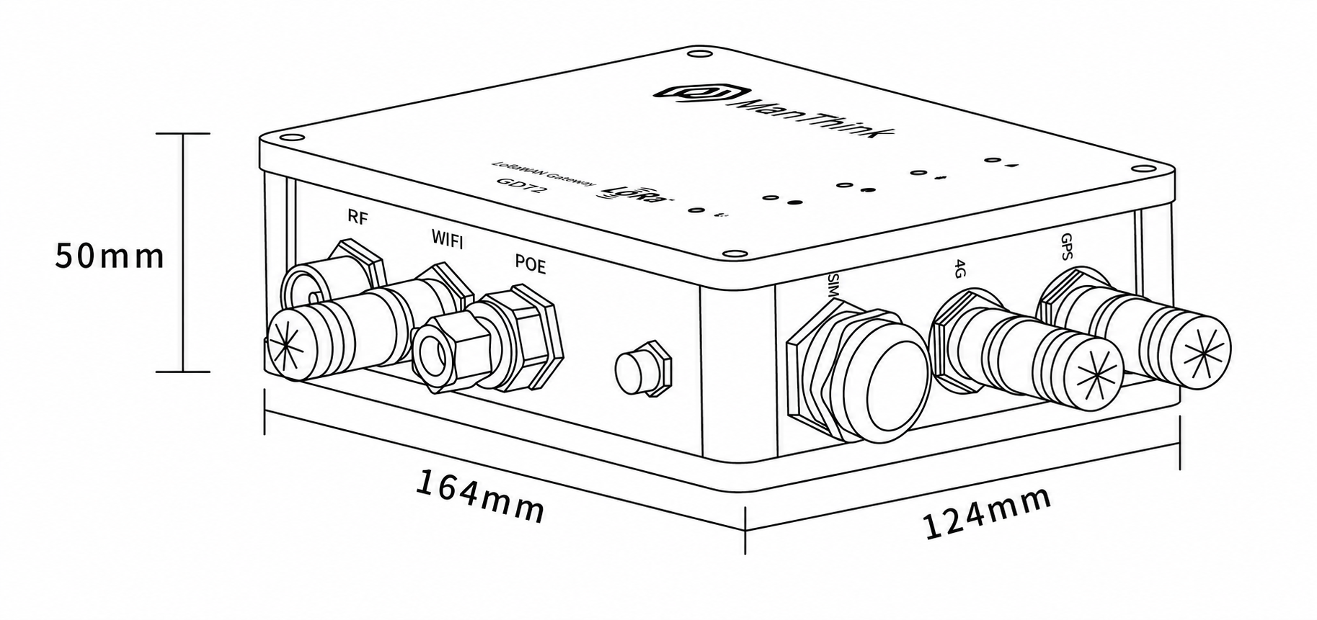
Figure GD72 product dimensions

7. Interface Description
Interface | Description
RF | LoRa antenna interface
WIFI | Wi-Fi antenna interface
POE | PoE/PoE+ power and Ethernet interface
SIM | External nano-SIM slot
4G | LTE antenna interface
GPS | GPS/BeiDou antenna interface
TYPE-C | Local configuration and debugging interface

8. Indicator Description
Indicator | Color/network | States and meanings
Run indicator  | — | Steady: System starting.  Off: Base startup complete; applications are starting.  1 Hz flashing: Normal operation.
Network indicator  | Blue/wired  Green/cellular | Blue, 1 Hz: Wired network normal.  Blue, every 500 ms: Wired network abnormal.  Blue, rapid: Network configuration in progress.  Green, off: No cellular module.  Green, steady: Module installed but no SIM.  Green, irregular: Cellular data activity.
LoRa transceiver indicator  | Green  Blue | Green flashing: Transmitting LoRa packets.  Blue flashing: Receiving LoRa packets.
LAN status indicator  | Red  Blue | Red: System-control state.  Blue: Wi-Fi connection state.
Fault indicator  | — | Rapid flashing: Startup phase 2.  Off: No fault.  Flashing: Fault detected.

9. Product Model

9.1 Standard Model
The GD72 standard model is GD728-AG-AS923-N-2.

9.2 Model Components
- GD728: series and RF band. GD72 identifies the outdoor LoRaWAN gateway series; 8 identifies the 800 MHz-and-above RF version.
- -AG: LoRa architecture and cellular configuration. A identifies one LoRa antenna, 8 frequency points, 65 channels and half-duplex operation; G identifies an integrated cellular module.
- -AS923: LoRaWAN regional standard. Identifies support for the AS923 regional parameters.
- -N: version code. N identifies the default version; other values are used for customized versions.
- -1: transmit-power version. Maximum transmit power is 27 dBm, with a maximum-power tolerance of ±2 dBm.
- -2: transmit-power version. Maximum transmit power is 22 dBm, with a maximum-power tolerance of ±2 dBm.

10. Gateway Installation
Do not open the gateway enclosure during installation. Disconnect power first and verify that antennas, PoE, waterproof connectors and grounding measures meet site requirements.

11. Installation Direction
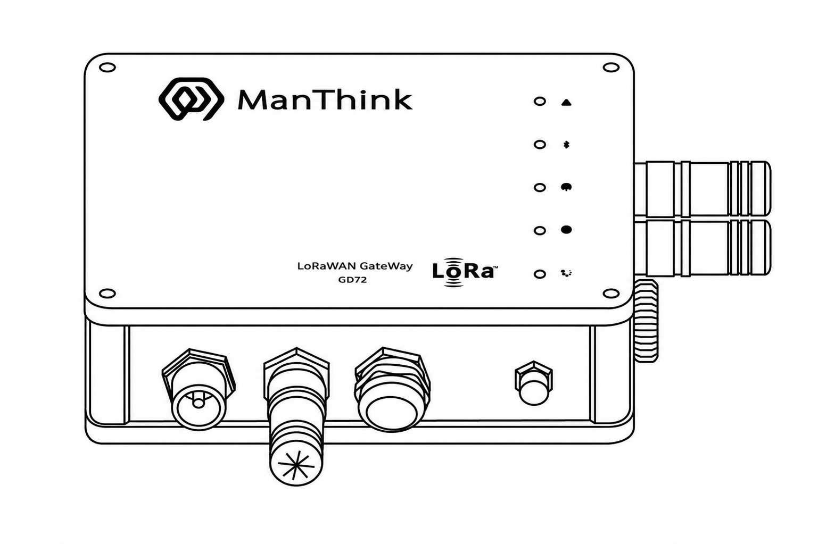
Figure Correct GD72 installation direction
The product front is shown above. The GPS and 4G/LTE antenna interfaces face right, and the Wi-Fi antenna interface faces down. Maintain this orientation to support drainage and ingress protection.

12. Backplate Installation
- Turn the gateway to the illustrated orientation and verify that the backplate is securely attached.
- Align the screws and tighten them evenly clockwise. Do not overtighten or damage the threads.
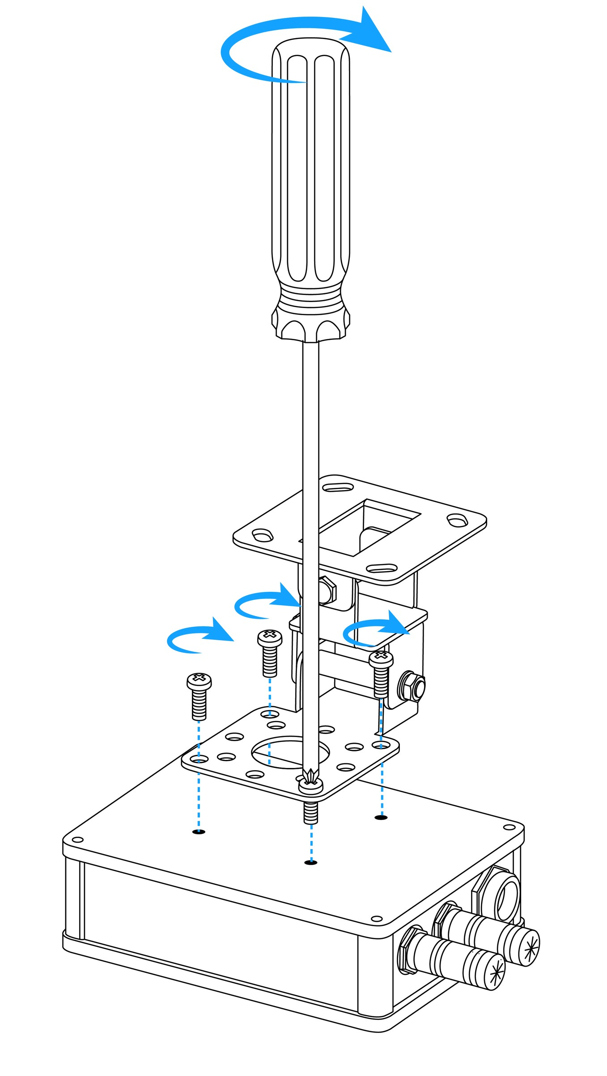
Figure GD72 backplate installation

13. Network Cable Installation
- Pass the waterproof-connector components over the cable in the illustrated order and assemble them tightly.
- Insert the RJ45 plug into the gateway POE port.
- Move the waterproof connector to the POE port and tighten it to form a reliable seal.
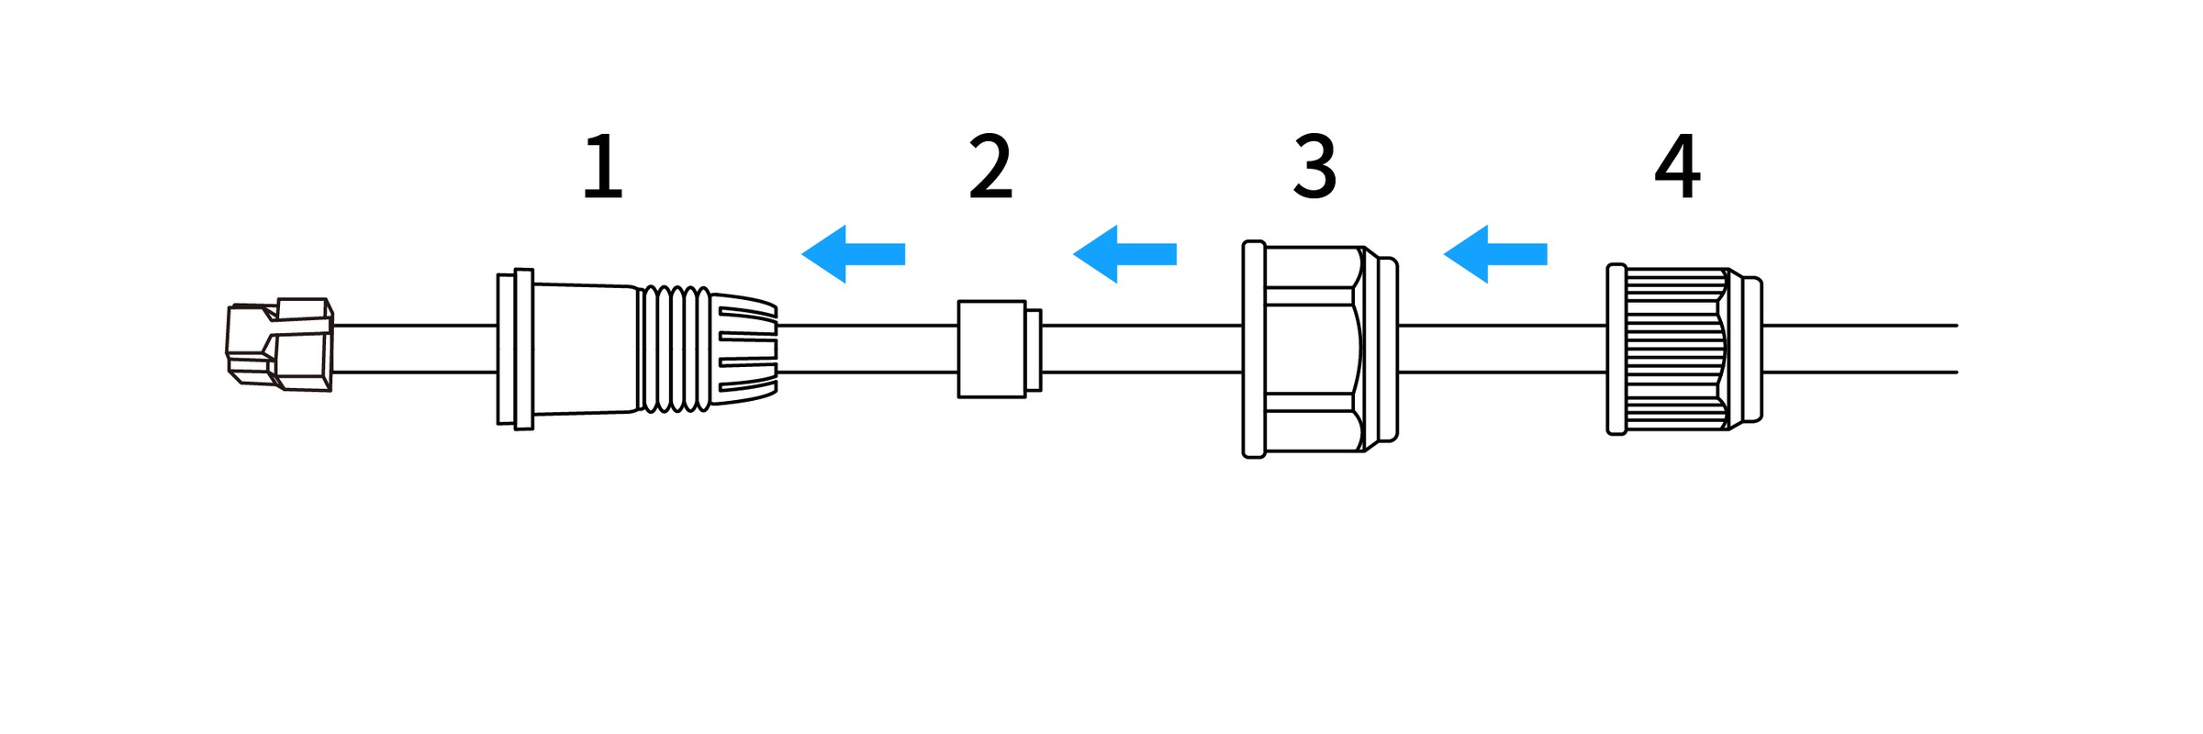
Figure GD72 network cable installation step one
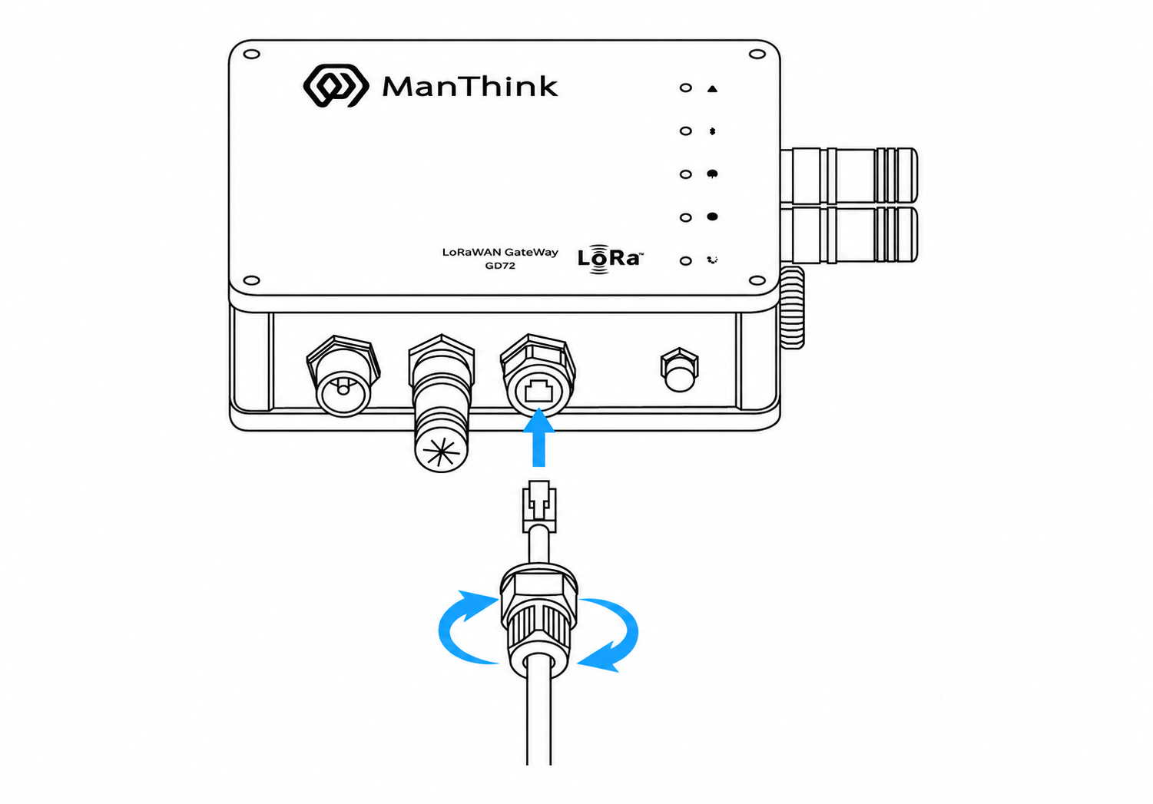
Figure GD72 network cable installation step two

14. SIM Card Installation
- Unscrew the waterproof cover on the SIM interface.
- Keep the SIM card contacts facing the TYPE-C interface.
- Insert the SIM card and tighten the waterproof cover.
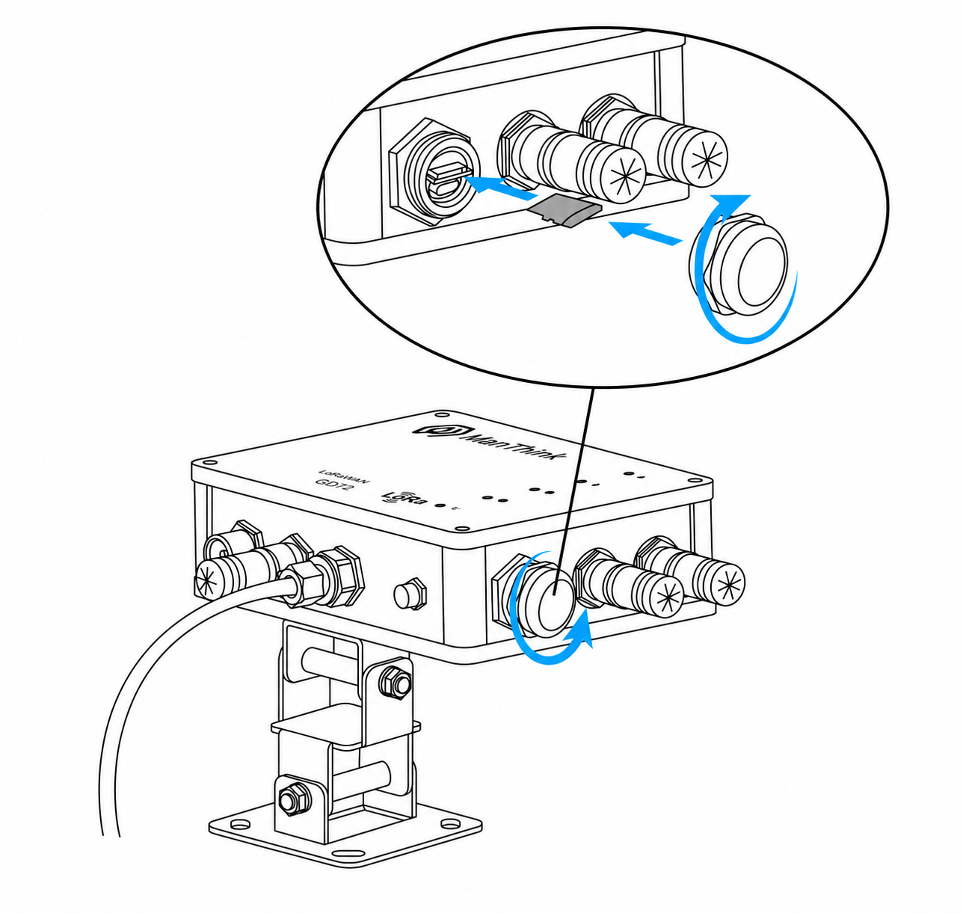
Figure GD72 SIM card installation

15. Power Connection
- Connect the PoE adapter OUT port to the gateway POE interface for power.
- Connect the PoE adapter IN port to a switch or router. With cellular backhaul, the site network design determines whether the IN port is required.
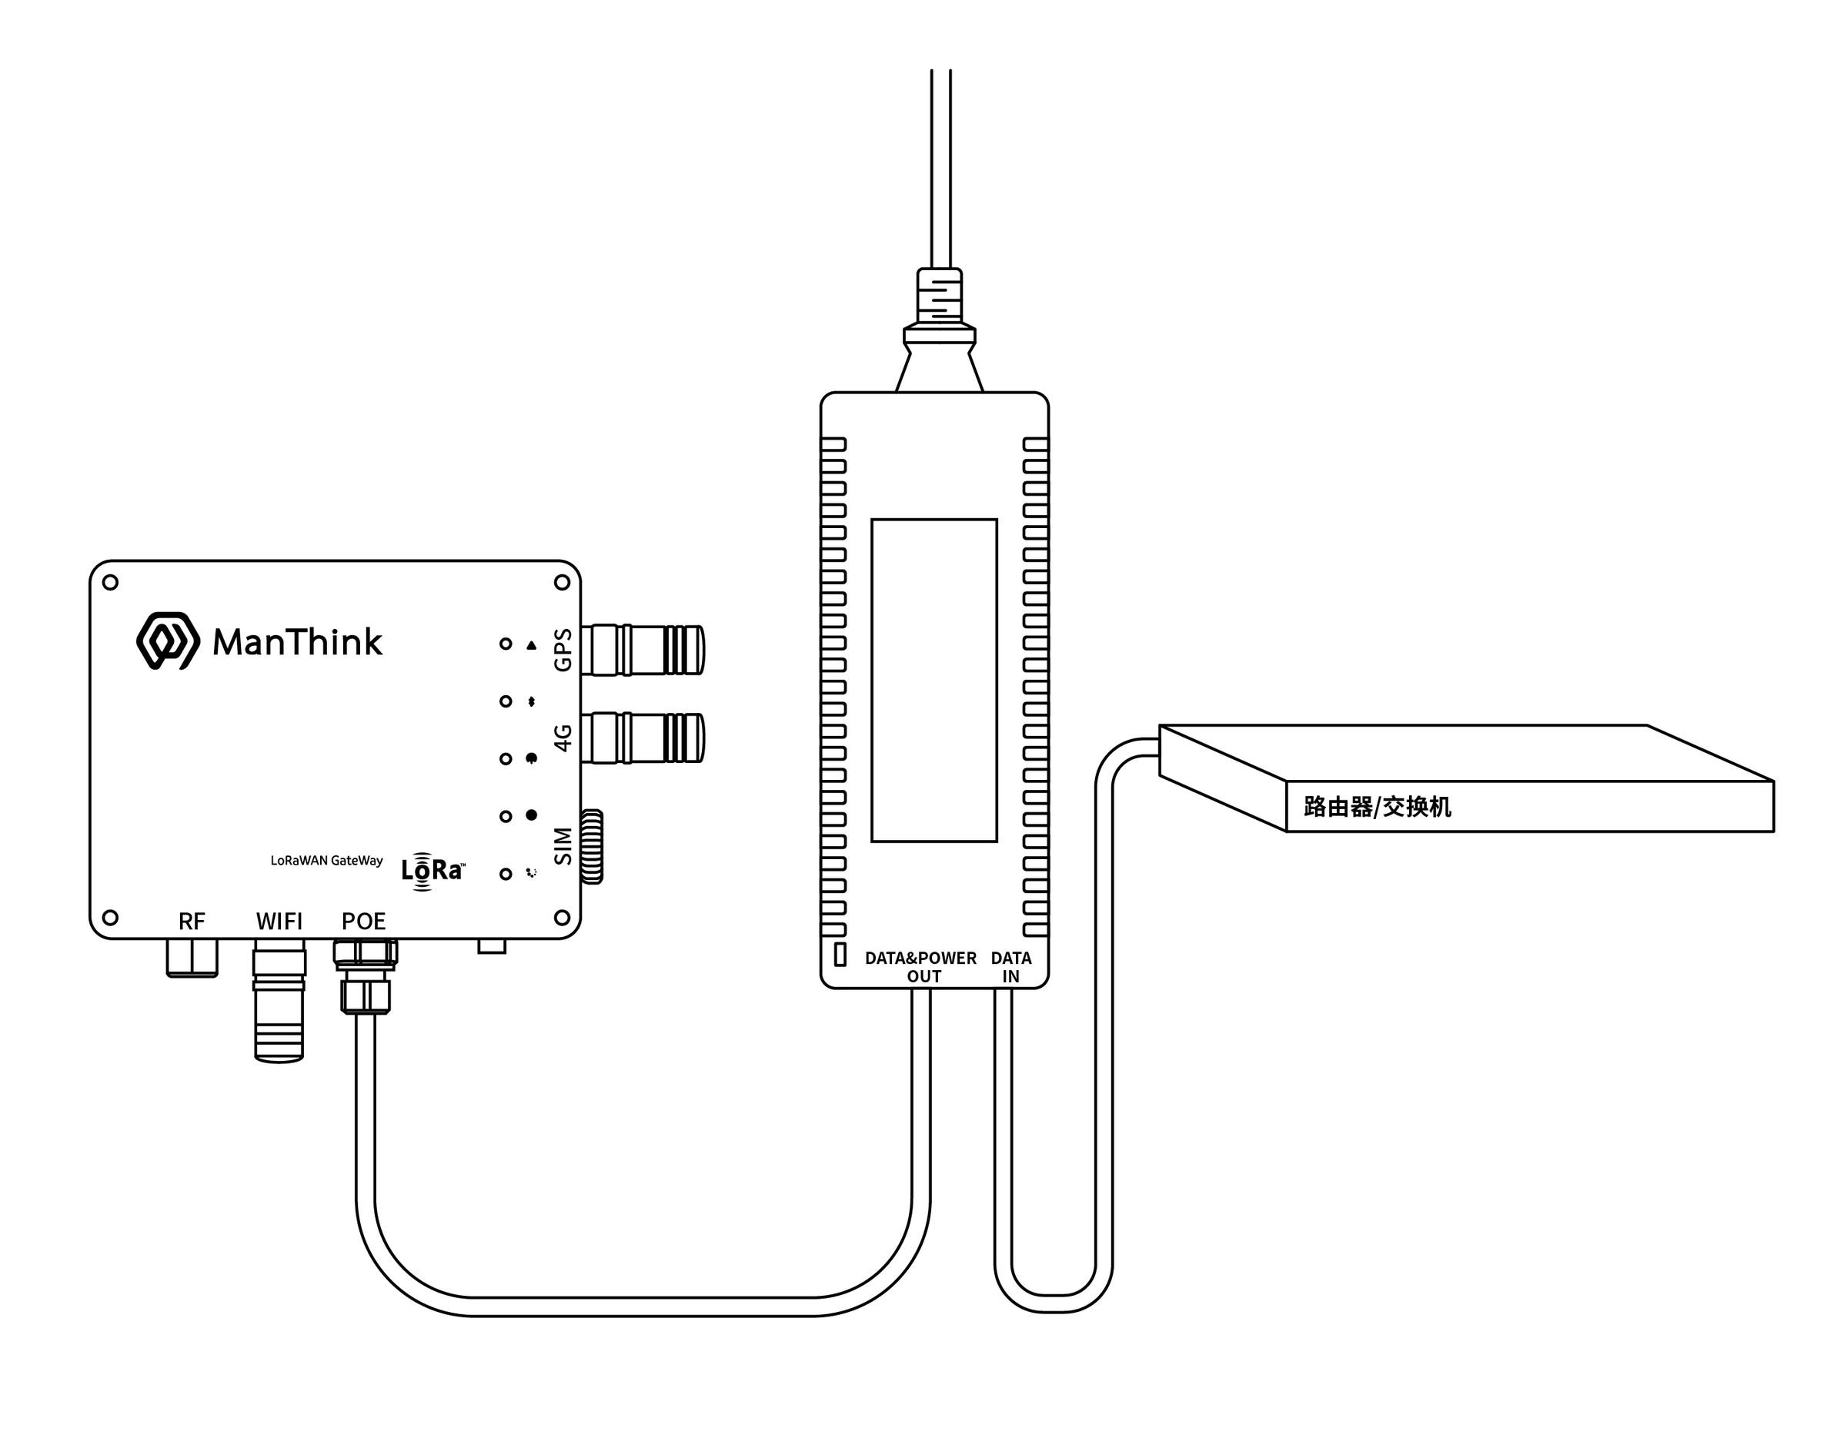
Figure GD72 PoE connection

16. Antenna Installation
- Connect the LoRa antenna to the RF interface.
- Connect the LTE, GPS/BDS and Wi-Fi antennas to their matching labeled interfaces.
- Weatherproof all outdoor antenna connections according to site practice.
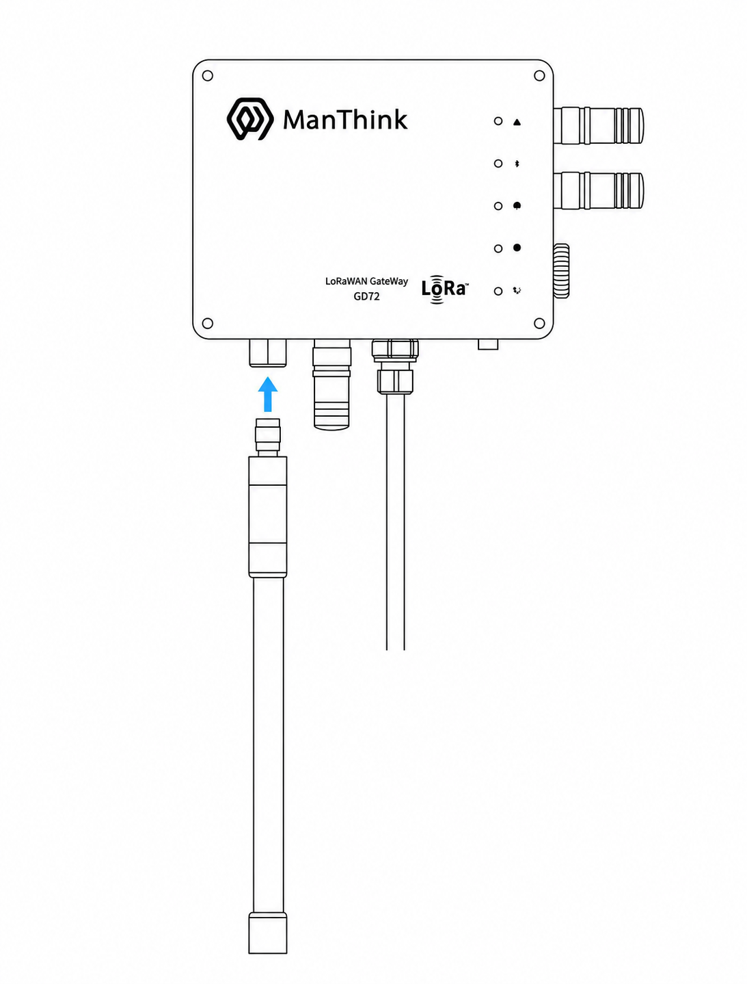
Figure GD72 LoRa antenna installation

17. Gateway Mounting

17.1 Wall Mounting
- Keep the gateway front facing up.
- Mark and drill the wall using the backplate holes, then install anchors suitable for the wall material.
- Pass the fasteners through the backplate and tighten them evenly.
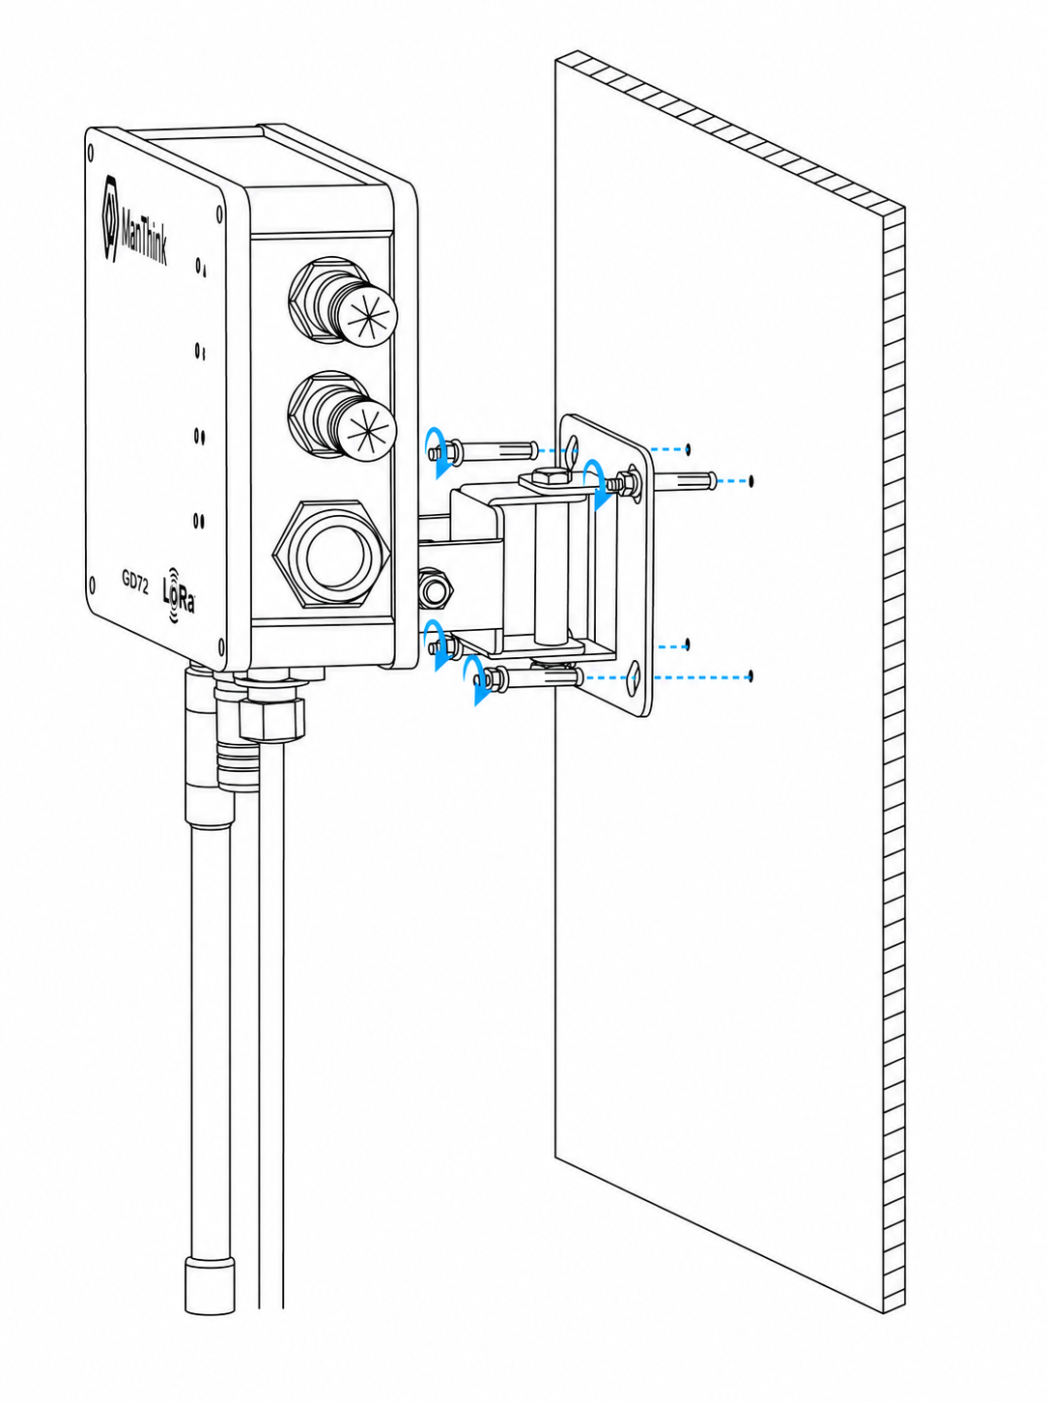
Figure GD72 wall mounting

17.2 Pole Mounting
- Keep the gateway front facing up.
- Confirm that the pole diameter is 30–52 mm.
- Assemble the pole clamps as illustrated and tighten the screws evenly.
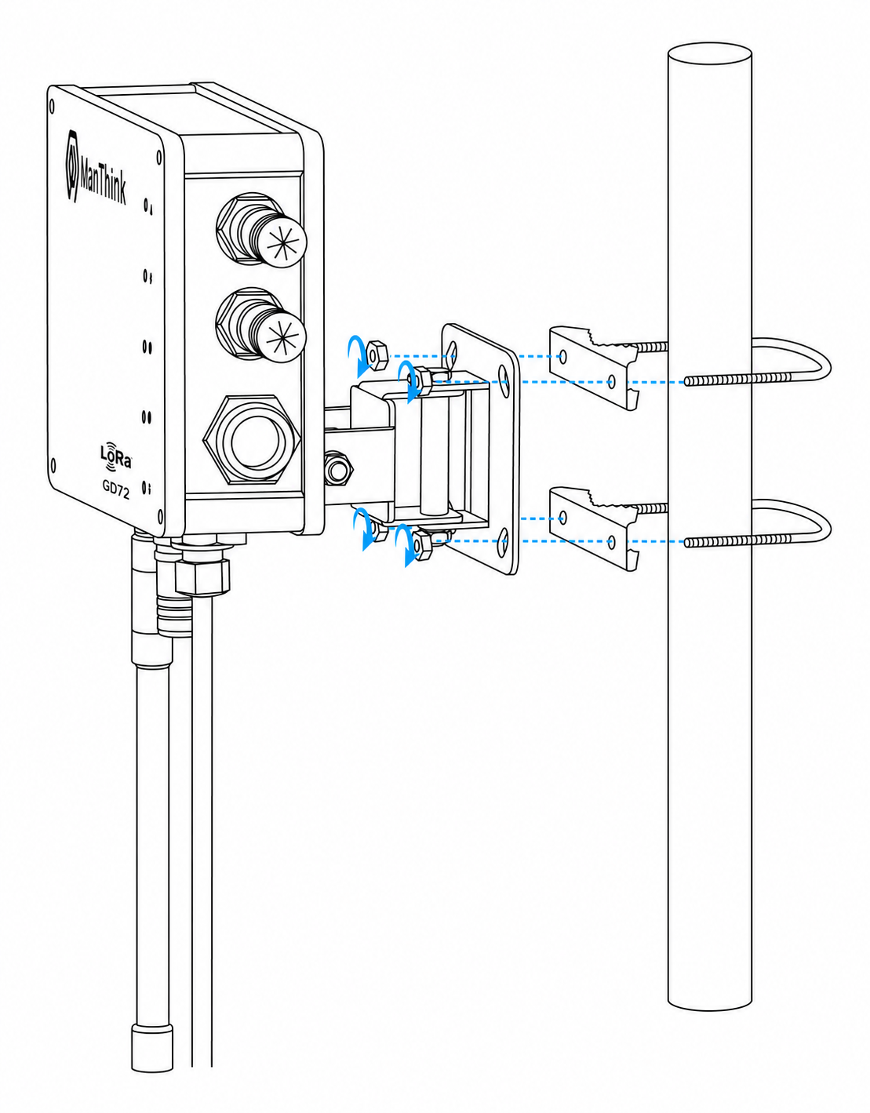
Figure GD72 pole mounting

18. Waterproofing Connections
- Wrap all connections with outdoor-rated insulating, self-amalgamating or waterproof material.
- Pay particular attention to cable entries, antenna interfaces, the SIM cover and the power/network interface.
- Completely cover each connection to form a continuous seal.
- Inspect seals periodically and replace any material that is aged, cracked or loose.

19. Gateway Ingress-Protection Check
- Verify that all cable entries and connectors are sealed according to the installation steps.
- Verify that unused ports have their supplied waterproof caps tightened.
- Provide drip loops so rainwater cannot follow cables into connectors.
- Complete the inspection before applying power.

20. PoE Adapter Waterproof Installation
- Install the PoE adapter in a weatherproof enclosure or another dry location; do not expose it directly to rain.
- Mount it vertically with the interfaces facing down to reduce water-entry risk.
- Seal cable entries and connections, and inspect the protection periodically.
Waterproofing must be designed for the site environment, local electrical rules and installation conditions. Use qualified personnel where required.

21. Gateway Configuration
GD72 is configured and maintained with gwTool7. See the gwTool7 Gateway Administrator Manual.

22. Using ThinkLink
See the ThinkLink User Guide.

23. Connecting to ChirpStack
See Connect to ChirpStack with Basic Station (gwTool7).

24. Connecting to TTN
See Connect to TTN with Basic Station (gwTool7).

25. Security Configuration Recommendations
- Change default administrative credentials during initial deployment and restrict management access to trusted networks.
- Enable the firewall or ACL and disable unnecessary services and ports.
- Use a prevailing TLS version and disable unsafe SSH/TLS cipher suites.
- Retain audit records for remote upgrades, configuration changes and administrator operations.
- Regularly review CPU, memory, storage, network and LoRa communication-quality alarms.

26. Contact Us
Website: www.manthink.cn
Email: info@manthink.cn
Tel: +86-15810684257

