MANTHINK / INDUSTRIAL IoT
GDI51
LoRaWAN Gateway
Standardized Device Manual
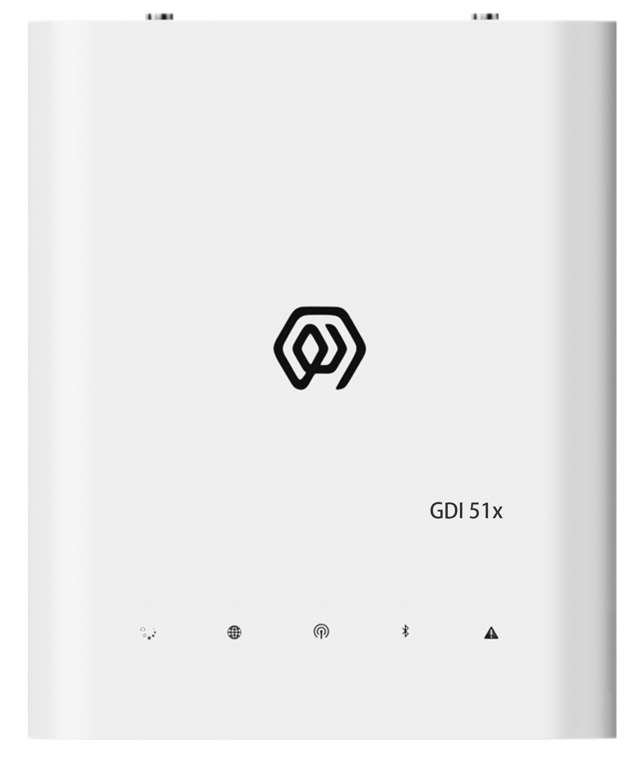
VERSION  2.01 | DOCUMENT  Device Manual

Product Introduction
GDI51 is an indoor gateway designed by ManThink based on SX1302 for LoRaWAN system. It can efficiently process large amounts of data to ensure the stability and reliability of communication. It is suitable for indoor environments such as parks, buildings, and buildings. With its powerful processing capabilities and flexible configuration functions, it provides users with an ideal Internet of Things solution.

Product Features
- Supports built-in TKL (including LoRaWAN NS and IoT platform)
- Supports historical data storage
- Supports Thing Model
- Supports Dashboard
- Supports PoE and Type-C power supply
- Supports 4G, Wi-Fi, and Ethernet connectivity
- Supports ThinkLink, ChirpStack, TTN, and LoRaWAN NS compatible with Basic Station/GWMP protocol
- 8 frequency points (BW = 125 kHz)
- 16 demodulators capable of processing 16 packets concurrently (8 × SF5-SF12 LoRa®demodulators, 8 × SF5-SF10 LoRa®demodulators)
- 65 channels (different configurations of SF, BW, and frequency points count as separate channels; BW = 125 kHz, totaling 65 channels)
- Transmit power: 22 dBm (Max)
- Receive sensitivity: -141 dBm (SF=12, BW=125 kHz)
- Supports LoRaWAN standards: US902, AU915, AS923, EU868, EU433, CN470
- Supports remote maintenance and firmware upgrades
- Visual and user-friendly web-based configuration

Specifications
Category | Parameter | Specification
COMPUTE AND STORAGE
 | SOC | LS1012A 64-bit ARM Cortex-A53 800MHz 2W
 | Memory type/rate | Support DDR3L 1066 MHz
 | Memory capacity | Memory:512MB
 | Storage | 8GB EMMC

Category | Parameter | Specification
SOFTWARE
 | Platform | Built-in NS and IoT platform (with integrated TKL)
 | Protocol/platform support | ThinkLink, ChirpStack, TTN, Basic Station, and GWMP protocols
 | Databases | PostgreSQL and Redis
 | Historical data | historical data storage
 | Leaf mode | Leaf mode
 | Thing Model | Thing Model
 | Application data parsing | application data parsing
 | Visualization | Dashboard

Category | Parameter | Specification
LORA
 | Operating frequency bands | CN470: 470–510 MHz  EU868: 863–870 MHz  EU433: 433–434 MHz  AS923: 920–928 MHz  US902: 902–928 MHz  AU915: 915–928 MHz
 | Communication rate | 292bps to 15.625kbps
 | Spreading factors | supports SF5 to SF12
 | Transmit power | 22dBm (Max)
 | Receiver sensitivity | -141 dBm (SF = 12, BW = 125 kHz)
 | Antenna type | Omnidirectional
 | Frequency points | 8 (BW = 125 kHz)
 | Demodulators | 16
 | Concurrent packets | 16 packets simultaneously
 | Demodulator composition | 8 × SF5-SF12 LoRa®demodulators; 8 × SF5-SF10 LoRa®demodulators
 | Channels | 65
 | Channel definition/note | each channel is defined by a unique combination of SF, BW, and frequency point; BW = 125 kHz, totaling 65 channels
 | Operating mode | Half-duplex
 | Single-channel bandwidth | 125KHz or higher

Category | Parameter | Specification
NETWORK AND BACKHAUL
 | Ethernet | 1000M/100M
 | 4G uplink | The Gateway uses 4G uplink by default, CAT1 module
 | LTE-FDD bands | B1/3/5/8
 | LTE-TDD bands | B34/38/39/40/41
 | 4G deployment note | If the frequency band used by the planned regional operator is not in the above frequency band, please contact the technical personnel of ManThink to replace the applicable 4G module.

Category | Parameter | Specification
PORTS AND TIMING
 | USB Type-C configuration | USB-TypeC
 | Ethernet configuration | Ethernet
 | Wi-Fi configuration | WiFi

Category | Parameter | Specification
POWER
 | PoE power | POE(48V)
 | USB power | USB TYPE-C(5V)
 | Power consumption | 5W

Category | Parameter | Specification
ENVIRONMENT AND ENCLOSURE
 | Working temperature | -20 ℃ ~ 65 ℃
 | Working humidity | 0% ~ 95% RH
 | Waterproof and dustproof | IP53
 | Weight | 0.3kg
 | Dimensions | 151mm x 125mm x 30mm
 | Installation method | wall mounting or free placement

Accessories List
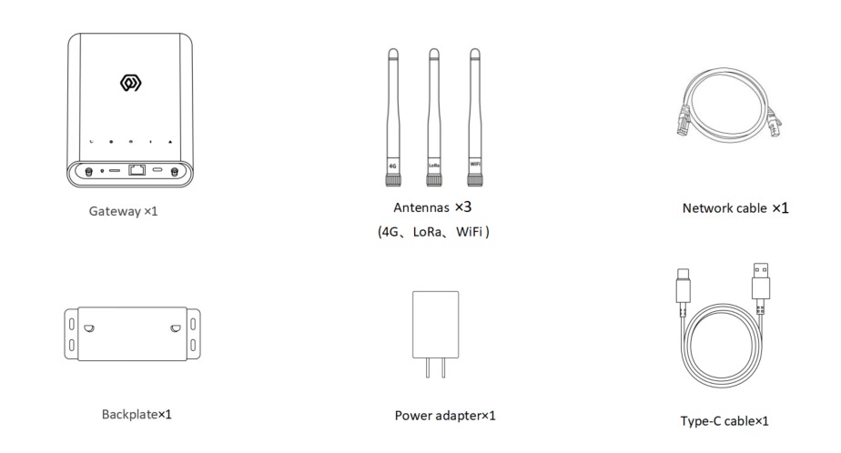
Figure Accessories List
NOTE The Indoor Gateway GDI51x does not support GPS by default. If you need GPS function, please contact the technical personnel of ManThink

Product size
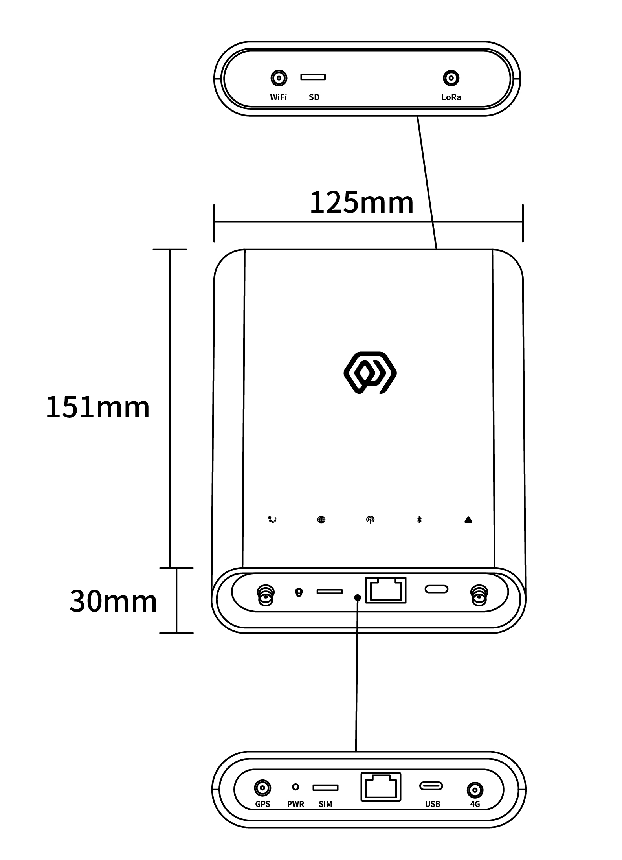
Figure Product size

Interface Description
Interface Name | Description
WiFi | WIFI antenna interface
SD | Memory card slot
LoRa | LoRa Antenna interface
GPS | GPS antenna interface
PWR | Reset key
SIM | SIM card slot
RJ45 | Network cable interface (POE power supply)
USB | Type-C interface
4G | 4G Antenna Interface

Indicator Description
Indicator | Color / network | Light states and meanings
Running indicator  | — | Steady on: The system is starting.  Off: Basic system startup is complete and application processes are starting.  Flashing at 1 Hz: The system is running normally.
Network indicator  | Green/wired network  Blue/4G network | Green, flashing at 1 Hz: The wired network connection is normal.  Green, flashing every 500 ms: The wired network connection is abnormal.  Green, flashing rapidly: Network configuration is in progress.  Blue, off: No 4G module is installed.  Blue, steady on: A 4G module is installed, but no SIM card is inserted.  Blue, flashing irregularly: Data is being exchanged over the 4G network.
LoRa data transceiver indicator  | Green  Blue | Green, flashing: A LoRa data packet is being transmitted.  Blue, flashing: A LoRa data packet is being received.
LAN status light  | Red  Blue | Red: System control status.  Blue: Wi-Fi connection status.
Fault indicator  | — | Flashing rapidly: The system is in the second startup phase.  Off: No system fault is present.  Flashing: The system has detected a fault.

Product Model

Model example
GDI518-AG-AS923-N-2

Model component breakdown
- GDI518: product series and RF band.
- GDI51 identifies a fifth-generation indoor LoRaWAN gateway.
- 8 identifies the 800 MHz-and-above RF version for EU868, AS923, AU915 and US902.
- Other band option: 4 identifies the 400 MHz RF version for EU433 and CN470.
- -AG: LoRa architecture and 4G configuration.
- A identifies one LoRa antenna, 8 frequency points, 65 channels and half-duplex operation.
- Other LoRa architecture option: D identifies two LoRa antennas, 16 frequency points, 130 channels and full-duplex operation.
- G identifies an integrated 4G module.
- Other 4G option: N identifies a configuration without a 4G module.
- -AS923: LoRaWAN regional standard.
- AS923 means that the gateway supports the LoRaWAN AS923 regional parameters.
- Other regional codes are CN470, EU433, EU868, AU915 and US902; US902 denotes the LoRaWAN US915 (902–928 MHz) regional parameters.
- -N: default version.
- N identifies the default version.
- Other values are reserved for customized or special versions.
- -2: LoRa concentrator chipset.
- 2 identifies the Semtech SX1302.
- Other chipset option: 1 identifies the Semtech SX1301.

Complete model meaning
The complete meaning of GDI518-AG-AS923-N-2 is:
This is a fifth-generation indoor LoRaWAN gateway in the 800 MHz-and-above RF class. It uses one LoRa antenna, 8 frequency points, 65 channels and half-duplex operation, includes a 4G module, supports the LoRaWAN AS923 regional standard, uses the default version code N, and is equipped with a Semtech SX1302 concentrator.

Gateway Installation
Note:
- The gateway shell does not need to be disassembled for installation
- Te Indoor Gateway GDI51x does not support GPS by default. If you need GPS, please contact the technical personnel of ManThink.

Accessories connection

Antenna connection
- Will respectively the LoRa, WiFi, GPS and 4G antennas are tightened to the corresponding interfaces.
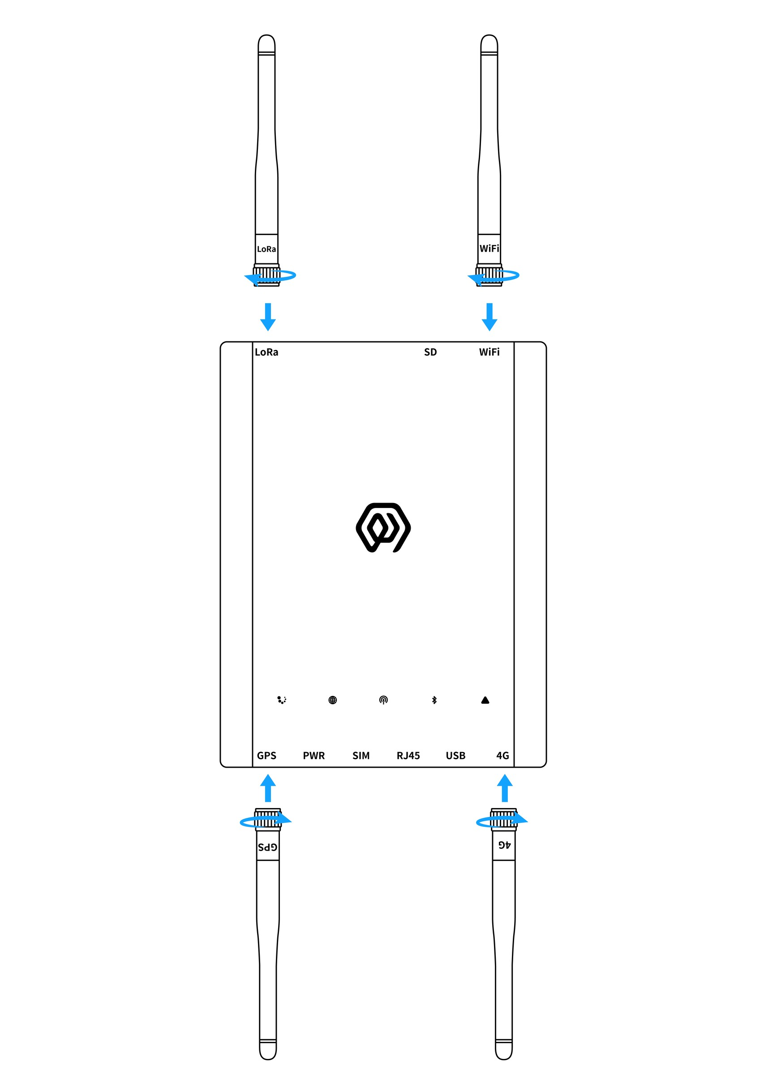
Figure Antenna connection

Type-C power cord connection
- When using POE power supply mode, the power cord does not need to be connected
- Will Type-C power cord connect to the Gateway USB interface ( Type-C interface)
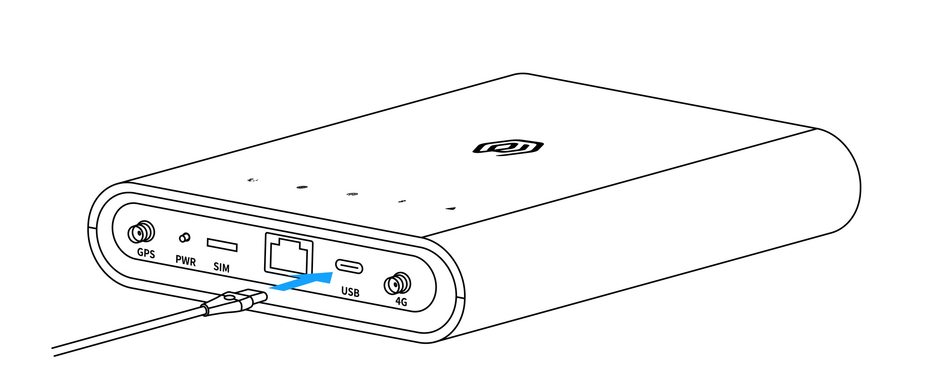
Figure Type-C power cord connection

Network cable connection
- Connect the network cable to the Gateway RJ45 interface
- This interface can accept POE power supply
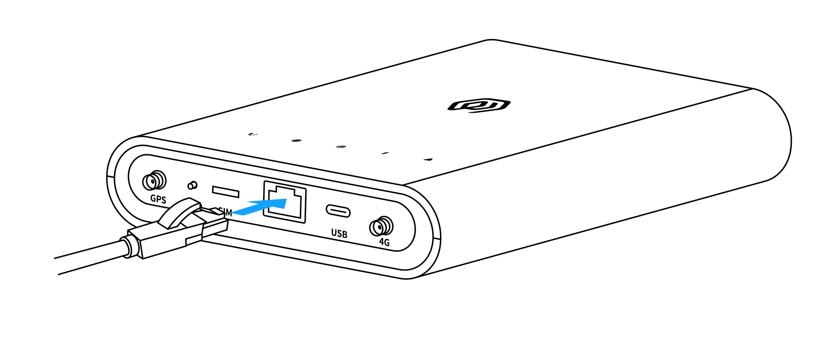
Figure Network cable connection

SIM card installation
- No need to insert a SIM card when connecting the network cable.
- Insert the SIM card into the gateway SIM interface.
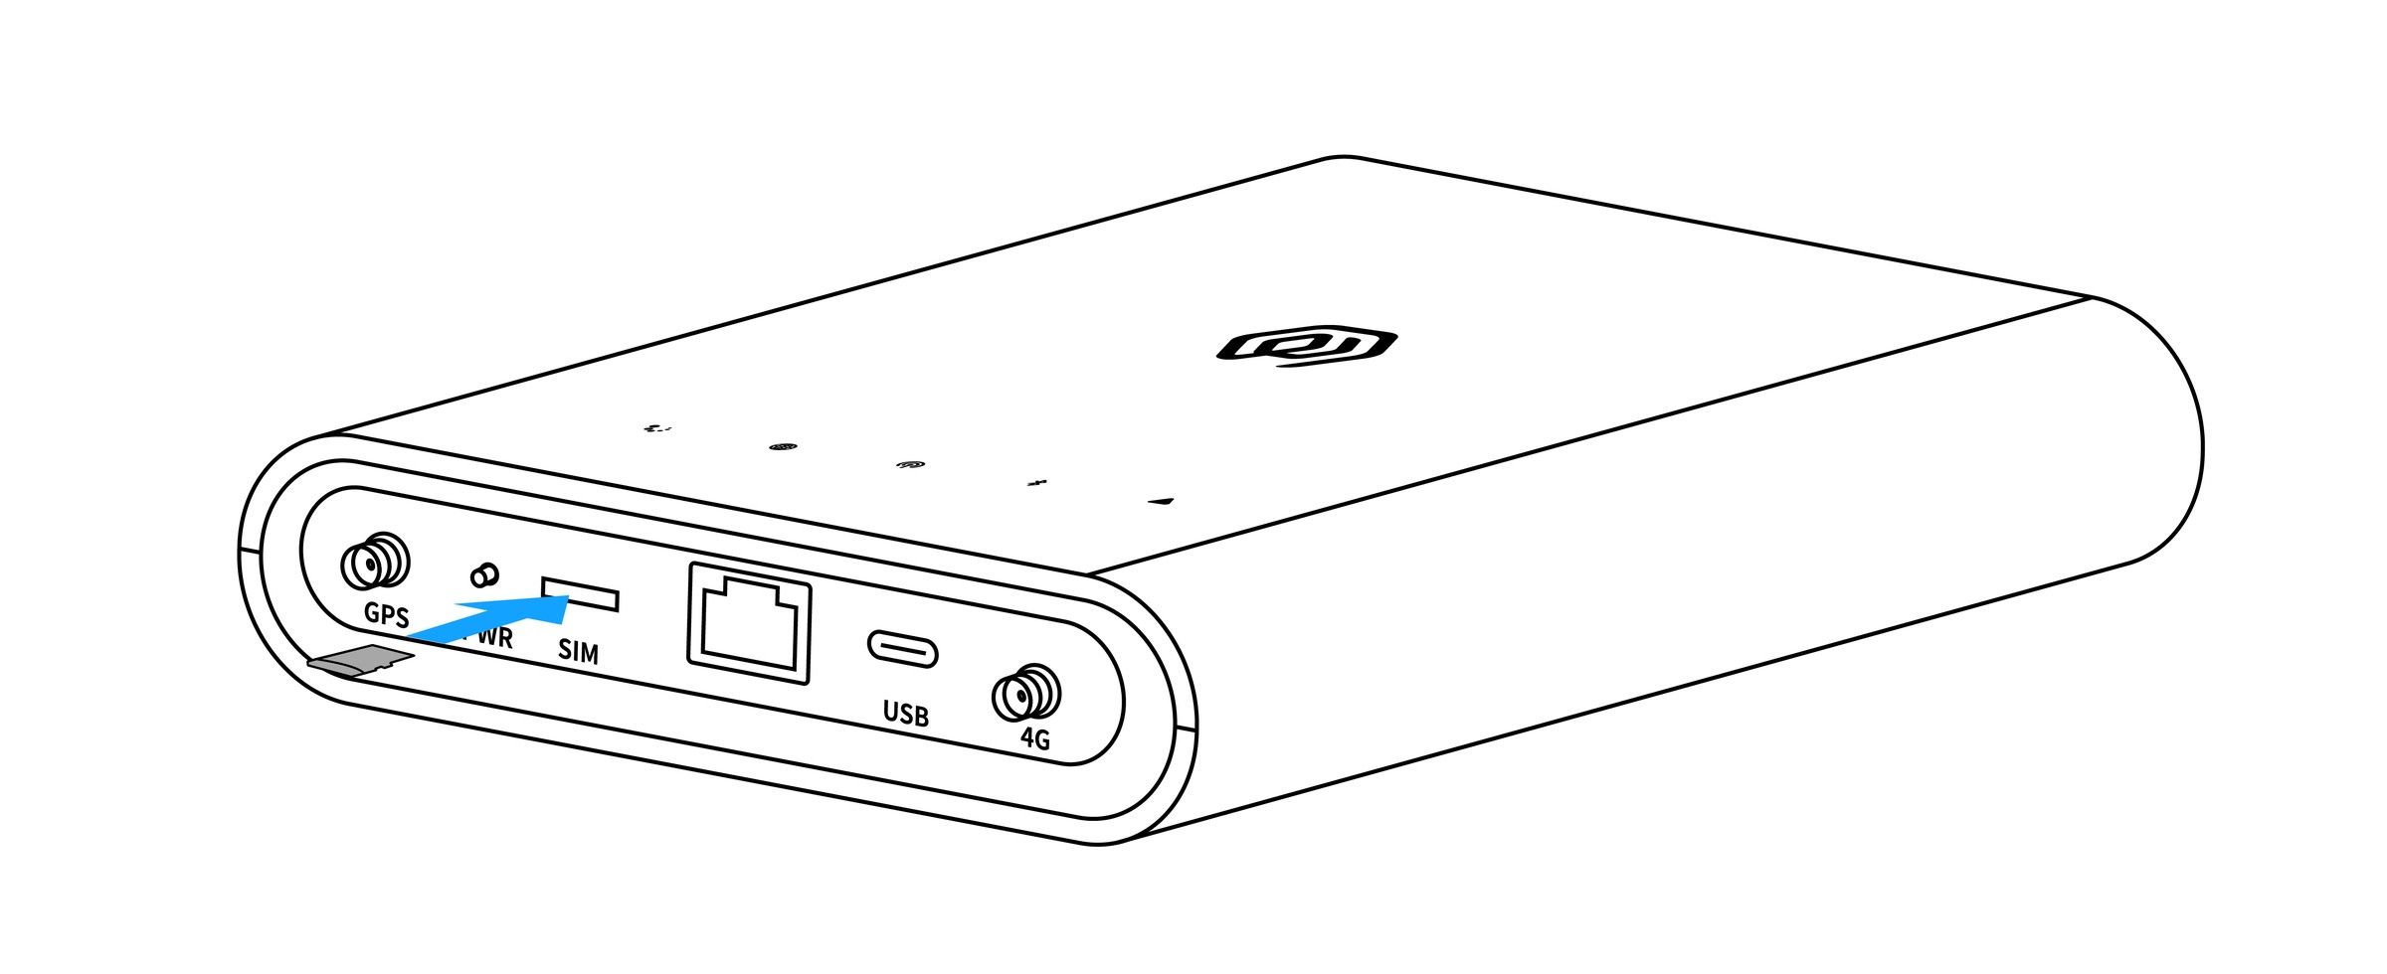
Figure SIM card installation
NOTE The correct orientation for inserting the SIM card is as shown in the figure below: chip facing downward, with the notch in the upper-left corner.

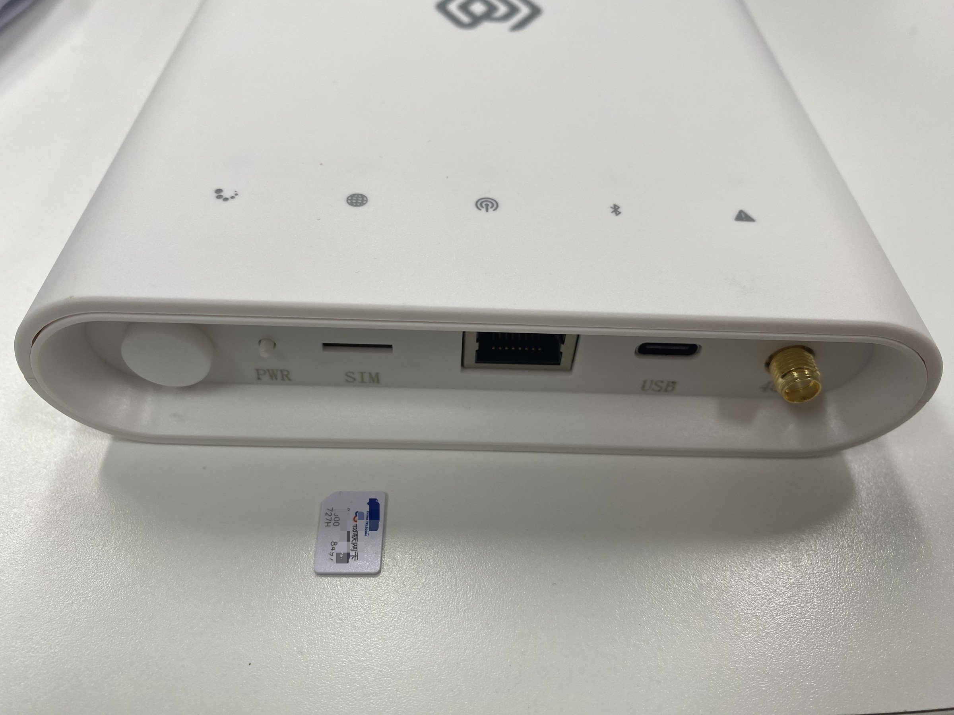
Figure SIM card installation

Gateway Installation

Wall-mounted fixed
- Screw the Gateway backboard to the wall
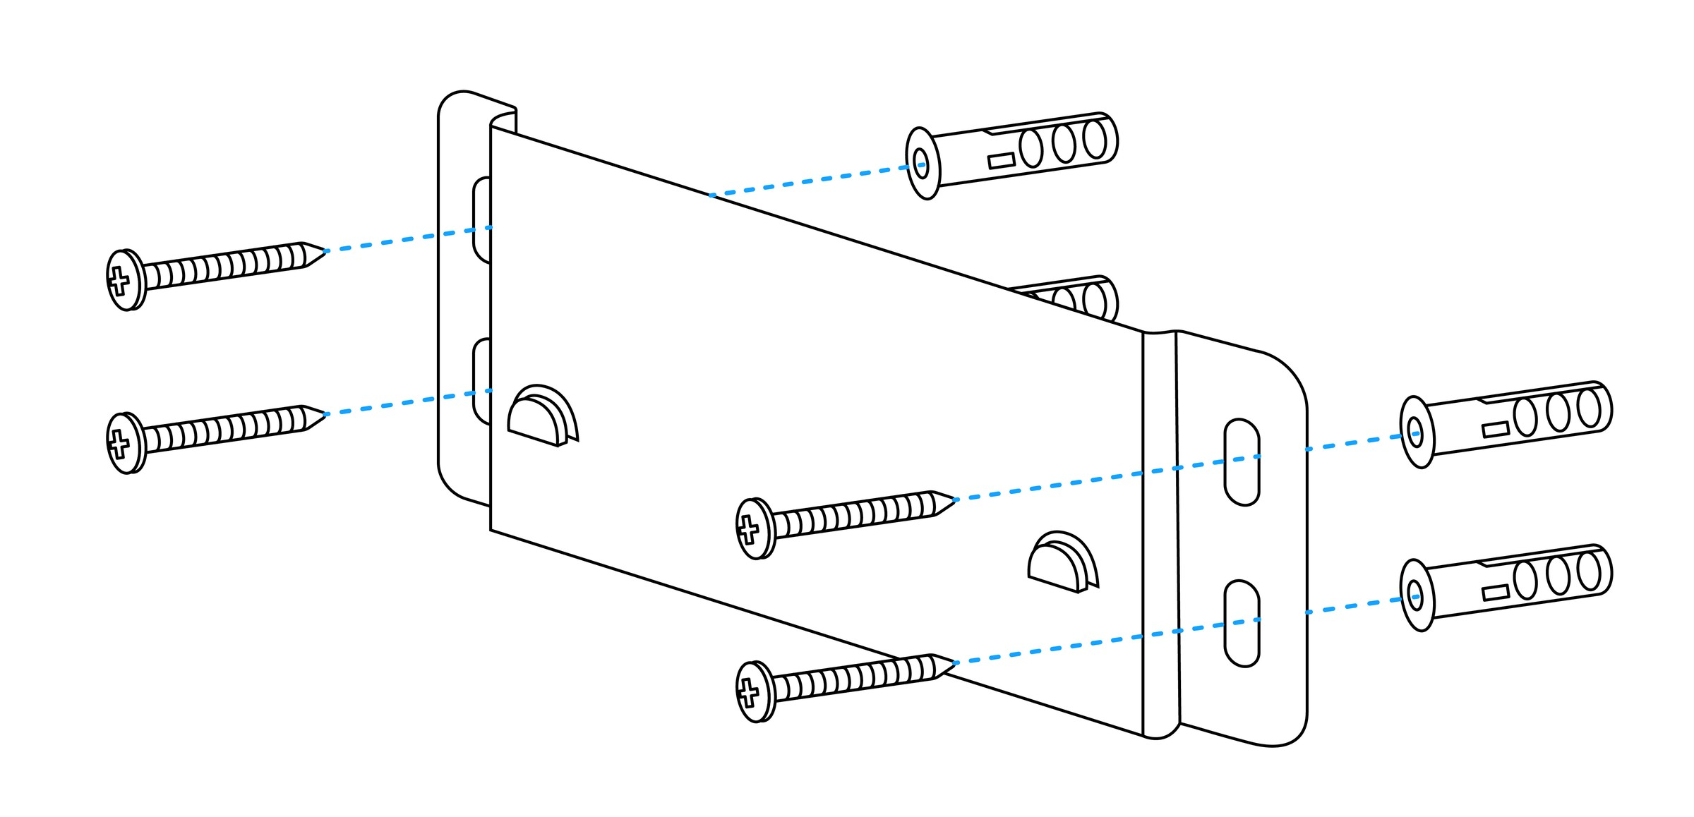
Figure Wall-mounted fixed
- Mount the gateway back hanging slot on the backboard
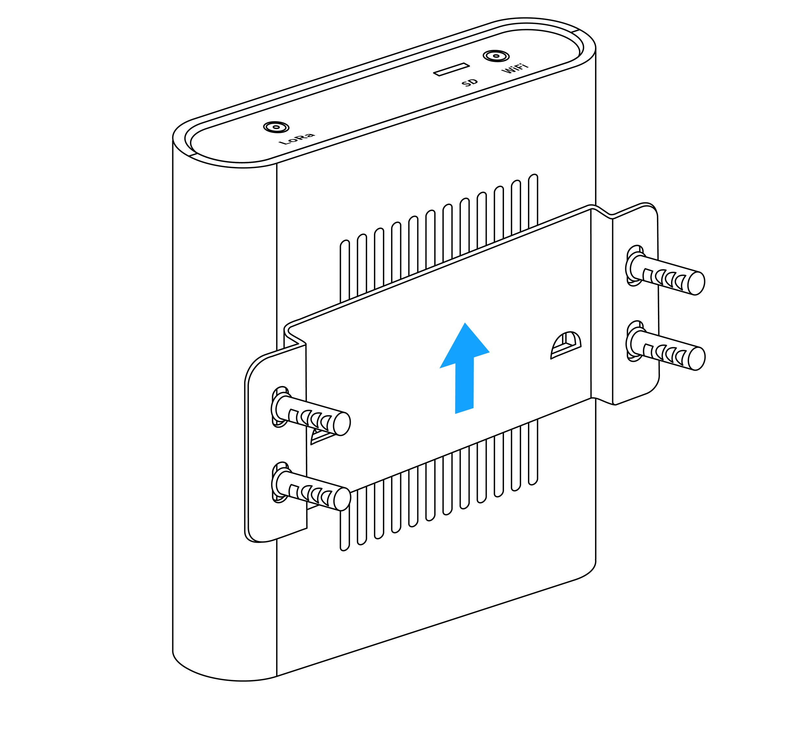
Figure Wall-mounted fixed

User Guide

Gateway Configuration
AN-25100108 Gateway User Guide

Using ThinkLink
\ThinkLink User Guide

Connecting to Chirp Stack
GW-AN08: Connecting to ChirpStack through Basic Station LNS (with TLS)

Connecting to TTN
GW-AN09: Connecting to TTN through Basic Station

Contact Us
Website: www.manthink.cn
Email: info@manthink.cn
Tel: +86 15810684257

