MANTHINK / INDUSTRIAL IoT
GDI52
LoRaWAN Gateway
Standardized Device Manual
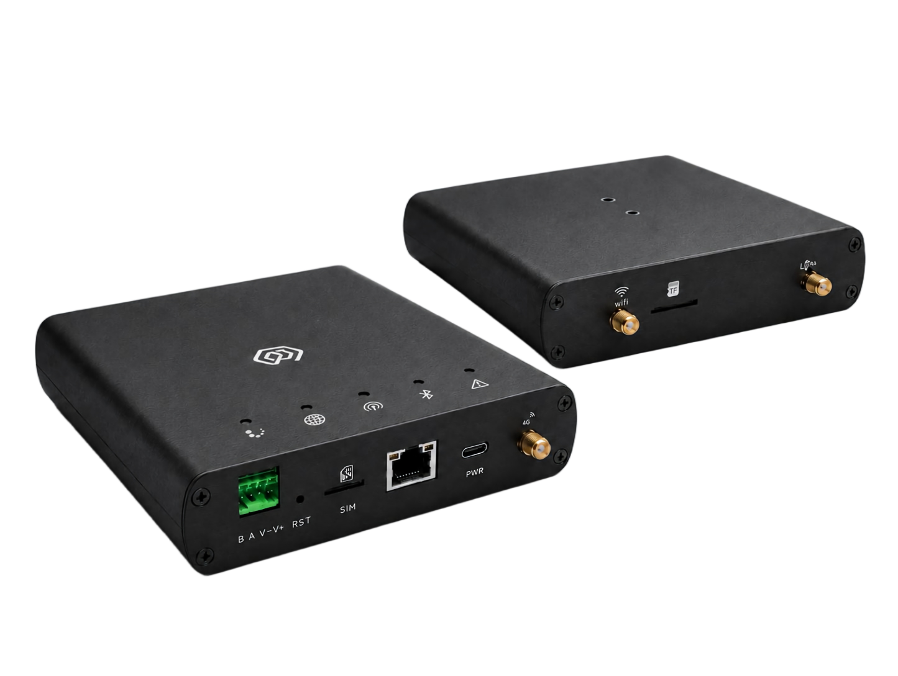
VERSION  1.0 | DOCUMENT  Device Manual

Revision History
Version | Change Description
1.0 | Current published version

Contents
1. Product Introduction
1.1 Product Introduction
1.2 Product Features
2. Specifications
2.1 Parameters
2.2 Product size
2.3 Interface Description
2.4 Indicator Description
2.5 Product Model
3. Gateway Installation
3.1 Accessories Connection
3.1.1 Antenna connection
3.1.2 Type-C power cord connection
3.1.3 Network cable connection
3.1.4 SIM card installation
3.1.5 RS485 connection
3.1.6 DC5-24V supply connection
3.2 Gateway Installation
3.2.1 Guide rail installation
4. User Guide
4.1 Gateway Configuration
4.2 Using ThinkLink
4.3 Connecting to Chirp Stack
4.4 Connecting to TTN
5. Contact Us

Language-version note: The Chinese manual additionally states that GDI52x does not support GPS and that installation does not require opening the enclosure. The Chinese and English manuals also differ on fast network-indicator flashing: English says no 4G module is installed; Chinese says the network is being configured. Confirm behavior against the current hardware revision or with technical support before service work.

1. Product Introduction

1.1 Product Introduction
GDI52x is a new-generation indoor gateway product designed by ManThink for LoRaWAN systems.
GDI52x inherits the core functional architecture of GDI51x. Based on a high-performance LoRaWAN gateway design, it supports LoRaWAN network access, ThinkLink platform integration, and third-party LoRaWAN Network Servers. It is suitable for IoT application scenarios including industrial parks, buildings, industrial sites, and smart property management.
Compared with GDI51x, GDI52x adopts an aluminum alloy enclosure design, improving structural strength and industrial appearance. The gateway adds an RS-485 communication interface and supports DC 5-24V wide-range power input.

1.2 Product Features
- Supports ThinkLink, ChirpStack, TTN and other LoRaWAN platforms
- Supports Basic Station and GWMP gateway protocols
- Built-in ThinkLink (TKL) platform for edge data processing and management
- Supports historical data storage
- Supports device models and application data parsing
- Supports Dashboard visualization
- Supports 4G, WiFi and Ethernet backhaul
- Supports RS-485 field device connection
- Supports DC 5-24V power supply
- Supports remote maintenance and upgrade
- Provides Web configuration interface
- 8 frequency channels (BW=125kHz)
- 16 LoRa demodulators for concurrent packet processing
- 65 configurable channels
- Maximum TX power: 22dBm
- RX sensitivity: -141dBm (SF=12, BW=125kHz)
- Supports US902, AU915, AS923, EU868, EU433 and CN470 LoRaWAN regions
- Aluminum alloy industrial enclosure

2. Specifications

2.1 Parameters
SOC | * LS1012A 64-bit ARM Cortex-A53 800MHz 2W
Memory | Support DDR3L 1066 MHz <br> Memory:512MB
Storage | * ≥ 16 GB eMMC
Software | * Built-in NS and IoT platform (with integrated TKL)  * Supports ThinkLink, ChirpStack, TTN, Basic Station, and GWMP protocols  * Supports PostgreSQL and Redis databases  * Supports historical data storage and Leaf mode  * Supports Thing Model and application data parsing  * Supports Dashboard
LoRa | * Working frequency band: CN 470 470M ~ 510MHz  EU868 863M~870MHz  EU433 433M~434MHz  AS923 920M~928MHz  US902 902M-928 MHz  AU915 915M-928 MHz  · Communication Rate: 292bps to 15.625kbps, supports SF5 to SF12  · Transmit Power: 22dBm (Max)  · Receiver sensitivity: -141 dBm (SF = 12, BW = 125 kHz)  · Antenna Type: Omnidirectional  · Frequency points: 8 (BW = 125 kHz)  · Demodulators: 16, capable of processing 16 packets simultaneously(8 × SF5-SF12 LoRa®demodulators; 8 × SF5-SF10 LoRa®demodulators)  · Channels: 65 (each channel is defined by a unique combination of SF, BW, and frequency point; BW = 125 kHz, totaling 65 channels)  · Operating Mode: Half-duplex  · Single Channel Bandwidth: 125KHz or higher
Data Backhaul | · Ethernet: 1000M/100M  · 4G  Note : The Gateway uses 4G uplink by default, CAT1 module, and supports the following frequency bands:LTE-FDD: B1/3/5/8;LTE-TDD: B34/38/39/40/41  If the frequency band used by the planned regional operator is not in the above frequency band, please contact the technical personnel of ManThink to replace the applicable 4G module.
Configure Ports | · USB-TypeC  · Ethernet  · WiFi
Power Supply | · POE(48V)  · USB TYPE-C(5V)  · DC 5-24V
Power Consumption | · 5W
Environmental Parameters | · Working temperature:-20 ℃ ~ 65 ℃  · Working humidity: 0% ~ 95% RH  · Waterproof and dustproof: IP53
Weight | 0.33kg
Dimensions | 139mm x 122mm x 28mm
Installation Method | Rail mounting

2.2 Product size
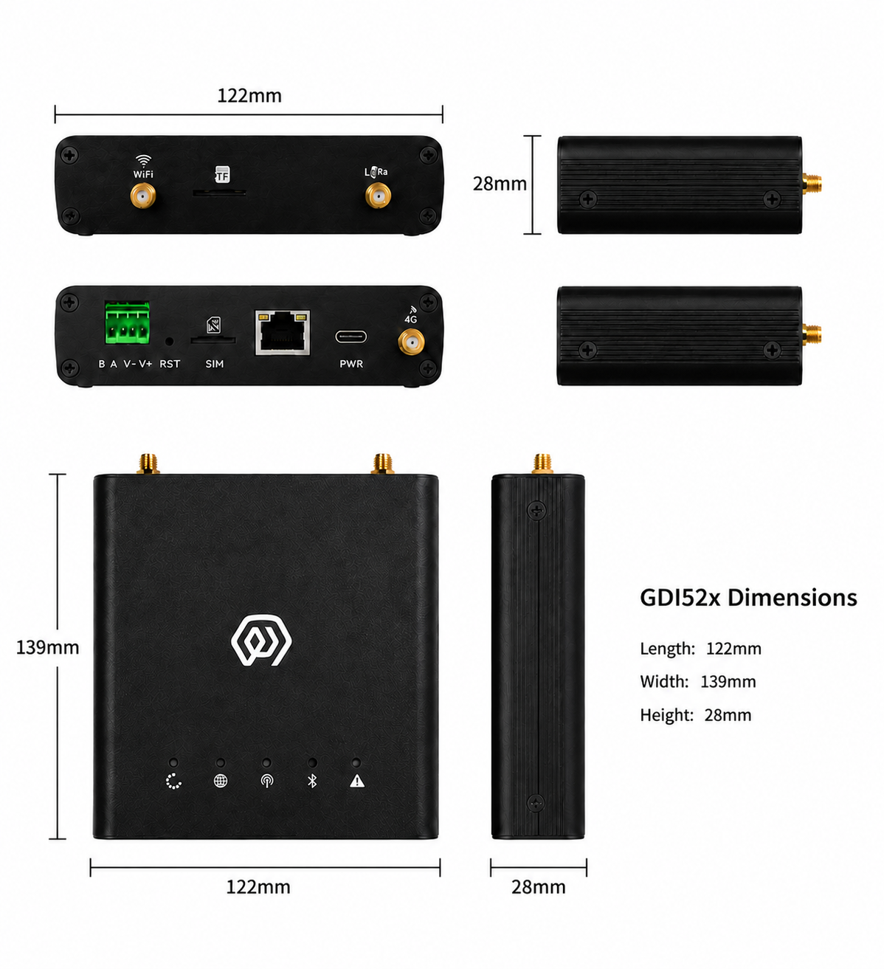
Figure GDI52 dimensions

2.3 Interface Description
Interface Name | Description
WiFi | WIFI antenna interface
TF | Memory card slot
LoRa | LoRa Antenna interface
B A V- V+ | RS485 interface/DC5-24V power supply
RST | Reset key
SIM | SIM card slot
RJ45 | Network cable interface (POE power supply)
PWR | Type-C interface
4G | 4G Antenna Interface

2.4 Indicator Description
Indicator | Function | Status | Description
 | Running Indicator | Steady On | System starting up
 |  | Off | System running normally, entering process startup phase
 |  | Flashing at 1Hz | System running normally
 | Network Indicator | Red (Wired Network Status) — Flashing at 1Hz | Network connection normal
 |  | Flashing at 500ms | Network connection abnormal
 |  | Fast Flashing | Gateway does not have 4G module installed
 |  | Blue (4G Network) — Off | Gateway does not have 4G module installed
 |  | Steady On | Gateway has 4G module installed but no SIM card inserted
 |  | Irregular Flashing | Gateway is performing data interaction
 | LoRa Data Transceiver Indicator | Red — Flashing | Gateway is sending a data packet
 |  | Blue — Flashing | Gateway is receiving a data packet
 | LAN Status Light | Red | System control
 |  | Blue | WiFi connection status
 | Fault Indicator | Fast Flashing | Second phase of startup process
 |  | Off | No fault
 |  | Flashing | Fault

2.5 Product Model
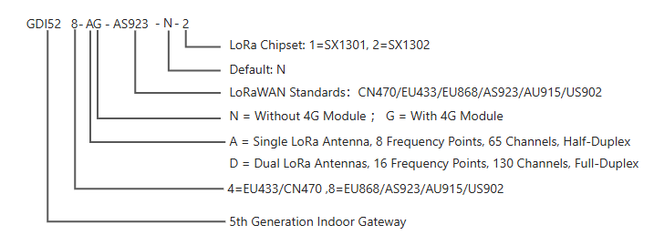
Figure GDI52 product model chart

3. Gateway Installation

3.1 Accessories Connection

3.1.1 Antenna connection
- tighten the LoRa, WiFi and 4G antennas to the corresponding interfaces respectively (LoRa, WiFi and 4G antennas are suction cup antennas)

3.1.2 Type-C power cord connection
- when using POE power supply mode, the power cord does not need to be connected
- connect the Type-C power cord to the Gateway PWR interface (Type-C interface)

3.1.3 Network cable connection
- connect the network cable to the Gateway RJ45 interface
- this interface can accept POE power supply

3.1.4 SIM card installation
- no need to insert SIM card when connecting network cable
- insert SIM card into Gateway SIM interface
NOTE the direction of SIM card insertion is, the chip is downward, and the notch is in the upper left corner.

3.1.5 RS485 connection
- B A port connected to the green terminal

3.1.6 DC5-24V supply connection
- V- V + port connected to green terminal

3.2 Gateway Installation

3.2.1 Guide rail installation
- screw the Gateway accessory rail backplane to the back of the Gateway
- install the rail back plate card in the rail

4. User Guide

4.1 Gateway Configuration
gwTool7 Gateway Administrator Manual

4.2 Using ThinkLink
ThinkLink User Guide

4.3 Connecting to Chirp Stack
Connect to ChirpStack with Basic Station (gwTool7)

4.4 Connecting to TTN
Connect to TTN with Basic Station (gwTool7)

5. Contact Us
Website: www.manthink.cn
Email: info@manthink.cn
Tel: +86 15810684257

