MANTHINK / INDUSTRIAL IoT
KS31
LoRaWAN Sensor
Standardized Device Manual
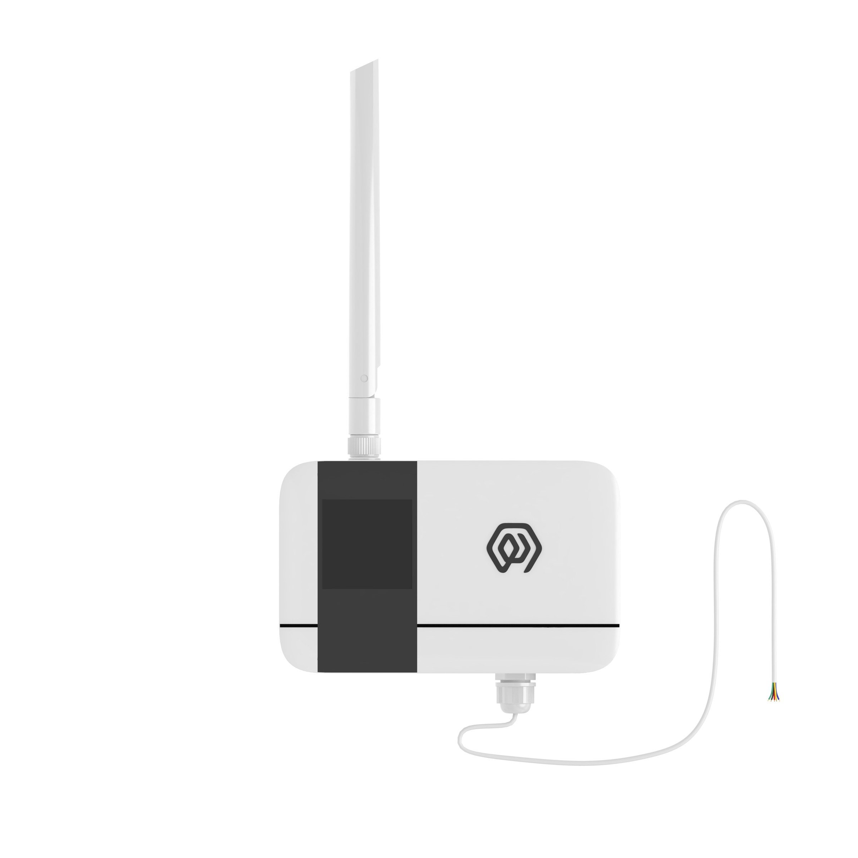
VERSION  当前版本 | DOCUMENT  Device Manual

Product Description
KS31 is a LoRaWAN-based The AI collector for communication provides 4-20mA and 0-10v interfaces, which can easily connect devices supporting the above two interfaces.
KS31 based on LoRa®Wireless technology, supports standard LoRaWAN®Networking communication has the characteristics of long communication distance and low power consumption. The product has 4 built-in 2700 mA-hour large-capacity lithium battery, which can last for more than 6 years.
Product support with ManThink/third-party LoRaWAN®The gateway is combined with the ThinkLink/Chirp stack/TTN third-party IoT platform to realize the monitoring and management of 4-20mA and 0-10v interface switches.
KS31 has a high protection level of IP65, adapt to the harsh outdoor environment, and can be widely used in the management needs of smart industries, smart buildings and other scenarios.

Main Features
- IP65 protection rating .
- Support 4-20mA, 0-10V interface.
- Battery powered, 10800mA high performance lithium battery, battery life up to 6 years.
- Support ThinkLink/ChirpStack/TTN platform docking.
- Support US902,AU915,AS923,EU868,EU433,CN470 LoRaWAN standard.

Specifications

Performance Parameters
Item | Value
INTERFACE
connect type | PG7
Wiring quantity | 5 (Including GND wire)
Number of grounding wires | 1
display | none

Item | Value
WIRELESS PARAMETERS
Protocol | Standard LoRaWAN®Agreement
Regional Standards | CN470/EU433/EU868/AS923/AU915/Us902
Transmit Power | Maximum Support 22dBm ( can be changed)
Receiving Sensitivity | -142dBm(SF=12,BW=125kHz)
Working mode | OTAA/ABP Class A

Item | Value
CONFIGURATION
Test /Trigger mode | The magnet, 2 seconds trigger heartbeat data 6 seconds trigger into the network
Configuration | By NS issue instruction

Item | Value
PHYSICAL CHARACTERISTICS
power supply mode | 4*2700mAh ER14505 lithium battery
Sleep current | < 3uA (25°C at room temperature)
Emission current | < 110mA (22dBm transmit power)
Battery life | 6 years (15-minute reporting cycle, 25 °C at room temperature)
Working Temperature | -40°C ~85°C
Relative humidity | ≤95% (no condensation)
Protection level | IP65
Material & Color | ABS + PC, White
Dimensions | 120mm * 72mm * 28mm
Installation method | Wall Hanging

Dimensions and Interfaces
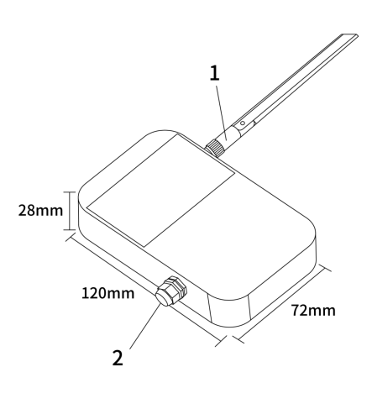
Figure Dimensions and Interfaces
Serial Number | Iinterface Description | Specific details
1 | LoRa Antenna interface | Inner hole outer screw, according to different LoRaWAN standard match
2 | Wiring Port | PG7 waterproof connector, 1 GND,4 leads, 5 leads in total

Model List

Model example
KS318-A1-AS923-N

Model component breakdown
- KS318: product series and RF band.
- KS31 identifies a second-generation IP65 analog input acquisition module.
- 8 identifies the 800 MHz-and-above RF version for EU868, AS923, AU915 and US902.
- Other band option: 4 identifies the 400 MHz RF version for EU433 and CN470.
- -A1: acquisition interface and power configuration.
- A identifies a 4–20 mA analog input.
- Other interface option: B identifies a 0–10 V analog input.
- 1 identifies a built-in 10800 mAh battery.
- Other power option: 2 identifies external DC 5–24 V input.
- -AS923: LoRaWAN regional standard.
- AS923 means that the device supports the LoRaWAN AS923 regional parameters.
- Other regional codes are CN470, EU433, EU868, AU915 and US902; US902 denotes the LoRaWAN US915 (902–928 MHz) regional parameters.
- -N: default version.
- N identifies the default version.
- Other values are reserved for customized or special versions.

Complete model meaning
The complete meaning of KS318-A1-AS923-N is:
This is a second-generation IP65 analog input acquisition module in the 800 MHz-and-above RF class. It provides a 4–20 mA analog input, includes a 10800 mAh battery, supports the LoRaWAN AS923 regional standard, and uses the default final version code N.

Instructions For Use

Network Topology
KS31 is a standard LoRaWAN device, KS31 normal operation requires LoRaWAN network support. You can use the LoRaWAN gateway of ManThink or a third-party LoRaWAN gateway with the support of LoRaWAN NS.
KS31 supports access to standard LoRaWAN networks such as ThinkLink, Chirp stack, and TTN. You can use the ThinkLink configuration model to implement business functions, card view presentation, and other business logic.
The LoRaWAN network topology is as follows:
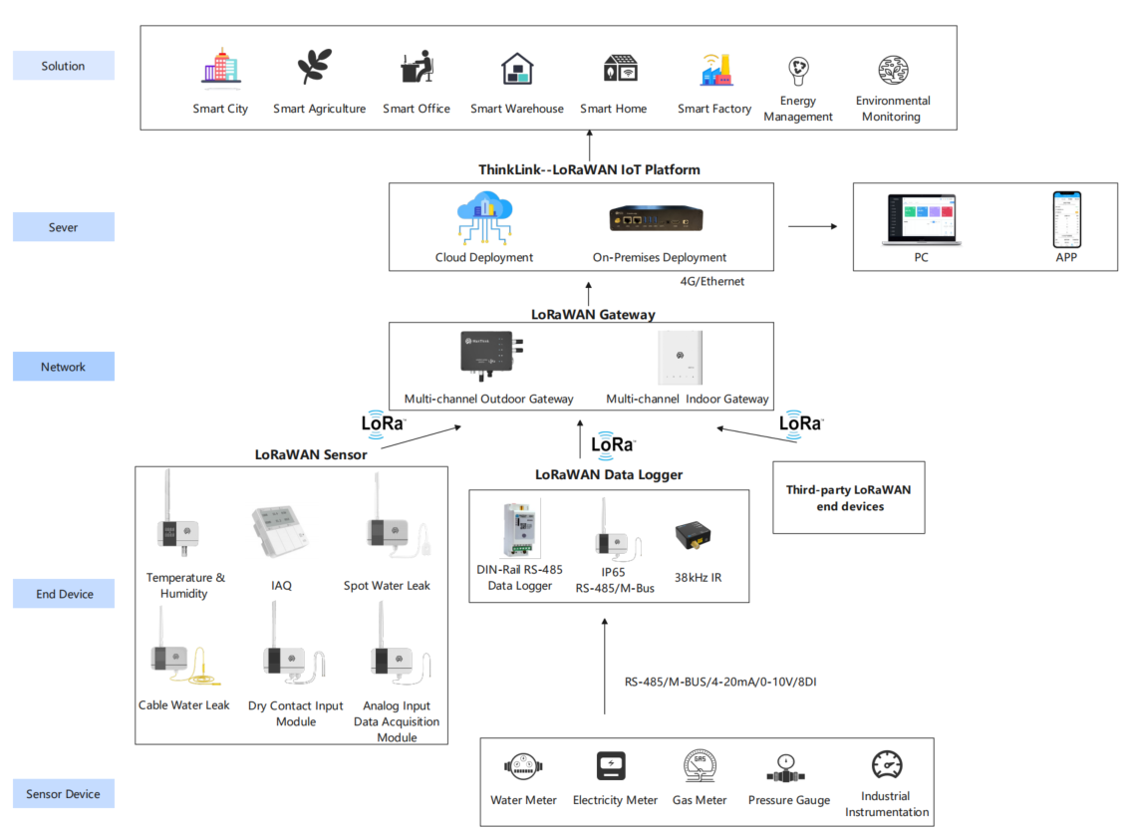
Figure Network Topology

Working Mode

Periodic Acquisition and Heartbeat
- The KS31 has 4 AI interfaces that perform periodic sampling and transmit data periodically.
- The KS31 allows setting a COV (Change of Value) threshold. When the sampled data from an AI interface exceeds this threshold, it triggers an uplink data packet.
- The protocol format for triggered uploads and periodic heartbeats is the same.

Communication Test
Use a magnet to stick the position of QR code on KS31 to trigger 2s-4S, which can trigger a packet of upstream measurement data.

Join
Use a magnet to stick the position of QR code on KS31 to trigger 6s-8s, which can trigger a packet of join.

Installation
- Use the drill to fix the back plate to the Wall (keep the back plate Arrow Up)
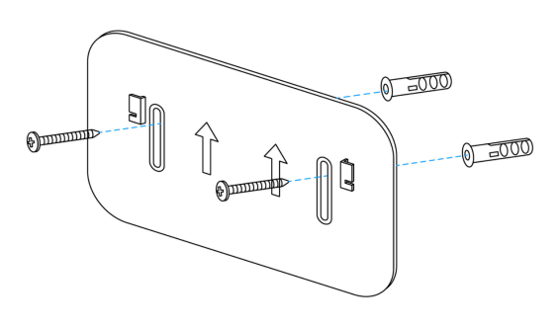
Figure Installation
- Hatch the product on the back plate (slide down after aligning the groove on the back of the sensor with the convex part of the back plate)
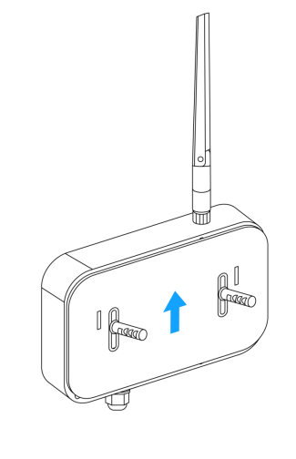
Figure Installation

communication Protocol

According to the Standard
Reference: PTL-D01 ManThink Technology IoT Terminal Application Layer General Protocol V1.5
> Note: The 0–10 V and 4–20 mA models use different identifiers; all other fields have the same layout.

Data items and identifiers for 0-10V Interfaces
LoRaWAN port 11; version 0x82; control word 0x25; identifier 0x17.
Example frame:
82 25 17 00 D4 15 01 00 D0 16 00 00 D0 16 01 00 D0 16 01 00 FE
Number | Data Item | Example | Start Address | Length | Description
1 | Version | 0x82 | 0 | 1 byte | Fixed at 0x82
2 | Control word | 0x25 | 1 | 1 byte | Fixed at 0x25
3 | Identifier | 0x17 | 2 | 1 byte | Fixed at 0x17 for the 0–10 V model
4 | Device status | 0x00 | 3 | 1 byte | 0x00: normal; 0x01: communication fault
5 | Port 1 sample | D4 15 01 00 → 0x000115D4 | 4 | 4 bytes | Unsigned 32-bit little-endian integer; actual value = sample × 11 / 64000.00 V
6 | Port 2 sample | D0 16 00 00 → 0x000016D0 | 8 | 4 bytes | Unsigned 32-bit little-endian integer; actual value = sample × 11 / 64000.00 V
7 | Port 3 sample | D0 16 01 00 → 0x000116D0 | 12 | 4 bytes | Unsigned 32-bit little-endian integer; actual value = sample × 11 / 64000.00 V
8 | Port 4 sample | D0 16 01 00 → 0x000116D0 | 16 | 4 bytes | Unsigned 32-bit little-endian integer; actual value = sample × 11 / 64000.00 V
9 | Battery voltage | 0xFE | 20 | 1 byte | Actual value = sample × 1.6 / 254 + 2 V

Data items and identifiers for the 4-20mA interface
LoRaWAN port 11; version 0x82; control word 0x25; identifier 0x18.
Example frame:
82 25 18 00 D4 15 01 00 D0 16 00 00 D0 16 01 00 D0 16 01 00 FE
Number | Data Item | Example | Start Address | Length | Description
1 | Version | 0x82 | 0 | 1 byte | Fixed at 0x82
2 | Control word | 0x25 | 1 | 1 byte | Fixed at 0x25
3 | Identifier | 0x18 | 2 | 1 byte | Fixed at 0x18 for the 4–20 mA model
4 | Device status | 0x00 | 3 | 1 byte | 0x00: normal; 0x01: communication fault
5 | Port 1 sample | D4 15 01 00 → 0x000115D4 | 4 | 4 bytes | Unsigned 32-bit little-endian integer; actual value = sample × 10 / 64000.00 mA
6 | Port 2 sample | D0 16 00 00 → 0x000016D0 | 8 | 4 bytes | Unsigned 32-bit little-endian integer; actual value = sample × 10 / 64000.00 mA
7 | Port 3 sample | D0 16 01 00 → 0x000116D0 | 12 | 4 bytes | Unsigned 32-bit little-endian integer; actual value = sample × 10 / 64000.00 mA
8 | Port 4 sample | D0 16 01 00 → 0x000116D0 | 16 | 4 bytes | Unsigned 32-bit little-endian integer; actual value = sample × 10 / 64000.00 mA
9 | Battery voltage | 0xFE | 20 | 1 byte | Actual value = sample × 1.6 / 254 + 2 V

ThinkLink Reference Model
Sign in to ThinkLink, search for KS31 in the model menu, and add the device with the KS31 template.

Parameter Modification
Parameter changes follow *PTL-D01 ManThink Technology IoT Terminal Application Layer General Protocol V1.5*.

Configuration Parameter Address Table
Number | Data Item | Default Value | Start Address | Length | Description
1 | Reset | Write-only | 9 | 1 byte | Write 0x01
2 | Upload period | 900 | 40 | 4 bytes | Little-endian, in seconds
3 | COV enable mask | 0x0F | 150 | 1 byte | bit0–bit3 correspond to AI channels 1–4; 0: disable COV, 1: enable COV
4 | System reserved | — | 151 | 1 byte | Reserved
5 | Sampling period | 5 | 152 | 2 bytes | Little-endian, in seconds
6 | Channel 1 COV | — | 154 | 4 bytes | Unsigned 32-bit little-endian integer; 4–20 mA threshold = COV × 10 / 64000.00 mA; 0–10 V threshold = COV × 11 / 64000.00 V
7 | Channel 2 COV | — | 158 | 4 bytes | Unsigned 32-bit little-endian integer; use the channel 1 conversion
8 | Channel 3 COV | — | 162 | 4 bytes | Unsigned 32-bit little-endian integer; use the channel 1 conversion
9 | Channel 4 COV | — | 166 | 4 bytes | Unsigned 32-bit little-endian integer; use the channel 1 conversion

Contact Us
Website: www.manthink.cn
Email: info@manthink.cn
Tel: +86-15810684257

