MANTHINK / INDUSTRIAL IoT
KS32
LoRaWAN Sensor
Standardized Device Manual
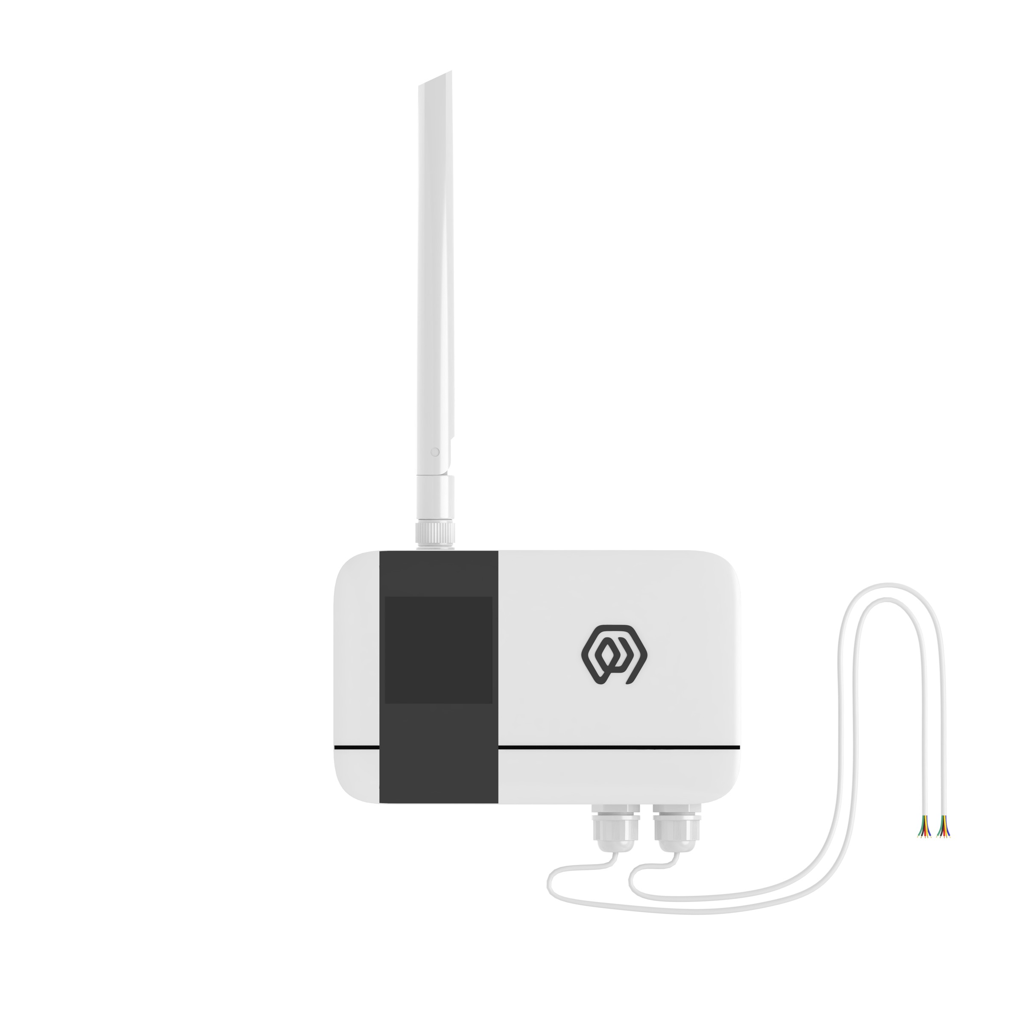
VERSION  当前版本 | DOCUMENT  Device Manual

Product Description
KS32 is a LoRaWAN-based ®The dry contact collector for communication, the product provides 6 Dry contact interfaces, triggers internal level reversal when the dry contact state changes, KS32 triggers interruption to realize real-time collection of the dry contact change state and uploads the dry contact state and count value to LoRaWAN's NS server through LoRaWAN gateway.
KS32 based on LoRa®Wireless technology, supports standard LoRaWAN®Networking communication has the characteristics of long communication distance and low power consumption.
Product built-in 4*2700mAh large-capacity lithium battery, life up to 6 years.
In addition, product support with ManThink/third-party LoRaWAN The gateway is combined with the third-party IoT platform of ThinkLink, Chirp stack, and TTN to realize the monitoring and management of dry-contact switches.
KS32 has a high protection level of IP65, which can adapt to the harsh outdoor environment and can be widely used in the management needs of smart industries, smart buildings and other scenarios.

Main features
- IP65 protection level
- Support 6 ports Dry contact
- Battery powered, 10800mA high performance lithium battery, battery life up to 6 years
- Support ThinkLink/ChirpStack/TTN platform docking
- Support US902,AU915,AS923,EU868,EU433,CN470 LoRaWAN standards

Specifications

Performance Parameters
Item | Value
INTERFACE
connect Type | PG7
Number of dry contact interfaces | 6
Number of grounding wires | 2
Display | None

Item | Value
WIRELESS PARAMETERS
Protocol | Standard LoRaWAN®Agreement
Regional Standards | CN470/EU433/EU868/AS923/AU915/Us902
Transmit power | Maximum Support 22dBm ( can be changed)
Receiving sensitivity | -142dBm(SF=12,BW=125kHz)
Working mode | OTAA/ABP Class A

Item | Value
AGREEMENT /CONFIGURATION
Test/Trigger mode | The magnet 2 seconds trigger heartbeat data 6 Seconds trigger into the network
Configuration | By NS issue instruction

Item | Value
PHYSICAL CHARACTERISTICS
Power supply mode | 4 x 2700 mAh ER14505 lithium battery
Sleep current | <5uA (25 ℃ at room temperature)
Emission current | <110mA (22dBm transmit power)
Battery life | 6 years (15-minute reporting cycle, 25 ℃ at room temperature)
Working Temperature | -40°C ~85°C
Relative humidity | ≤95% (no condensation)
Protection level | IP65
Material & Color | ABS + PC, White
Dimensions | 120mm * 72mm * 28mm
Installation method | Wall Hanging

Dimensions and Interfaces
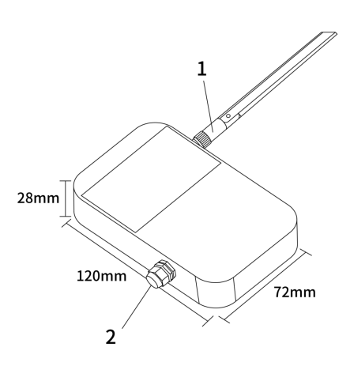
Figure Dimensions and Interfaces
Number | Interface Description | Specific Details
1 | LoRa Antenna interface | Inner hole outer screw, according to different LoRaWAN standard match
2 | Wiring Port | PG7 waterproof connector 2 GND,6 DI input interface, a total of 8 leads

Model List

Model example
KS328-A1-AS923-N

Model component breakdown
- KS328: product series and RF band.
- KS32 identifies a second-generation IP65 dry-contact input module.
- 8 identifies the 800 MHz-and-above RF version for EU868, AS923, AU915 and US902.
- Other band option: 4 identifies the 400 MHz RF version for EU433 and CN470.
- -A1: acquisition interface and power configuration.
- A identifies six digital inputs (6DI).
- 1 identifies a built-in 10800 mAh battery.
- -AS923: LoRaWAN regional standard.
- AS923 means that the device supports the LoRaWAN AS923 regional parameters.
- Other regional codes are CN470, EU433, EU868, AU915 and US902; US902 denotes the LoRaWAN US915 (902–928 MHz) regional parameters.
- -N: default version.
- N identifies the default version.
- Other values are reserved for customized or special versions.

Complete model meaning
The complete meaning of KS328-A1-AS923-N is:
This is a second-generation IP65 dry-contact input module in the 800 MHz-and-above RF class. It provides six digital inputs, includes a 10800 mAh battery, supports the LoRaWAN AS923 regional standard, and uses the default final version code N.

Instructions for use

Network topology
KS32 is a standard LoRaWAN device and needs LoRaWAN network support to work properly. You can use the LoRaWAN gateway of ManThink or a third-party LoRaWAN gateway with the support of LoRaWAN NS.
KS32 supports accessing standard LoRaWAN networks such as ThinkLink, Chirp stack, and TTN. You can use the ThinkLink configuration model to implement business functions, card view presentation, and other business logic.
The LoRaWAN network topology is as follows:
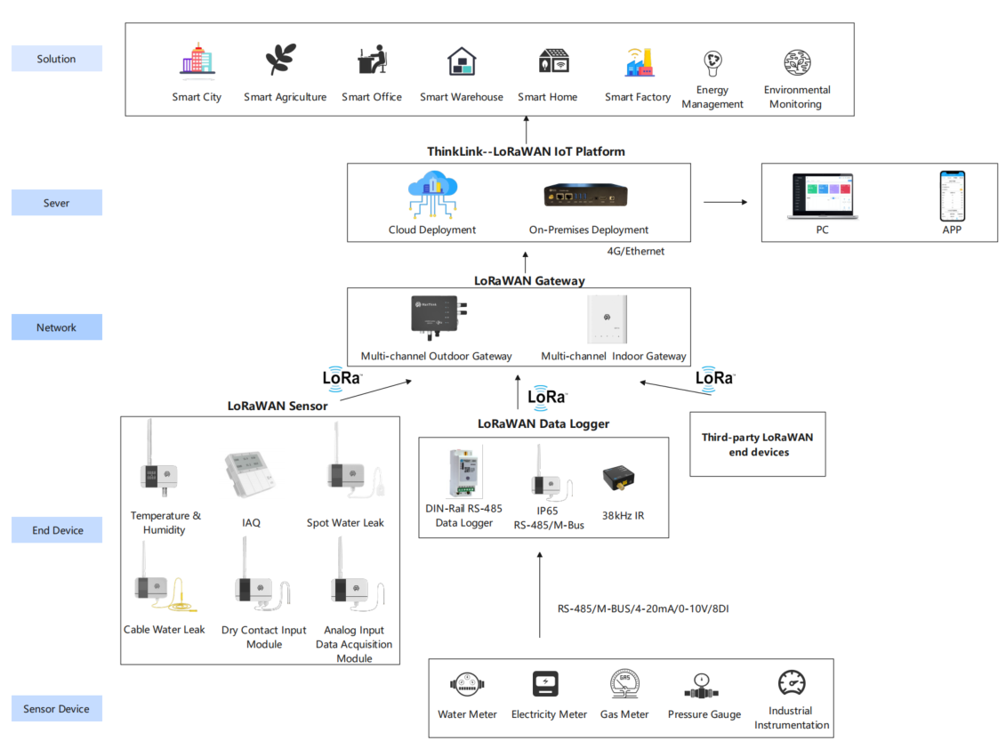
Figure Network topology

Working mode

Periodic Upload and trigger Upload
- [x] KS32 has 6 DI interfaces. KS32 monitors the Accessed DI signals in real time. When the state of any DI interface changes, it will record the number of overturns and send a packet of data to the state of the DI interface.
- [x] When no trigger event occurs, KS32 periodically reports the status and count values of six DI interfaces
- [x] The Upload cycle of KS32 is set according to the heartbeat cycle address.
*Note: KS32 can only be connected to dry contacts**.*

Communication Test
Use a magnet to stick the loction of QR code on KS32 to trigger 2S-4S, which can trigger a packet of upstream measurement data.

Network access
Use a magnet to stick the location of QR code on KS32 to trigger 6s-8s, which can trigger a packet of network access data.

Installation and fixing
- Use the drill to fix the back plate to the Wall (keep the back plate Arrow Up)
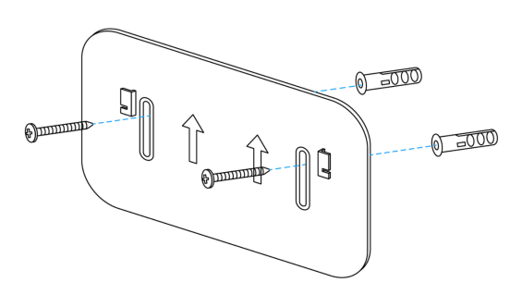
Figure Installation and fixing
- Hatch the product on the back plate (slide down after aligning the groove on the back of the sensor with the convex part of the back plate)
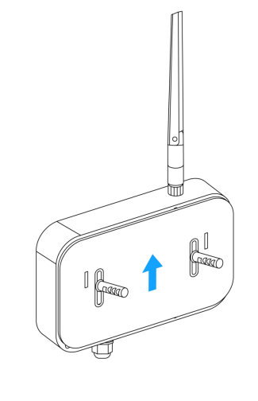
Figure Installation and fixing

Communication Protocol

According to the standard
Reference: PTL-D01 ManThink Technology IoT Terminal Application Layer General Protocol V1.5

Data Items and Identifiers
- LoRaWAN port number = 15
KS32 supports only one data format, for example:
82 24 1A FF00AE 0D000000 D1000000 52000000 52000000 1C000000 28000000 69000000 F4000000
Number | Data Item | Example | Start Address | Length | Description
1 | Version number | 0x82 | 0 | 1 byte | Fixed at 0x82
2 | Control word | 0x24 | 1 | 1 byte | Fixed at 0x24
3 | Identifier | 0x1A | 2 | 1 byte | Fixed at 0x1A
4 | DI status | 0xFF | 3 | 1 byte | See the bit mapping and values below
5 | Fault status | 0x00 | 4 | 1 byte | 0x00: normal; 0x01: ferroelectric-memory fault
6 | Battery voltage | 0xAE | 5 | 1 byte | Actual value = sample × 1.6 / 254 + 2 V
7 | Port 1 count | 0x0000000D | 6 | 4 bytes | Unsigned 32-bit little-endian integer
8 | Port 2 count | 0x000000D1 | 10 | 4 bytes | Unsigned 32-bit little-endian integer
9 | Port 3 count | 0x00000052 | 14 | 4 bytes | Unsigned 32-bit little-endian integer
10 | Port 4 count | 0x00000052 | 18 | 4 bytes | Unsigned 32-bit little-endian integer
11 | Port 5 count | 0x0000001C | 22 | 4 bytes | Unsigned 32-bit little-endian integer
12 | Port 6 count | 0x00000028 | 26 | 4 bytes | Unsigned 32-bit little-endian integer
13 | Port 7 count | 0x00000069 | 30 | 4 bytes | Unsigned 32-bit little-endian integer
14 | Port 8 count | 0x000000F4 | 34 | 4 bytes | Unsigned 32-bit little-endian integer

DI status bit mapping
Bit | DI input | 0 | 1
bit0 | DI1 | Closed | Open
bit1 | DI2 | Closed | Open
bit2 | DI3 | Closed | Open
bit3 | DI4 | Closed | Open
bit4 | DI5 | Closed | Open
bit5 | DI6 | Closed | Open
bit6 | DI7 | Closed | Open
bit7 | DI8 | Closed | Open

ThinkLink reference model
Sign in to ThinkLink, search for KS32 in the model menu, and add the device with the KS32 template.

Parameter Modification
Parameter changes follow *PTL-D01 ManThink Technology IoT Terminal Application Layer General Protocol V1.5*.

Configuration parameter address table
Number | Data Item | Default Value | Start Address | Length | Description
1 | Reset | Write only | 9 | 1 byte | Write 0x01
2 | Upload interval | 900 | 40 | 4 bytes | Unit: seconds
3 | Trigger-uplink enable | 1 | 90 | 1 byte | See the value table below
4 | Firmware version | 1 | 91 | 1 byte | Firmware version
5 | Wake-up protection threshold | 5 | 92–93 | 2 bytes | Little-endian, unit: seconds
6 | Throttle protection window | 5 | 94–95 | 2 bytes | Little-endian, unit: seconds
7 | Minimum pulse width | 0 | 96–97 | 2 bytes | Little-endian, unit: ms
8 | Maximum pulse width | 200 | 98–99 | 2 bytes | Little-endian, unit: ms
9 | Base-counter verification value | 0xFAFA | 100 | 2 bytes | Must be written as 0xFAFA when changing a base counter
10 | Channel 1 base counter | 0 | 102 | 4 bytes | Metering base counter for channel 1
11 | Channel 2 base counter | 0 | 106 | 4 bytes | Metering base counter for channel 2
12 | Channel 3 base counter | 0 | 110 | 4 bytes | Metering base counter for channel 3
13 | Channel 4 base counter | 0 | 114 | 4 bytes | Metering base counter for channel 4
14 | Channel 5 base counter | 0 | 118 | 4 bytes | Metering base counter for channel 5
15 | Channel 6 base counter | 0 | 122 | 4 bytes | Metering base counter for channel 6

Trigger-uplink enable values
Value | Behavior when a DI input level changes
0x00 | Increment the counter only; do not send an uplink packet
0x01 | Send one uplink packet immediately when any DI input level changes

Contact Us
Website: www.manthink.cn
Email: info@manthink.cn
Tel: +86-15810684257

