MANTHINK / INDUSTRIAL IoT
KS51
LoRaWAN Sensor
Standardized Device Manual
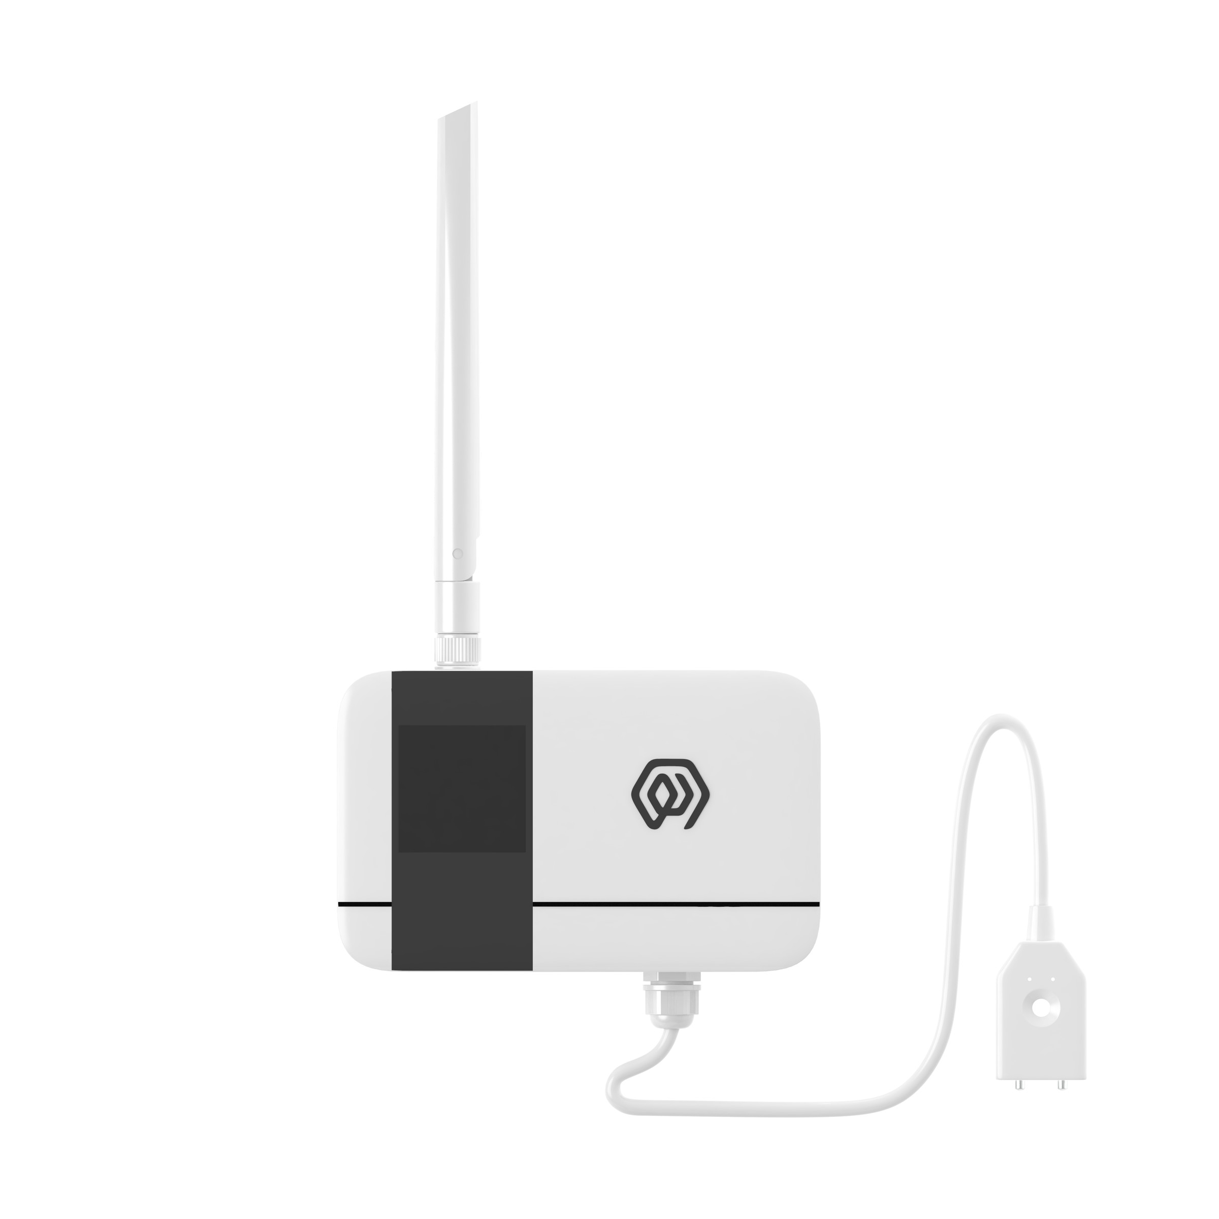
VERSION  当前版本 | DOCUMENT  Device Manual

Product Description
KS51 is a wireless water leakage detector sensor device, which monitors whether there is a water leakage event in the area monitored by the probe in real time through the sensor. When a water leakage event occurs, the alarm information is triggered and transmit to the application platform through LoRa signal.
KS51 periodically sends heartbeat information to ensure that the application platform monitors the status of the device in real time. The default configuration period is 3 hours. The user can set the sampling period and the heartbeat period through the palm machine or the management platform.
Supports LoRaWAN and LinkWAN protocols, IP65 protection level.
KS51 through real-time monitoring of flooding events, and alarm, the first time to inform the management of the flooding site for timely treatment, for storage, warehouse, factory and other events to protect, to avoid the loss of goods or equipment due to flooding events.
KS51 based on LoRa®Wireless technology, supports standard LoRaWAN®Networking communication has the characteristics of long communication distance and low power consumption. The product has 4 built-in 2700 mAh large-capacity lithium battery, the battery life is more than 8 years.
KS51 support with ManThink/3rd party LoRaWAN gateway, is combined with the ThinkLink/Chirp stack/TTN third-party Internet of Things platform to realize point-type and rope-type interfaces.
KS51 has a high protection level of IP65, which can be widely applied to the management requirements of smart industries, smart buildings and other scenarios.

Application Areas
- Warehousing and warehouse of logistics
- Data Center and Service Room
- Unattended factory, workshop
- Smart Home, Smart Building

Key Features
- Low battery voltage alarm
- Equipment failure alarm
- Support ThinkLink platform operation and maintenance
- LoRa modulation, receiving sensitivity up to-139dBm
- Standby power consumption <5uA
- High energy density lithium battery, to ensure that the product has a continuous working life of 8 years (3 hours heartbeat cycle)
- Support US902,AU915,AS923,EU868,EU433,CN470 LoRaWAN standard.

Specifications
Item | Value
INTERFACE
Connect Type | PG7, point/rope
Number of interfaces | 1
Display | None

Item | Value
WIRELESS PARAMETERS
Communication Protocol | Standard LoRaWAN®Agreement
Regional Standards | CN470/EU433/EU868/AS923/AU915/Us902
Transmit Power | Maximum Support 22dBm ( can be changed)
Receiving sensitivity | -142dBm(SF=12,BW=125kHz)
Working mode | OTAA/ABP Class A

Item | Value
CONFIGURATION
Test /Trigger mode | The magnet 2 seconds trigger heartbeat data 6 seconds trigger into the network
Parameter configuration | By NS issue instruction

Item | Value
PHYSICAL CHARACTERISTICS
Power supply | 4*2700 mAh ER14505 lithium battery
Sleep current | <5uA (25 ℃ at room temperature)
Emission current | <110mA (22dBm transmit power)
Battery life | 8 years (3 hours heartbeat cycle, 25 ℃ at room temperature)
Working temperature | -40°C ~85°C
Relative humidity | ≤95% (no condensation)
Protection level | IP65
Material & Color | ABS + PC, White
Dimensions | 120mm * 72mm * 28mm
Installation method | Wall Hanging

Dimensions and Interfaces
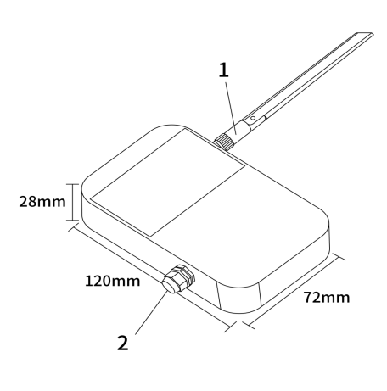
Figure Dimensions and Interfaces
No. | Interface
1 | LoRa antenna interface
2 | Point/rope sensor interface

Product Model

Model example
KS518-A1-AS923-N

Model component breakdown
- KS518: product series and RF band.
- KS51 identifies a second-generation IP65 water-leak sensor.
- 8 identifies the 800 MHz-and-above RF version for EU868, AS923, AU915 and US902.
- Other band option: 4 identifies the 400 MHz RF version for EU433 and CN470.
- -A1: sensor type and power configuration.
- A identifies point water-leak detection.
- Other sensor option: B identifies rope water-leak detection.
- 1 identifies a built-in 10800 mAh battery.
- Other power option: 2 identifies external DC 5–24 V input.
- -AS923: LoRaWAN regional standard.
- AS923 means that the device supports the LoRaWAN AS923 regional parameters.
- Other regional codes are CN470, EU433, EU868, AU915 and US902; US902 denotes the LoRaWAN US915 (902–928 MHz) regional parameters.
- -N: default version.
- N identifies the default version.
- Other values are reserved for customized or special versions.

Complete model meaning
The complete meaning of KS518-A1-AS923-N is:
This is a second-generation IP65 point water-leak sensor in the 800 MHz-and-above RF class. It includes a 10800 mAh battery, supports the LoRaWAN AS923 regional standard, and uses the default final version code N.

Instructions for use

Network topology
KS51 is a standard LoRaWAN device, KS51 normal operation requires LoRaWAN network support. You can use the LoRaWAN gateway of ManThink or the LoRaWAN gateway of a third party, and it needs the support of LoRaWAN NS. KS51 supports accessing standard LoRaWAN networks such as ThinkLink, Chirp stack, and TTN. You can use the ThinkLink configuration model to implement business functions, card view presentation, and other business logic.
The LoRaWAN network topology is as follows:
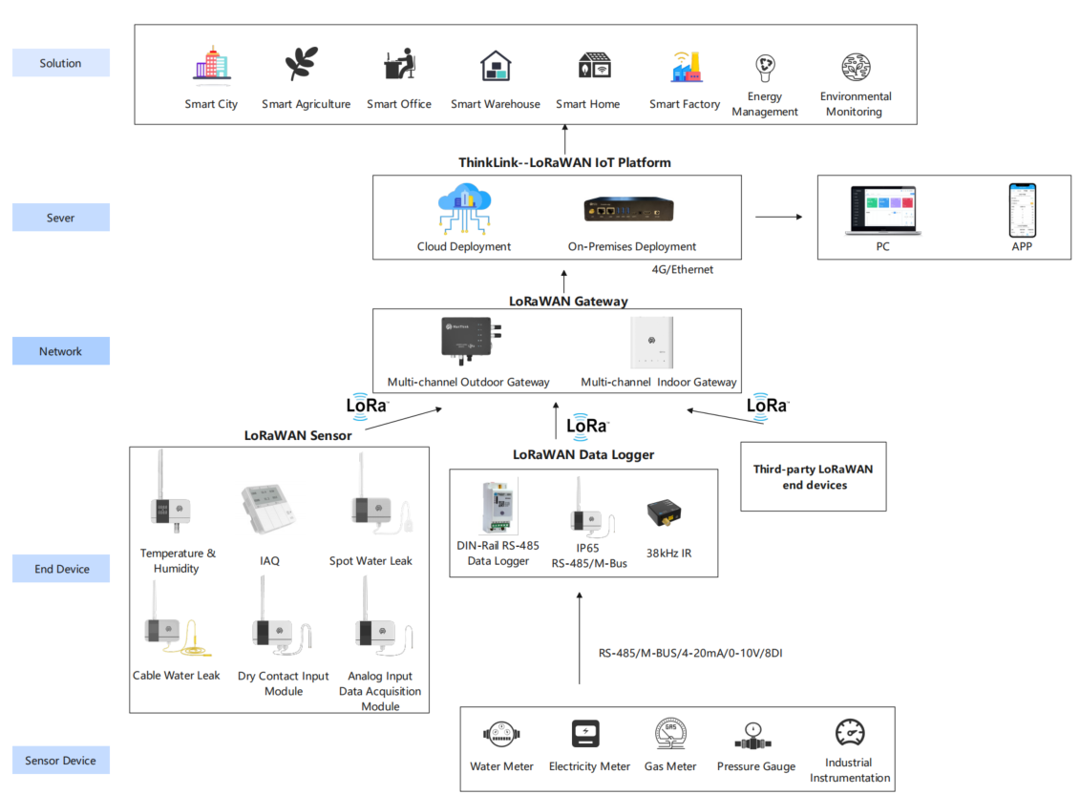
Figure Network topology

Working mode

Condition monitoring
- KS51 continuously monitors the water leakage status,
- Upload alarm information after leakage event.
- After transmit the alarm information, enter the protection mechanism and no alarm will be given within 1 minute.
- 1 minute after the alarm, the detection probe level status will upload information again if there is no water leakage
NOTE It is impossible to detect the leakage state of non-conductive liquids, such as organic solvents, purified water, etc.

Periodic heartbeat
The format of the heartbeat protocol is the same as that of the heartbeat trigger protocol, and the heartbeat period can be set by issuing instructions through NS.

Communication Test
Use a magnet to stick a two-dimensional code on KS51 to trigger 2s-4S, which can trigger a packet of upstream measurement data.

Network access
Use a magnet to stick a two-dimensional code on KS51 to trigger 6s-8s, which can trigger a packet of network access data.

Installation Instructions

Single point type water immersion installation diagram
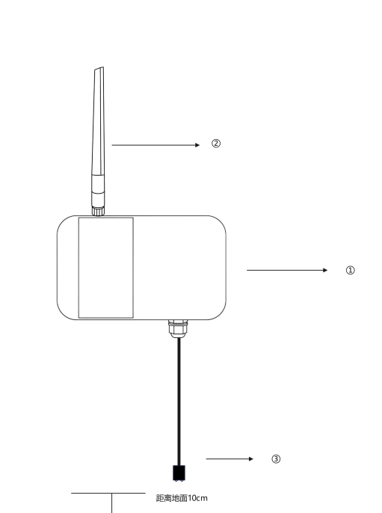
Figure Single point type water immersion installation diagram
① Hang the water detector sensor vertical wall on the wall, and the back of the water leakage sensor is installed with a back plate for fixing.
② Tighten the LoRa antenna
③ The root of the water immersion probe shall be closely attached to the wall surface with double-sided adhesive, and the height from the ground shall be 10cm.
NOTE Please ensure that the installation is covered by the Gateway when leakage

Rope type water immersion installation diagram
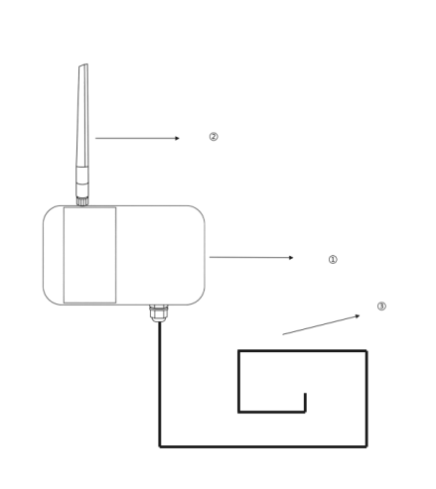
Figure Rope type water immersion installation diagram
① Hang the water leakage vertical wall on the wall, and the back of the water leakage sensor is equipped with a back plate for fixing.
② Tighten the LoRa antenna
③ Water leakage detection extension rope
preparation tools: Impact drill, drill bit, Phillips screwdriver, Buckle
use an electric drill to drill holes in the installation position in advance. The left and right sides of the water leakage detector will be equipped with installation holes, which will be fixed by screws. Then connect the extension cord, and use the buckle to fix the extension cord at the position where the water leakage needs to be monitored.

Communication Protocol

According to the standard
\PTL-D01 ManThink Technology IoT Terminal Application Layer General Protocol V1.5

Data Items and Identifiers
- LoRaWAN port number = 11
KS51 supports only one data format and sends data periodically according to a set period. When a flooding event occurs, it triggers one frame of uplink data.
Example (hex):82 21 12 00 F1 50 06
Number | Data Item | Example | Start Address | Length | Description
1 | Version number | 0x82 | 0 | 1 byte | Fixed at 0x82
2 | Control word | 0x21 | 1 | 1 byte | Fixed at 0x21
3 | Identifier | 0x12 | 2 | 1 byte | Fixed at 0x12
4 | Status | 0x00 | 3 | 1 byte | 0x00: dry; 0x01: water detected
5 | Battery voltage | 0xF1 | 4 | 1 byte | Actual value = sample × 1.6 / 254 + 2 V
6 | RSSI | 0x50 | 5 | 1 byte | Actual value = reported value - 160 dBm
7 | SNR | 0x06 | 6 | 1 byte | uint8, unit: dB

ThinkLink reference model
Log in to <https://thinklink.manthink.cn>\n○ Search for KS51 in the model menu\n○ add using template KS51

Parameter modification
\PTL-D01 ManThink Technology IoT Terminal Application Layer General Protocol V1.5

Configuration parameter address table
Number | data Item | default Value | start Address | length | description
1 | upload period | 900 | 40 | 4 bytes | upload period, in seconds

Contact Us
Website: www.manthink.cn
Email: info@manthink.cn
Tel: +86 15810684257

