MANTHINK / INDUSTRIAL IoT
KS52
LoRaWAN Sensor
Standardized Device Manual
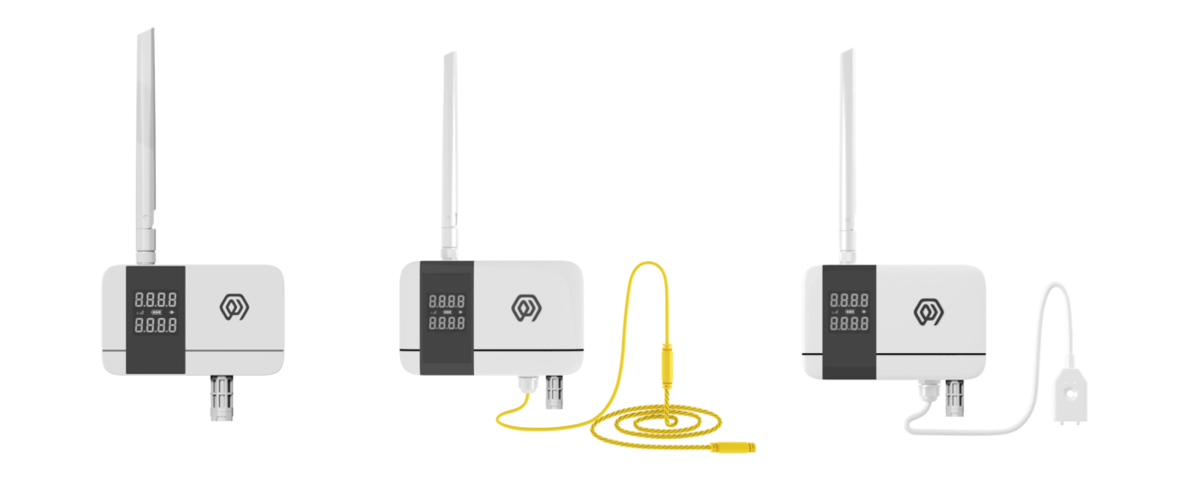
VERSION  当前版本 | DOCUMENT  Device Manual

Product Introduction
KS52 is a LoRa-based ®The digital temperature and humidity sensor of wireless technology uses high-precision sensing elements to collect environmental temperature and humidity data in real time, and through LoRaWAN®The protocol periodically reports measurements to the application platform.
The KS52's optional water leakage detection function enables real-time monitoring of water leakage incidents and triggers alarms to immediately notify management personnel, allowing prompt on-site response. This feature helps protect warehouses, storage facilities, factories, and similar environments, preventing loss or damage to goods and equipment caused by water intrusion.
Users can flexibly configure the sampling and reporting period through the management platform, and the default setting is to upload data every 15 minutes.
The product has 4 built-in 2700mAh high-capacity lithium sub-batteries. With low-power design, the battery life can reach more than 6 years in typical application scenarios.
Relying on LoRaWAN®Standard protocol, KS52 has the advantages of long-distance transmission and low-power operation, and supports access to ManThink Technology and third-party LoRaWAN. ®The gateway is compatible with IoT platforms such as ThinkLink, ChirpStack, and The Things Network(TTN) to realize remote monitoring and intelligent management of environmental parameters.
KS52 with IP65 level of advanced protection, resistant to complex outdoor environment, widely applicable to intelligent industry, intelligent buildings, warehousing and logistics, agricultural monitoring and other scenarios, to meet the application requirements of all-weather environmental monitoring.

Features
- IP65
- Battery powered, 10800mA high performance lithium battery, battery life can reach more than 6 years
- COV
- Low power LCD display
- Temperature accuracy: ± 0.3 ℃
- Humidity accuracy: ± 3% RH
- Support ThinkLink/ChirpStack/TTN platform docking
- Support US902,AU915,AS923,EU868,EU433,CN470 LoRaWAN standards

Specifications
Parameter | Specification
Temperature/humidity sensor | IP65 waterproof sensor (SHT41 package)
Water-leak sensor | Point/rope type
Wire count | 0
Display | Low-power segment LCD
Acquisition interval | 5 seconds
Temperature accuracy | ±0.3 ℃
Humidity accuracy | ±3%RH

Item | Value
WIRELESS PARAMETERS
Protocol | standard LoRaWAN®Agreement
Regional Standards | CN470/EU433/EU868/AS923/AU915/Us902
Transmit power | maximum Support 22dBm ( can be changed)
Receiving sensitivity | -142dBm(SF=12,BW=125kHz)
Working mode | OTAA/ABP Class A

Item | Value
CONFIGURATION
Test /Trigger mode | the magnet 2 seconds trigger heartbeat data > 6 seconds trigger joining
Parameter Configuration | by NS issue instruction

Item | Value
PHYSICAL CHARACTERISTICS
Power supply mode | 4*2700 mAh ER14505 lithium battery
Sleep current | <5uA (25 ℃ at room temperature)
Emission current | <110mA (22dBm transmit power)
Battery life | 6 years (15-minute reporting cycle, 25 ℃ at room temperature)
Working Temperature | -40°C ~85°C
Relative humidity | ≤ 95% (no condensation)
Protection level | IP65
Material & Color | ABS + PC, White
Dimensions | 120mm * 72mm * 28mm
Installation method | Wall Hanging

Dimensions and Interfaces
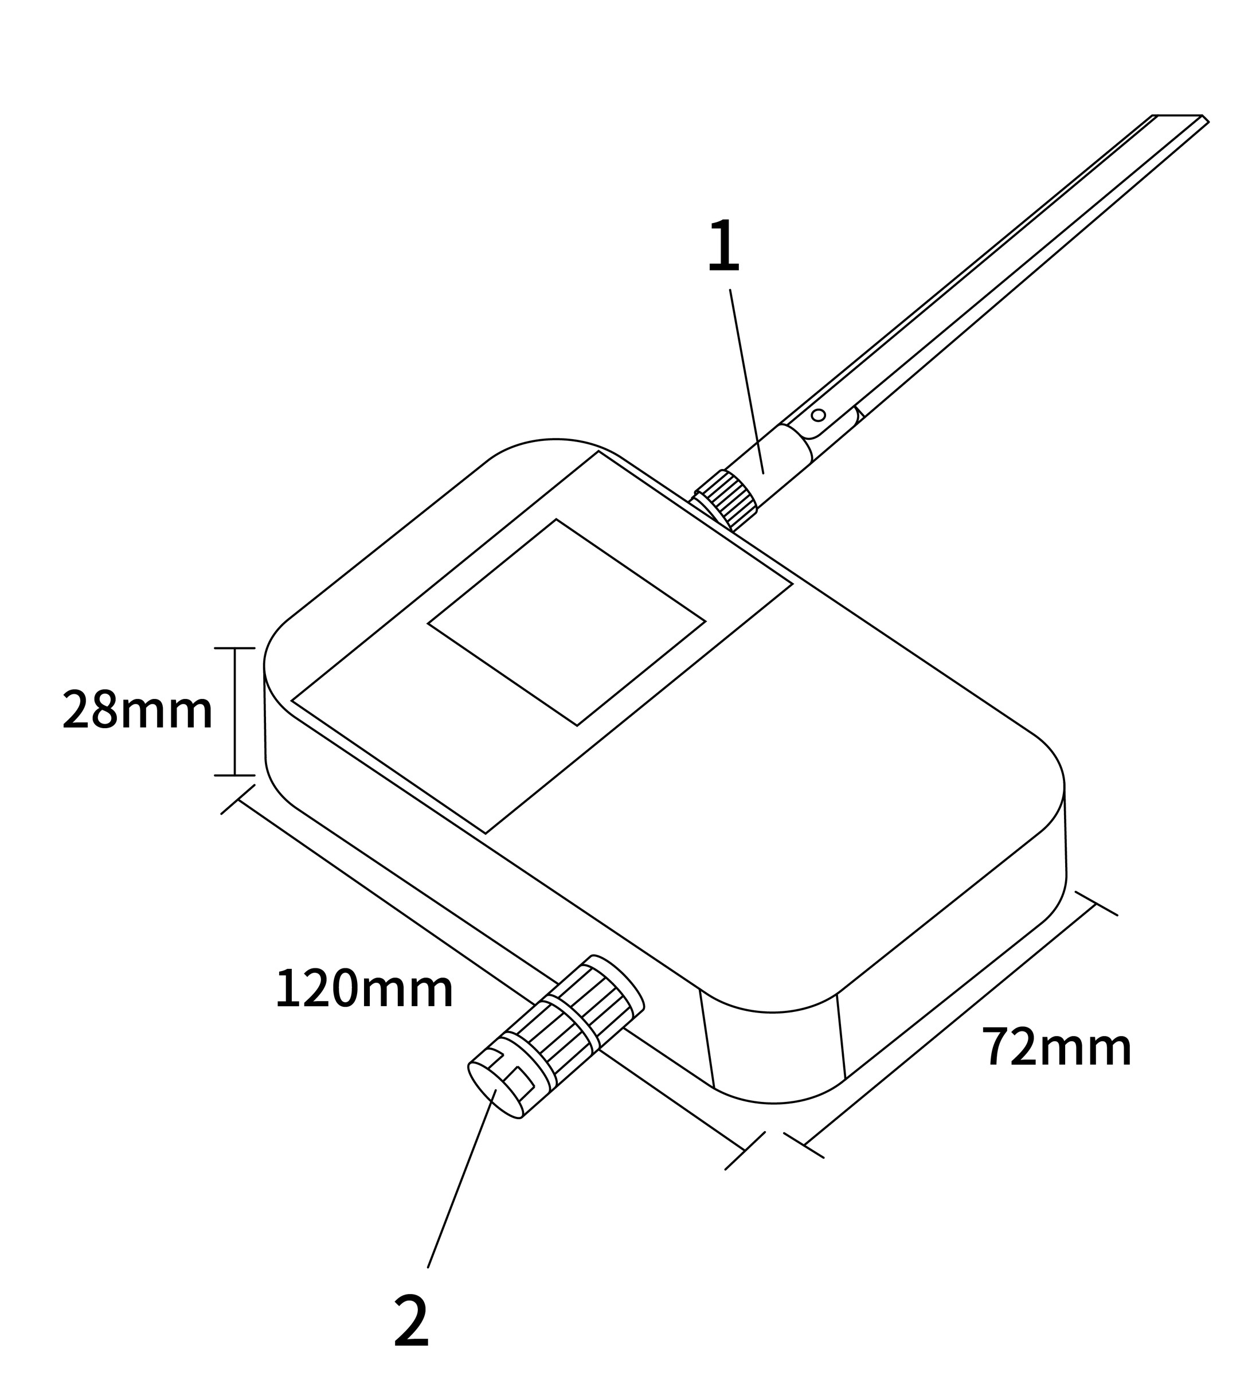
Figure Dimensions and Interfaces
No. | Interface
1 | LoRa antenna interface
2 | Sensor interface

Product Model

Model example
KS528-A1-AS923-N

Model component breakdown
- KS528: product series and RF band.
- KS52 identifies a second-generation IP65 temperature and humidity sensor.
- 8 identifies the 800 MHz-and-above RF version for EU868, AS923, AU915 and US902.
- Other band option: 4 identifies the 400 MHz RF version for EU433 and CN470.
- -A1: sensor combination and power configuration.
- A identifies a temperature-and-humidity-only configuration.
- Other sensor options: B adds point water-leak detection, while C adds rope water-leak detection.
- 1 identifies a built-in 10800 mAh battery.
- Other power options: 2 identifies external DC 5–24 V input, while 3 identifies an external 2.2–3.6 V battery.
- -AS923: LoRaWAN regional standard.
- AS923 means that the device supports the LoRaWAN AS923 regional parameters.
- Other regional codes are CN470, EU433, EU868, AU915 and US902; US902 denotes the LoRaWAN US915 (902–928 MHz) regional parameters.
- -N: default version.
- N identifies the default version.
- Other values are reserved for customized or special versions.

Complete model meaning
The complete meaning of KS528-A1-AS923-N is:
This is a second-generation IP65 temperature and humidity sensor in the 800 MHz-and-above RF class. It uses the temperature-and-humidity-only sensor configuration, includes a 10800 mAh battery, supports the LoRaWAN AS923 regional standard, and uses the default final version code N.

Instructions for use

Network topology
KS52 is a terminal device that conforms to the standard LoRaWAN protocol, and its normal operation depends on the complete LoRaWAN network support. The network needs to include LoRaWAN gateway and network server (NS), wherein the Gateway can choose the self-developed products of ManThink or the third-party compatible equipment, and NS must have the capability of protocol resolution and equipment management.
KS52 supports access to LoRaWAN Network platforms, including ThinkLink, ChirpStack, and The Things Network (TTN), to ensure flexible deployment and system integration. Users can use ThinkLink IoT platform to configure the object model, implement rich functions such as data parsing, business logic processing, and card view display, and quickly build application systems for actual scenarios.
A typical LoRaWAN network topology is as follows:
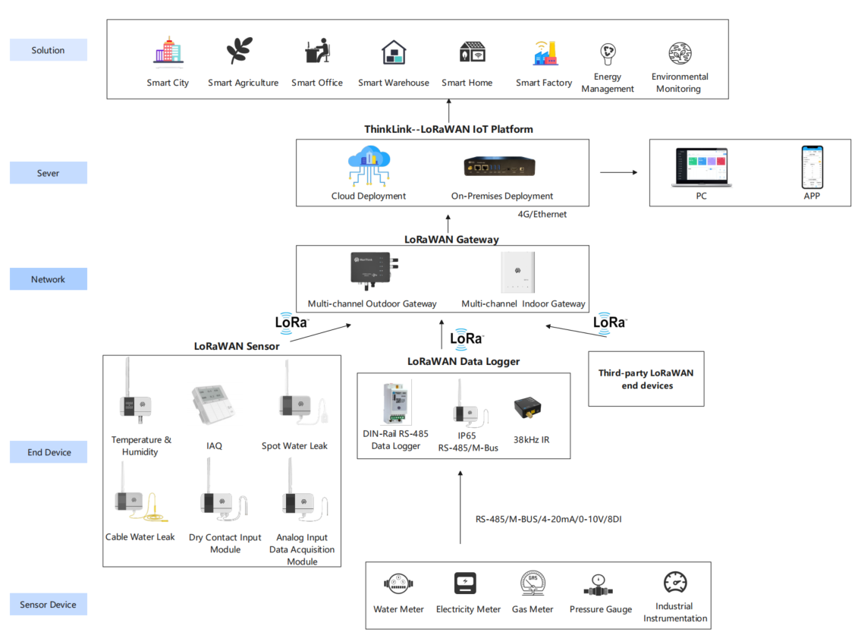
Figure Network topology

Working mode

Periodic collection and Upload
- KS52 collects temperature and humidity values every 5 seconds, and uploads the temperature and humidity values according to the set period. The Upload period can be set by NS delivery.
- KS52 continuously monitors the water leakage status,
- Upload alarm information after leakage event.
- After transmit the alarm information, enter the protection mechanism and no alarm will be given within 1 minute.
- 1 minute after the alarm, the detection probe level status will upload information again if there is no water leakage
NOTE It is impossible to detect the leakage state of non-conductive liquids, such as organic solvents, purified water, etc.

COV Upload
KS52 supports COV mode, when the temperature or humidity changes exceed the threshold, you can trigger a packet of data upload. The Upload protocol format is the same as the periodic Upload format.
KS52 default COV temperature threshold is 1 ℃, and default COV humidity threshold is 5% RH.

Communication Test
Use a magnet to stick the location of QR code on KS52 to trigger 2s-4S, which can trigger a packet of measurement data.

Network access
Use a magnet to stick the location of QR code on KS52 to trigger 6s-8s, which can trigger a packet of LoRaWAN join.

Installation

Wall Mount
- Fix back panel to wall (keep back panel Arrow Up)
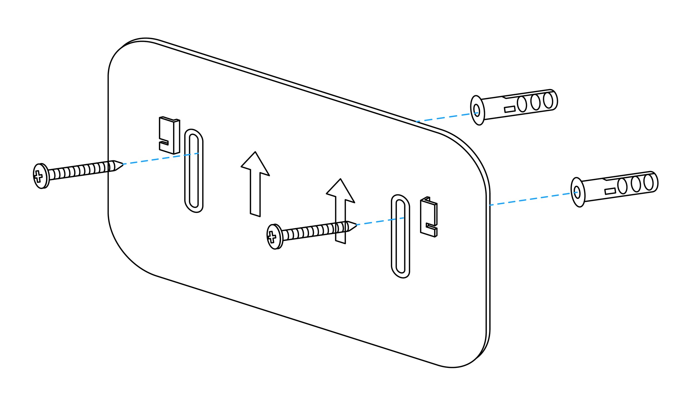
Figure Wall Mount
- Tighten the LoRa antenna to the antenna interface
- Hitch the temperature and humidity sensor on the back plate (after aligning the back groove of the sensor with the convex part of the back plate, slide it down)
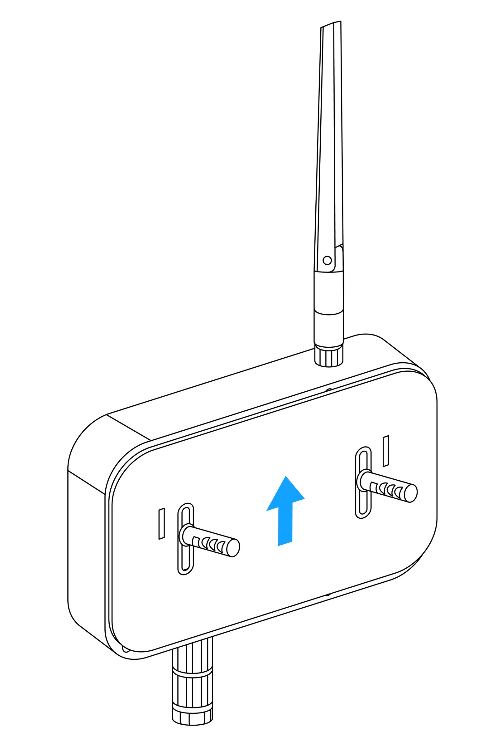
Figure Wall Mount

Single point type water immersion installation diagram
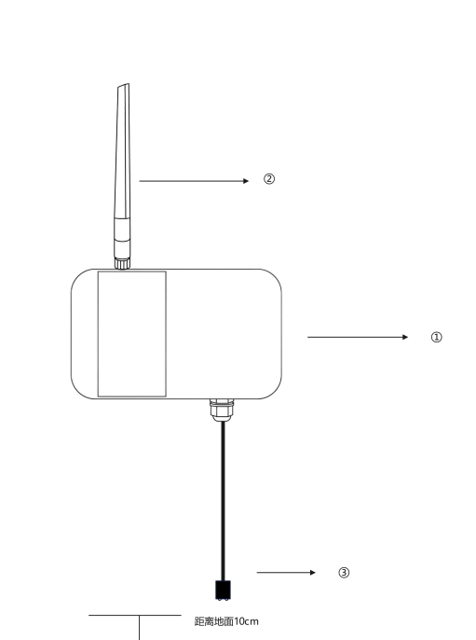
Figure Single point type water immersion installation diagram
① Hang the water detector sensor vertical wall on the wall, and the back of the water leakage sensor is installed with a back plate for fixing.
② Tighten the LoRa antenna
③ The root of the water immersion probe shall be closely attached to the wall surface with double-sided adhesive, and the height from the ground shall be 10cm.
NOTE Please ensure that the installation is covered by the Gateway when leakage

Rope type water immersion installation diagram
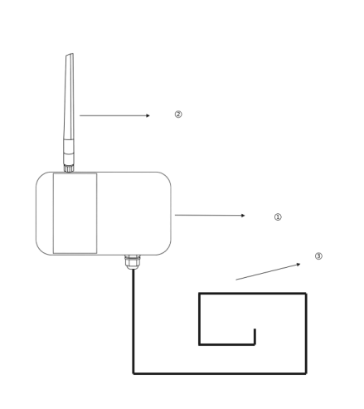
Figure Rope type water immersion installation diagram
① Hang the water leakage vertical wall on the wall, and the back of the water leakage sensor is equipped with a back plate for fixing.
② Tighten the LoRa antenna
③ Water leakage detection extension rope
preparation tools: Impact drill, drill bit, Phillips screwdriver, Buckle
use an electric drill to drill holes in the installation position in advance. The left and right sides of the water leakage detector will be equipped with installation holes, which will be fixed by screws. Then connect the extension cord, and use the buckle to fix the extension cord at the position where the water leakage needs to be monitored.

Communication Protocol

Data Items and Identifiers
- LoRaWAN port number = 11
KS52 supports only one data format and sends data periodically according to the set period. When a COV event occurs, it triggers one frame of uplink data.
Example (hex):21 07 03 0C 6E A005 00 F604 8C03 DB 00 00
Number | Data Item | Example | Start Address | Length | Description
1 | Version number | 0x21 | 0 | 1 byte | Fixed at 0x21
2 | Control word | 0x07 | 1 | 1 byte | Fixed at 0x07
3 | Identifier | 0x03 | 2 | 1 byte | Fixed at 0x03
4 | Hardware version | 0x0C | 3 | 1 byte | Decimal 10 represents V1.0, and so on
5 | Software version | 0x6E | 4 | 1 byte | Decimal 100 represents V1.00, and so on
6 | Reserved bytes | A0 05 | 5 | 2 bytes | Reserved; do not use for application parsing
7 | Device status | 0x00 | 7 | 1 byte | See the bit0, bit1, bit2, and bit4 definitions below
8 | Temperature | 0x04F6 | 8 | 2 bytes | Unsigned 16-bit little-endian integer; actual temperature = (raw value - 1000) / 10 ℃
9 | Humidity | 0x038C | 10 | 2 bytes | Unsigned 16-bit little-endian integer; actual humidity = raw value × 0.1 %RH
10 | Battery voltage | 0xDB | 12 | 1 byte | Actual value = sample × 1.6 / 254 + 2 V
11 | RSSI | 0x00 | 13 | 1 byte | Actual value = reported value - 160 dBm
12 | SNR | 0x00 | 14 | 1 byte | Actual value, unit: dB

Device status bit mapping
Bit | Status item | 0 | 1
bit0 | Sensor status | Normal | Fault
bit1 | LoRaWAN mode | Class A | Class C
bit2 | Display status | Normal | Fault
bit4 | Water-leak status | Dry | Water detected

ThinkLink reference model
Sign in to ThinkLink, search for KS52 in the model menu, and add the device with the MT-KS52 template.

Parameter modification
KS52 supports remote parameter configuration by sending downlink commands through a LoRaWAN Network Server (NS).
Parameter modification uses the ManThink Technology application-layer general protocol. All parameter configuration commands are transmitted via LoRaWAN port 214.
- Communication port: 214
- Function code: 0xCF (Modify service parameters)
- Multi-byte parameters: Little-endian format
- Successful parameter configuration response:
6F 01 00

Parameter Configuration Address Table
Index | data Item | default Value | start Address | length | description
1 | data period | 900 | 40 | 4 bytes | upload cycle, in seconds
2 | measure period | 5 | 142 | 2 bytes | little Endian mode, in seconds
3 | temperature COV | 10 | 144 | 1 byte | magnification 0.1, unit ℃
4 | humidity COV | 20 | 145 | 1 byte | magnification 0.1, unit: RH%

Parameter Modification Examples

Modify Upload Interval (Single Command)
Example: Set the upload interval to 900 seconds
- Hex representation: 0x00000384
- Little-endian format: 84 03 00 00
Command:
CF 06 28 04 84 03 00 00

Modify Collection Interval and COV Parameters (Continuous Addresses, Single Command)
Example parameter settings:
Parameter | Target Value | Written Value
Collection interval | 5 seconds | 05 00
Temperature COV | 1.0 °C | 0A
Humidity COV | 2.0 %RH | 14

- Start address: 142 (0x8E)
- Continuous length: 4 bytes (142–145)
Command:
CF 06 8E 04 05 00 0A 14

Example of Concatenated Downlink Commands
On the NS platform, multiple parameter modification commands can be concatenated into a single downlink payload. The device will parse and execute them sequentially.
CF 06 28 04 84 03 00 00 CF 06 8E 04 05 00 0A 14

Notes
- All parameter configurations must use LoRaWAN port 214
- KS52 is a Class A device and can only receive downlink parameter configurations after an uplink transmission
- If no response is received after parameter configuration, please check the device online status and gateway coverage

Contact Us
Website: www.manthink.cn
Email: info@manthink.cn
Tel: +86 15810684257

