MANTHINK / INDUSTRIAL IoT
KS53
LoRaWAN Sensor
Standardized Device Manual
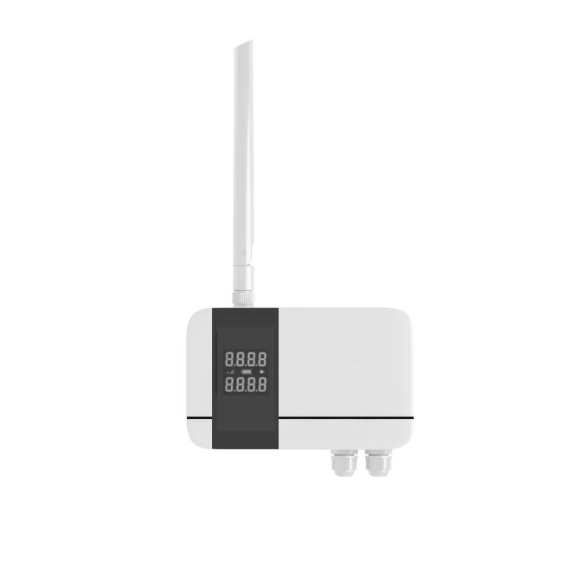
VERSION  当前版本 | DOCUMENT  Device Manual

Product Introduction
this product is based on the LoRa®Wireless technology digital temperature sensor, using high-precision sensing elements to collect real-time ambient temperature data, and through the LoRaWAN®The protocol periodically reports measurements to the application platform. Users can flexibly configure the sampling and reporting cycle through the management platform, and the default setting is to upload data every 15 minutes.
Relying on LoRaWAN®Standard communication protocol. This product has The advantages of long-distance transmission and low-power operation. It supports access to gateways compatible with various platforms, and is compatible with mainstream IoT platforms such as ThinkLink, ChirpStack, and The Things Network(TTN) to realize remote monitoring and intelligent management of environmental parameters.
It has IP65 level advanced protection, tolerates complex outdoor environment, and is widely used in smart industry, smart buildings, warehousing and logistics, agricultural monitoring and other scenarios to meet the application requirements of all-weather environmental monitoring.

Main features
- IP65 protection level
- COV
- Low power LCD display
- Temperature accuracy: ± 0.5 ℃
- Support ThinkLink/ChirpStack/TTN platform docking
- Support US902,AU915,AS923,EU868,EU433,CN470 LoRaWAN standards

Specification parameters

Parameters
Parameter | Specification
Sensor type | IP65 waterproof sensor (DS18B20 package)
Sensor extension cable | 1 meter by default
Display | Low-power segment LCD
Acquisition interval | 5 seconds
Temperature accuracy | ±0.5 ℃

Item | Value
WIRELESS PARAMETERS
communication Protocol | standard LoRaWAN®Agreement
regional Standards | CN470/EU433/EU868/AS923/AU915/Us902
transmit power | maximum support 22dBm (can change the parameter)
receiving sensitivity | -142dBm(SF=12,BW=125kHz)
network access/working mode | OTAA/ABP Class A

Item | Value
PROTOCOL/CONFIGURATION
test/Trigger Mode | Magnet, 2 seconds trigger heartbeat data,>6 seconds trigger into the network
parameter configuration | issuing instructions via NS

Item | Value
PHYSICAL CHARACTERISTICS
power supply mode | rail switching power supply
sleep current | <5uA (25 ℃ at room temperature)
emission current | <110mA (22dBm transmit power)
working temperature | -40 ° C -125 ° C
protection level | IP65
materials & Colors | ABS + PC, White
dimensions | 120mm * 72mm * 28mm
installation method | wall Hanging

Dimensions and Interfaces
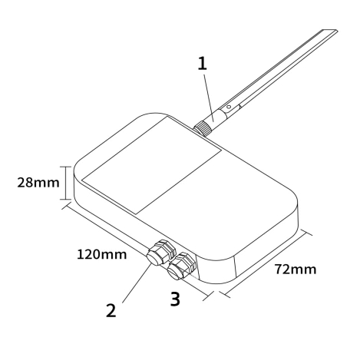
Figure Dimensions and Interfaces
No. | Interface
1 | LoRa antenna interface
2 | Sensor interface
3 | Power interface

Model List

Model example
KS538-A1-AS923-N

Model component breakdown
- KS538: product series and RF band.
- KS53 identifies a second-generation IP65 temperature sensor.
- 8 identifies the 800 MHz-and-above RF version for EU868, AS923, AU915 and US902.
- Other band option: 4 identifies the 400 MHz RF version for EU433 and CN470.
- -A1: sensor probe and power configuration.
- A identifies a DS18B20 temperature probe.
- Other probe option: N identifies a unit supplied without a sensor probe.
- 1 identifies a built-in 10800 mAh battery.
- Other power option: 2 identifies external DC 5–24 V input without a power output for another device.
- -AS923: LoRaWAN regional standard.
- AS923 means that the device supports the LoRaWAN AS923 regional parameters.
- Other regional codes are CN470, EU433, EU868, AU915 and US902; US902 denotes the LoRaWAN US915 (902–928 MHz) regional parameters.
- -N: antenna configuration.
- N identifies an external antenna with an SMA connector.
- Other antenna option: S identifies an internal antenna.

Complete model meaning
The complete meaning of KS538-A1-AS923-N is:
This is a second-generation IP65 temperature sensor in the 800 MHz-and-above RF class. It includes a DS18B20 temperature probe and a 10800 mAh battery, supports the LoRaWAN AS923 regional standard, and uses an external antenna with an SMA connector.

Instructions for use

Network Topology
This product is a terminal device that conforms to the standard LoRaWAN protocol, and its normal operation depends on the complete LoRaWAN network support. The network needs to include a LoRaWAN gateway and a network server (NS), where the Gateway can be a brand-compatible gateway, and the NS must have Protocol resolution and device management capabilities.
Supports access to mainstream LoRaWAN Network platforms, including ThinkLink, ChirpStack, and The Things Network (TTN), ensuring flexible deployment and system integration. Users can use ThinkLink IoT platform to configure the object model, implement rich functions such as data parsing, business logic processing, and card view display, and quickly build application systems for actual scenarios.
A typical LoRaWAN network topology is as follows:

Working mode

Periodic Collection and Upload
collect the temperature value every 5 seconds and upload the temperature value according to the set cycle. The Upload cycle can be set by NS delivery.

COV Upload
COV mode is supported. When the temperature or humidity changes exceed the threshold, a packet of data can be uploaded. The Upload protocol format is the same as the periodic Upload format.
The default COV temperature threshold is 1°C.

Communication Test
use a magnet to trigger 1S -2s when sticking a two-dimensional code to trigger a packet of upstream measurement data.

Network access
use a magnet to trigger 6s-8s on the two-dimensional code to trigger a packet of network access data.

Installation

Wall Mount
· fix back panel to wall (keep back panel Arrow Up)
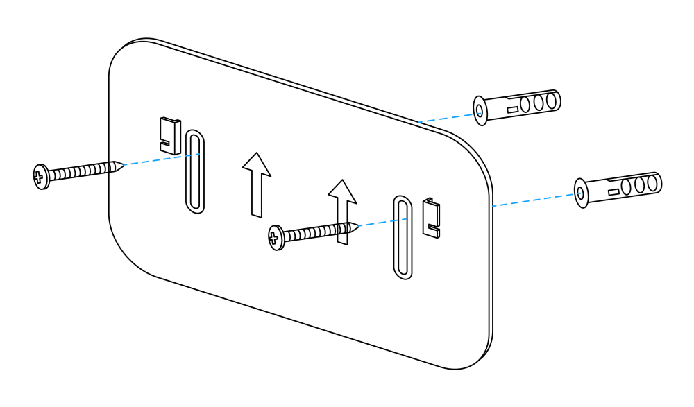
Figure Wall Mount
· Tighten the LoRa antenna to the antenna interface
· hitch the temperature sensor to the back plate (slide down after aligning the groove on the back of the sensor with the protrusion on the back of the back plate)
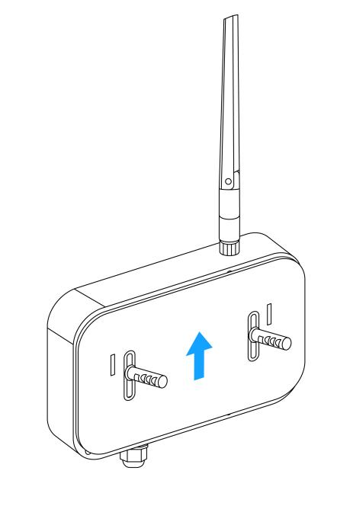
Figure Wall Mount

Communication protocol

Data items and identifiers.
LoRaWAN port number = 11
only one data format is supported. Data is sent periodically according to the set period. When a COV event occurs, one frame of uplink data is triggered.
Example (hex):82 21 05 00a005 DB 0201
Number | Data Item | Example | Start Address | Length | Description
1 | Version number | 0x82 | 0 | 1 byte | Fixed at 0x82
2 | Control word | 0x21 | 1 | 1 byte | Fixed at 0x21
3 | Identifier | 0x05 | 2 | 1 byte | Fixed at 0x05
4 | Device status | 0x00 | 3 | 1 byte | See the bit0 definition below
5 | Temperature | 0x05A0 | 4 | 2 bytes | Unsigned 16-bit little-endian integer; actual temperature = (raw value - 1000) / 10 ℃
6 | Battery voltage | 0xDB | 6 | 1 byte | Actual value = sample × 1.6 / 254 + 2 V
7 | Reserved bytes | 0x0102 | 7 | 2 bytes | Reserved; do not use for application parsing

Device status bit mapping
Bit | Status item | 0 | 1
bit0 | Sensor status | Normal | Fault

ThinkLink reference model.
Sign in to ThinkLink.
- search KS53 in Model Management
- add devices according to template MT-KS53

Parameter modification
Parameter changes follow *PTL-D01 Internet of Things Terminal Application Layer General Protocol V1.5* (see Annex 1).

Configuration parameter address table
serial Number | data Item | default Value | start Address | length | description
1 | reset | write Only | 9 | 1 byte | write 0x01
2 | upload cycle | 90 | 40 | 4 bytes | upload cycle, in seconds
3 | acquisition cycle | 5 | 142 | 2 bytes | little Endian mode, in seconds
4 | Temperature COV | 10 | 144 | 1 byte | magnification 0.1, unit ℃

Contact Us
Website: www.manthink.cn
Email: info@manthink.cn
tel: +86 15810684255

